Fresh Approach Collective Worship Planning
Year 3 Term 1: Together Again

Week 1 | Rebuilding together  (with acknowledgement to the Diocese of Guildford schools’ department)
Week 2 | Learning together from Jesus the Teacher  Education Sunday is in early September
Week 3 | Growing together in a growing world (Harvest)  Use this week where appropriate for your school calendar
Week 4 | Flourishing together
Week 5 | Compassion together
Week 6 | Resilience together
Week 7 | Kindness together (including ‘thank your vicar’)
As a new school year starts, these materials aim to help you to grow and develop together as a school community. This is an opportunity to re-establish your school’s vision and values by exploring the characteristics of strong and flourishing relationships. You might want to include a week for addressing your school’s particular values rather than those suggested here.
Thank you for all that you will do to adapt the suggestions in ways which will best bless your school community.
The LORD bless you and keep you: The LORD make his face to shine upon you, and be gracious to you: The LORD lift up his countenance upon you, and give you peace. (Numbers 6:24-26 RSV)
Liturgical colour | Monday  Whole School | Tuesday  Whole School | Wednesday  Whole School  Psalm Praise / Singing Worship | Thursday  Worship in the classroom | Friday  Celebration worship
Week 1: Display the illustrations provided as reminders of the messages of the week | UNDERSTANDING OUR COMMUNITY  Nehemiah 1-6  Look at the picture of the jigsaw at puzzle-game-solution-connection or use a real one. I wonder which things you can ‘build’ words, Jenga, house, boat, jigsaw, friendships etc. I wonder what you like / do not like to build. Look at the picture of the puzzle. How do you ‘build’ a jigsaw puzzle?  I wonder whether everyone likes to build jigsaws in the same way. I wonder if our school community is a bit like a jigsaw puzzle.  Read the story of Nehemiah – there is a version provided below as an appendix or use an appropriate Bible.  I wonder….  …why Nehemiah was so sad when he heard the news from his brother.... …how Nehemiah felt to be given the job of re-building Jerusalem... ….or how it felt to return home....  I wonder what the most difficult part of the re-building was.... ….and how you might re-build a community....or someone’s heart.... I wonder how this story might help us today as we come back together after our summer holidays....  Give each child a jigsaw puzzle piece. Our school community is like a big jigsaw.  Dear God, Please help us to remember that we are all important in our school community, that we each matter. Help us to be thankful for each other as we come together again and learn to live as one community.  AMEN | ENCOURAGING OUR COMMUNITY  Nehemiah 8, 9, 12  You will need the picture of the Torah scroll https://pixabay.com/photos/torah-scroll-israel-jewish-4299038/ It is the sacred holy book for the Jewish people. I wonder what the scroll is for and what it might say. The scroll contains words that are very important to Jewish people. I wonder what words are important to you.  In the story (Part 2 below), Ezra the teacher read out the rules that God had given to his people through Moses. People sometimes call them the Ten Commandments. I wonder if you know any of these. What do you think they were. [You can find them in Exodus chapter 20]  I wonder….. …how the words that Ezra read from the Torah helped to rebuild the people’s hearts…. why the great stories of their past helped them to remember who they were…. how the stories reminded them of who God was…. why the words gave them a reason to celebrate….  Nehemiah wrote in his story that there had never been a celebration like it!.... I wonder why  Take a piece of paper to make your own scrolls. I wonder which words are important to you today.... write or draw your thoughts onto your scroll….  This prayer is based on the much longer prayer of Nehemiah 9. In v 5, it says, ’Stand up. Praise the Lord your God. He lives for ever and ever’. I wonder how we can stand up and praise and thank God for all he has done. Your response might be a song or a prayer in which you can encourage each other. | BUILDING A STRONG COMMUNITY  Matthew 7:24-27  Use the picture of the broken down wall below or here at: stone-wall-blocks-broken-ancient plus the picture of Nehemiah and the walls of Jerusalem below and some building bricks or Lego® to use for the reflection activity and your school values.  Look at the picture of the broken-down wall – and the pictures that remind us about the story of Nehemiah’s wall. I wonder how you would go about rebuilding these broken-down walls. I wonder what would happen if you tried to put new bricks on it as they are. I wonder which is the most important part of the wall.  Read or watch the story of the 2 Builders (see below)  https://www.youtube.com/watch?v=CXWHLB1f6_U  I wonder…. what you think Jesus meant about ‘building your life on the rock’....how we might ‘build’ our lives…what our ‘foundations’ might be. What are our school’s values? How do they help to build a strong school community.  Use the bricks to think about your actions today and as you add it to the others say - I will try to…..’  Dear God, help me to build up myself and others today by what I think, by what I say and by what I do.  AMEN | OFFERING OUR GIFTS  Nehemiah 10:39  Remind yourselves of the story of Nehemiah’s Big Build – and the things that were being built and created.  Think about some of the objects in front of Nehemiah (picture below) which are things that the people who were rebuilding the walls and the people who were in Babylon gave to help Nehemiah in his work. I wonder which objects you think would have been most useful …how you think each thing helped with the rebuilding. Look at the phrases on the wall – these were all things that the people did to help Nehemiah. I wonder how you think these actions helped with the rebuilding.  I wonder how these actions might help us to ‘give’ to our school community. Spend some time thinking about all the things you’re good at and write on the back of a ‘gift’ and offer these to help as we build our school community together day by day.  We want to give wisely:  ‘We will give all we can.’  In our friendships and family: ‘We will give all we can.’  In our work and in our play: ‘We will give all we can.’  As we rebuild our school community:  ‘We will give all we can.’  AMEN | CELEBRATE  Being together as a whole school community again  Philippians 1:4  With our families and our friends, God:  ‘Help us to build well’  As we share our lives together, God:  ‘Help us to build well’  As we live out our school values, God:  ‘Help us to build well’  As we rebuild our school community, God:  ‘Help us to build well’ AMEN
Week 2: Use this as an opportunity to talk about the learning expectations in your school within the context of the ideas here | JESUS THE TEACHER  Matthew 5:1, Matthew 11:15  https://www.youtube.com/watch?v=p6SNCvIN4EI Was Ben a good teacher?  I wonder if you can think of something that it was easy for you to learn and something which it was hard to learn.  I wonder what made the difference to your learning.  I wonder how you make sure that you are ready to learn. I wonder how Jesus made sure that his followers, friends and disciples were ready to learn. They were gathered on a hillside and ready to listen to Jesus. I wonder how you make sure that you are ready to listen to your teachers. Jesus said, ‘Listen then if you have ears to hear’ – I wonder what he meant.  To learn, you need to be ready to listen – I wonder what then makes for the best teacher as you listen.  https://www.youtube.com/watch?v=402aa9urw4I  Do you agree with anything in this clip?  Think about what you know about Jesus. I wonder how he brought out the best in people.  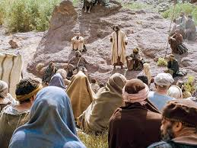  Thank you God for Jesus the teacher and for everyone who teaches us day by day. Help us to open our eyes, ears and minds to see, listen and think so that we can learn more about you and about your world. AMEN | LEARNING FROM JESUS THE TEACHER ABOUT TREATING OTHERS AS YOU WOULD WANT TO BE TREATED  Matthew 7:12  Jesus did not teach about things that were easy to do/hear: good teachers do not shrink from difficult messages.  Describe a situation such as this:  Tom loved chocolate it was his favourite. Whenever he had some chocolate he always kept it to himself he would never share any with his friends. When his friend Michael won a competition, the prize was the biggest bar of chocolate Tom had ever seen - surely Michael would share his prize with his friends. He shared the bar of chocolate with all his friends, all his friends except Tom. Tom was very sad and very hurt by these actions so he asked Michael. “Why did you share with everyone else but not me?” Michael’s reply was simple. “You never share any of your chocolate with us and that makes us sad, so why should I share with you? If you want us to share with you must share with us.” Suddenly Tom realised what he had been doing and he apologised. Next time Tom had any chocolate, sweets, crisps, games etc he always made sure that he shared and he found that is friends always shared with him  Or use  https://www.youtube.com/watch?v=3OedgmVP0uA (aimed at young children)  Make the link with Matthew 7:12. I wonder how you can rise to this challenging teaching. I wonder how the world would look different if everybody rose to this challenge.  Dear Lord, please help us to think carefully  about our actions. Help us always to  treat others in a way that we would like them to treat us.  AMEN | LEARNING FROM JESUS THE TEACHER ABOUT OUR ACTIONS  Matthew 7:15-20  I wonder if peaches could ever grow on thorny bushes or if oranges could ever grow on stinging nettles. They could not because this is the way God made things. But Jesus uses questions like these to help him explain to the crowd that we are known by our actions (Matt 7:15-20). Before people meet us, they may hear of or read about our actions and they start to think that they know us. Jesus said that people know us by our actions.  If we do good things, we are like a good tree growing good fruit. Ask a child to come out to the front and to  hold up their arms like a tree! Have ready various fruit-shaped pieces of card. Ask the children what they think are good actions. Write these suggestions on the fruit and stick them onto the ‘tree’.  I wonder why we are known by our actions. I wonder how we can try and  be like a good tree growing good fruit.  Dear God, may our actions always be good so that people will know us by these actions. We know that you want us to do good things, help us always to try our best to follow you  and be... (read out the ideas on the fruits) AMEN  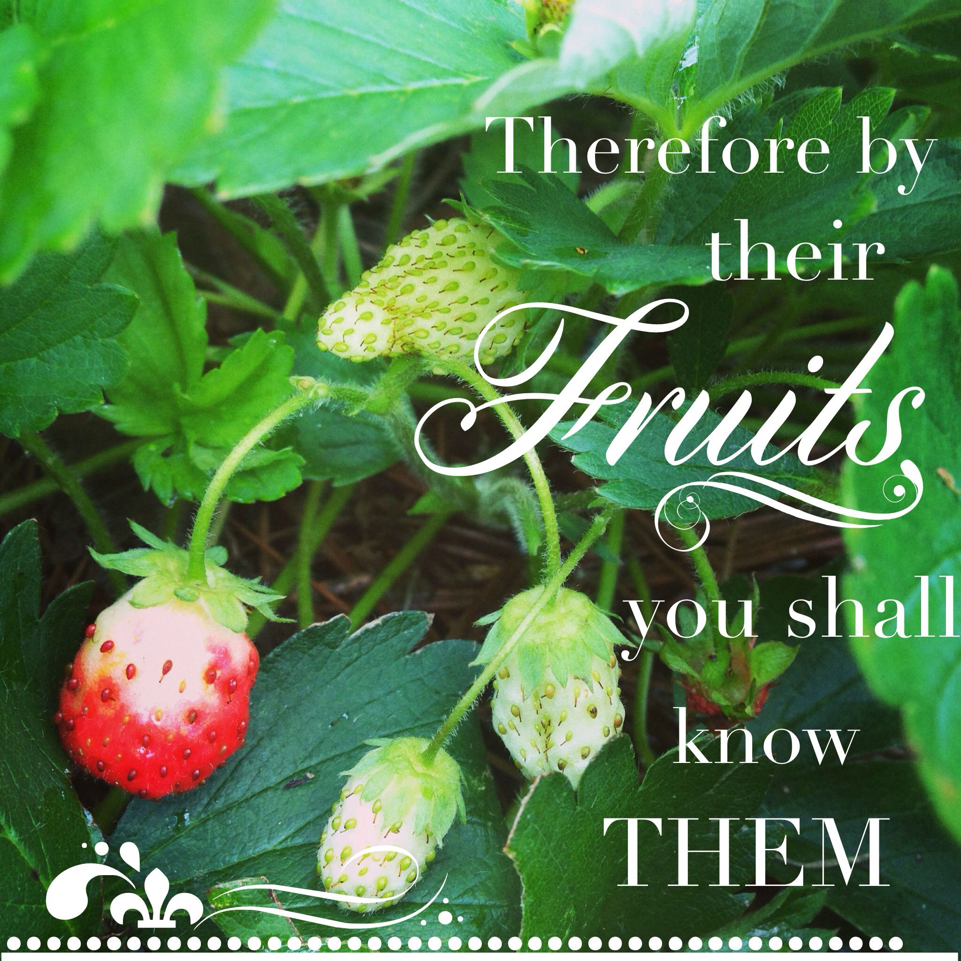 | LEARNING FROM JESUS THE TEACHER ABOUT HOW TO PRAY  Matthew 6:9-13  Use some time at the beginning of the year to remind pupils about the Lord’s Prayer. Jesus’ disciples said to him, ‘Lord teach us how to pray’ (in Luke’s version) – so the Lord’s Prayer was actually a short lesson in how to pray by Jesus. Explore its meaning in age appropriate ways in class worship. Remember it is a prayer to be prayed not just said.  The suggestions mainly draw on the traditional words:  Makaton signing  https://www.youtube.com/watch?v=_a7mYX_9UlU  British sign language (modern)  https://www.youtube.com/watch?v=WrpjmrtF7Z0  A musical version aimed at younger pupils with images which might help exploration  https://www.youtube.com/watch?v=u0mA9SGZVjs  Children saying the Lord’s prayer  https://www.youtube.com/watch?v=wlBK97Q4Ae8  Thought provoking images and explanations for older pupils  https://www.youtube.com/watch?v=rgN0s2xmCuM  https://www.youtube.com/watch?v=LSrs1NhAoBk  Reflective musical version  https://www.youtube.com/watch?v=-HaEoCqH47Y | CELEBRATE HOW YOU LEARN TOGETHER IN SCHOOL  I Thessalonians 1:2-3  It is pupils’ achievements and successes that are usually celebrated each week.  This week might provide an opportunity for the school community to focus on those who teach them and give awards and affirmation to the special things that they have done this week.
Week 3: HARVEST: You may have a local harvest to celebrate or your community may have a particular focus for harvest festival which you can add for this week | GROWING IS GOD’S GIFT  Genesis 1  I wonder how and why our bodies grow. I wonder what would stop us from growing. I wonder what the Bible says about how the world first started to grow. This retelling might only be able to be done by a small group of children, unless you are feeling brave and let everyone have a go at being Creation statues.  Based on the Biblical account:  On Day 1, God gave the gift of light: statue of a candle - hands together over their heads, flickering.  On Day 2, God gave the gift of water: statue of a fountain - hands rising and falling above your heads like a fountain.  On Day 3, God gave the gift of land, plants and flowers: growing statue of a tree or plant - start small and slowly grow upwards, unfolding your body.  On Day 4, God gave the gift of day and night: statue of a star, hands 'twinkling'.  On Day 5, God gave the gift of fish and birds: hand movements for a bird and a fish  On Day 6, God gave the gift of land creatures: statue of any creature - big, small, tame and wild - leave this to everyone's imagination! Point to each other and smile.  On Day 7, God gave the gift of rest: invite everyone to become a statue of someone doing something relaxing – lots of different things  You could repeat this activity of describing the gifts, possibly making the statues faster and faster like a 'Simon says' game.  I wonder which of these things you like the best and which is most important and which you would like to say thank you for. | GROWING IS COSTLY  Deuteronomy 8:7-11  God’s people in the Old Testament were warned not to assume that their food would always grow.  I wonder how many miles a pizza travels. I wonder if it really just a few miles from the delivery shop round the corner. You could have children assemble a pizza as follows:  Flour (base) 5400 miles from N America  Tomatoes 1000 miles Italy  Tuna 5600 miles Mauritius  Pineapples 4500 miles Kenya  Peppers 400 miles Dutch  Mushrooms 200 miles even though UK  Black pepper 5000 miles India  Mozzarella 1000 miles Italy  Total=23000 miles  Or you could do something similar with foods from the supermarket that come from far away.  https://www.foodmiles.com/  With plentiful supplies, it can be easy to forget how much we depend on others for our food and we can forget to be thankful for it and for those who produce it, transport it and sell it to us.  Creator God, thank you for the food that grows all around the world which we eat from our tables at school and at home. Help us to be thankful for those who produce, harvest and transport our food. May we never forget to use the world’s resources wisely and for the good of everybody. AMEN.  https://www.youtube.com/watch?v=qd6XGvqNGVc which summarises the message | GROWING IS FOR SHARING  Luke 12:16-21  I wonder if you get to make choices when you go shopping. I wonder if you get to choose the biscuits, juice, yoghurt, butter etc (have examples to show) So much choice with shelves full of every single item! But we need to remember that many of those from other parts of the world will see barely one brand of every type and therefore have no choice at all. Supermarkets are certainly full of the harvest and it seems we need to keep building more and more shelves to accommodate it all.  Jesus once told a story about all this. He told it to two brothers who were arguing over money that had been left to them. 'Slow down,' says Jesus. 'Don't you realise that having lots of things - having more and more choices - isn't going to make you happy or bring you closer to God'  This can be told from an appropriate Bible version  https://www.freebibleimages.org/illustrations/rich-fool/  The rich man in the parable that Jesus tells certainly has more than enough but he has forgotten to share it with others. His attitude is a challenge to some of us who have enough to eat and a reminder that God’s plan is always that blessings should be passed on.  This is reminder of the choice given by our harvest and the fact that we should be thankful and share  https://www.youtube.com/watch?v=NTdIrlTlXks  (from https://ideas.brf.org.uk/celebrate-harvest | MY SOWING AND GROWING  II Corinthians 9:6  https://www.youtube.com/watch?v=ha628Pj_Rns (first minute)  This is a traditional hymn during which children bring up harvest gifts. I wonder what the words of this hymn make you think about. Perhaps you can show some pictures of farmers sowing seed or plant a sunflower seed and explain how we now have to wait but it will produce the flower and many more seeds which we can eat or sow again.  Think of people who sow and grow ‘seeds’ in their lives such as Greta Thumberg (or an appropriate example for the group). I wonder what the result of Greta’s ‘sowing’ will be.  I wonder what you work hard for. – your studies, your interests, your friendships. This is like planning and looking after seeds. I wonder how these seeds will grow and what you will harvest in the end. For younger pupils, this might be how a simple kindness can result in something special to someone else.  I wonder what ‘seeds’ you will plant today. I wonder if you will sow generously (see Bible verse). I wonder how God can help us as we ‘sow and grow’.  Dear God, As we celebrate harvest, we thank you for the ways in which our lives are producing fruits. Guide and sustain us in lives that make a difference to those around us every day. AMEN | CELEBRATE  Psalm 65:11  On one day this week, you will probably hold your own school’s harvest festival service.  You might want to think of different ways of celebrating what is produced in or near to your school or you might want to use some of the material from suggestions earlier in the week.  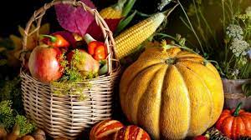
Week 4: think about a ‘flourishing’display in a common area in school or in your classroom | HOW JESUS HELPS US TO FLOURISH John 10:1-15  Flourishing as humans is something we all aim for. It can look different, depending on our beliefs and circumstances. Christians believe that Jesus offers ‘life in all its fullness’ which isn’t a life without trouble, but a life lived with him. A flourishing life is diverse, connected and outward-looking.  Explore the Bible passage through drama or images or a film clip:  https://www.youtube.com/watch?v=ar732X9uO3I up to 2 mins 20 secs  https://www.youtube.com/watch?v=zvi5N_y-910  I wonder how the sheep flourish because of the care of the good shepherd. I wonder who helps you to flourish at home and at school and in the activities you do. I wonder how you are able to flourish. Ask these questions of lots of different members of the school community. Perhaps you could make a display with speech bubbles of what people have said which express the flourishing in your school day by day.  You might want to watch and/or listen to this song for reflection  https://www.youtube.com/watch?v=5lpMma_eHHQ  It is a reminder that being cared for and close to Jesus can help our flourishing. | WE FLOURISH BETTER TOGETHER  Ecclesiastes 4:9-12  Think about this example  https://www.youtube.com/watch?v=zy2UvKKmCeM&feature=youtu.be  The experiment only works when there are a number of Menthos working together to produce the desired effect. It does not work when there is just one. The Bible reminds people again and again that human beings are meant to be together, to work together to be together in community.  The Bible reading today helps us to think about this – you could explore the examples in the passage in visual and interactive ways. The Bible is saying that people can do so much more when they work together – people can flourish when they encourage, support and help each other. They are stronger together.  Find some pictures of teams celebrating a success. I wonder… are these players flourishing… what difference it makes that they are together… when your life is flourishing, who you like to share that with… how working as a team helps us to flourish.  A fun, upbeat song which encourages us flourish ourselves so we can work together for the flourishing of all – Together (Sia): https://www.youtube.com/watch?v=vnfGni4_RlI  May the grace of our Lord Jesus Christ, and the love of God, and the fellowship of the Holy Ghost, be with us all evermore. AMEN | HELP ME TO FLOURISH  Psalm 23  Today we return to the image of the good shepherd taken from John 10 but also commonly found in the Old Testament, most notably in Psalm 23. I wonder how a shepherd makes sure that each of the sheep flourishes. I wonder how the words of this psalm of the shepherd/king David help us to understand how God helps us to flourish.  Two different approaches to exploring and explaining the psalm  https://www.youtube.com/watch?v=BMyYuYMck98  https://www.youtube.com/watch?v=2FK6NlUQbDo  Different sorts of musical versions to use for discussion and/or reflection  https://www.youtube.com/watch?v=AOU6JK3yBMY  https://www.youtube.com/watch?v=yLxdb3ov-zE  https://www.youtube.com/watch?v=pN4tPkX0MG0  I wonder if you can think of any ways listed in the psalm that you could use to help yourself to flourish so that your ‘cup overflows’ today.  Use Psalm 23 as a prayer now that you have explored its meaning.  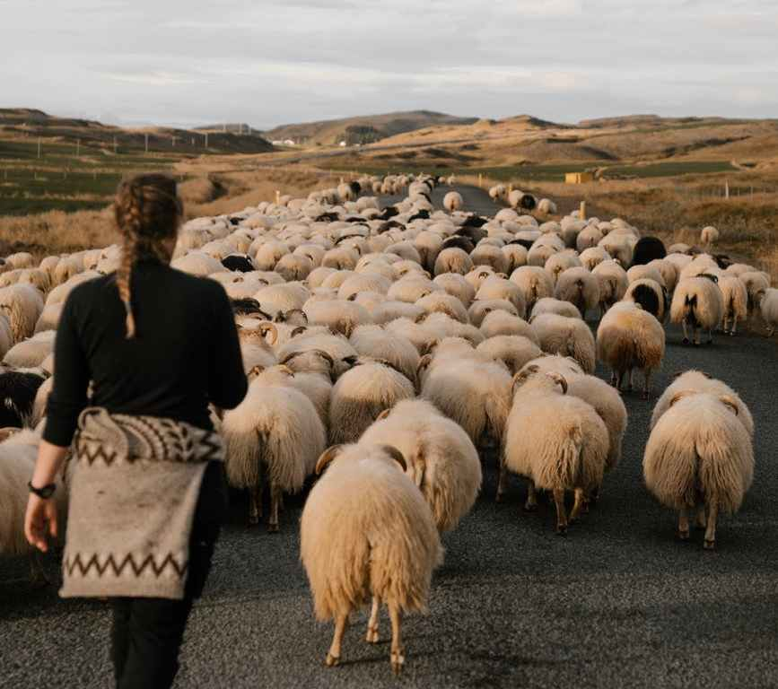 | I NEED TO FLOURISH BUT SO DOES EVERYONE ELSE  John 10:10  This is a story that can be enjoyed at all levels and questions for discussion can ensure that the ideas are explored in age appropriate ways.  ‘How full is your bucket?’ or watch a video reading here: https://www.youtube.com/watch?v=A5R6-2m_qHk  Talk about what fills our own emotional buckets, and what drains them. Christians believe that God wants us to have ‘life in all its fullness’ as in John 10:10 – a full bucket – but this takes work and collaboration. Encourage everyone to talk about what fills their buckets, and how they might go about asking for what they need.  I wonder… who helps you be the best you can be… who encourages you when you are struggling… who do you help and support… what kind of things can you do which will help someone else flourish today.  Perhaps you might like to draw a picture of someone you know who needs someone to care for them or encourage them. Maybe they are sad or nervous or tired. Perhaps they don’t find it easy to make friends. After you have finished fold up the paper and put it in your pocket. Every time you put your hand in your pocket perhaps you can think of one way that you might help them flourish by encouraging them or making them smile, or comforting them. | CELEBRATE  how we flourish when we celebrate and give to others  Make sure that those who have helped others to flourish this week are acknowledged, both pupils and adults.  Reflect on the service that is needed to ensure that everyone can flourish.  https://www.youtube.com/watch?v=MYpH3y4608E&list=RDuSG1qm5KT1c&index=2  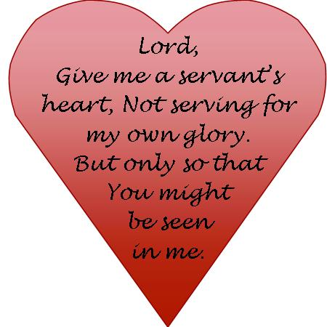
Week 5: pray for compassion in your school prayer and reflection areas this week | COMPASSION FOR THE HUNGRY THEN  John 6:5-13 (Matthew 14:14)  Compassion shouldn’t be patronising, it not about making ourselves feel good by helping other people. We must be start by recognising that we are all fail and make mistakes, we are all in need and we all need compassion.  I wonder what you think of when you hear the word compassion. I wonder who you think of when see others in trouble and distress. Do you feel sorry for them? Does it sometimes make you angry that others are suffering? I wonder if you can think of a time in your life when you helped others or you stood up for others who were suffering.  Here are some options  https://www.youtube.com/watch?v=UyXP-kQfooU this is a filmed reconstruction of the story  https://www.youtube.com/watch?v=CCA4oivfSYk this is a cartoon version based on the Beginners Bible  https://www.youtube.com/watch?v=dfTBwsPy05g&feature=youtu.be This storytelling version is by Rob James The Canon of Wells Cathedral  If you’d like an interactive version, then you can find a version here: https://engageworship.org/ideas/feast-for-5000-responsive-reading  There is also a version of the story using photographs from Freebibleimages: http://freebibleimages.org/photos/jesus-5000/  I wonder how you would have responded to Jesus’ words and actions if you had been there. Andrew took the attitude that they should start with what they had and work from there. I wonder - what have we got and what can we offer in compassionate response to people’s needs. | COMPASSION FOR THE HUNGRY NOW  James 2:14-17  Remind pupils of the Bible story from yesterday. Look at the Bible reading for today. I wonder what this is encouraging us to do. I wonder if people are still hungry today. Try and avoid stereotypes of the developing world and focus on hunger in the UK.  Talk about how Manchester Utd player Marcus Rashford’s work:  https://fareshare.org.uk/marcus-rashford/  He knew what it was like to be hungry and wanted to do something to prevent this happening to other children. His actions led to a government turnaround on free school meals for children over the summer holidays. In pairs, talk about how he showed compassion in action.  It might be that you have helped a local food bank and you might be able to link your teaching to this compassion in action locally or nationally  https://www.youtube.com/watch?v=BaVmjOx8KVA  https://www.youtube.com/watch?v=pKmioO1hp7U (up to 1 min 30 secs)  You might not be able to give loaves and fish (unless it’s canned tuna!) to a food bank. It might be that you can drop something into the box at your local centre or supermarket, praying that God will meet people’s needs through your donation. It may not be a large donation, but the boy’s packed lunch wasn’t much either! What does your local foodbank need most at the moment?  This is a song which speaks about Christians’ faith in a God of compassion  https://www.youtube.com/watch?v=HnXX8TbUX-E | COMPASSION FOR THE WORLD NOW  James 2:14-17  This song highlights the work of Tearfund in showing compassion to those who need help to build better lives for themselves long-term.  https://www.youtube.com/watch?v=AyIQ2c3Ep_A  There are lots of ways in which you can show compassion. Check out the resources on the Christian Aid website such as their magazine  https://www.christianaid.org.uk/our-work/christian-aid-magazine  Compassion is not just about helping, it’s about challenging the situations and policies that cause people to suffer. You need to find out why people are living in poverty, why climate change is such a threat to the poorest and then you need to do what you can to change things as individuals and groups.  Lord, I want to be aware of those in need. I want to have the means to help. Let me give to those who are not as privileged as I am. Give me confidence in my actions so that I can give back. Let me be what others need. Use me as a vessel of compassion to a world in need. AMEN | HOW CAN I SHOW COMPASSION?  John 6:5-13 (Matthew 14:14)  Explore this painting and the story of the feeding of the 5000 in an age appropriate way  https://www.methodist.org.uk/our-faith/reflecting-on-faith/the-methodist-modern-art-collection/index-of-works/the-five-thousand-eularia-clarke/  I wonder what is happening in this picture.  This image is a modern take on the Feeding of the 5000 painted by artist Eularia Clarke (from the Methodist Modern Art collection), with fish and chips! In the section before the story of the Feeding of the 5000, the Bible says that Jesus ‘had compassion’ on the crowd – and had been healing those who were sick. When they were hungry, Jesus showed compassion by feeding them.  I wonder if we can find ways of showing the same sort of compassion as Jesus.  What ‘loaves’ and ‘fishes’ have you got to bring? You might think it’s not enough, but we all know what Jesus did with the little boy’s lunch! Print and cut out the pictures of the loaf and fish below. Think about what you can do to show compassion to others: Write down what you could do on the loaves and fishes.  Base your prayers on these ideas. | CELEBRATE  The compassion that you have seen around you in school, at home, in your neighbourhood, nationally or internationally this week. Perhaps there could be some one-off awards for these which are put together in a display.  These songs might help you to think more about this:  https://www.youtube.com/watch?v=PKyWRsH5gcI  https://www.youtube.com/watch?v=EcxOkht8w7c  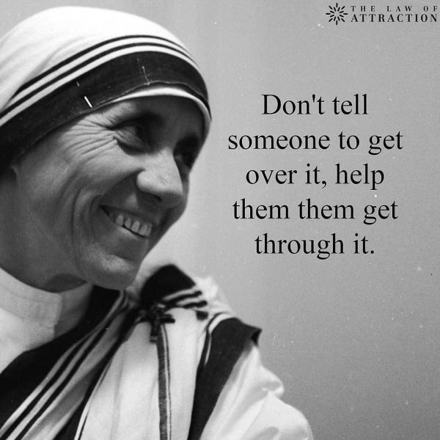
Week 6: make sure there are plenty of encouragements to build resilience around the school | WE CAN DO IT!  Luke 18:1-5  This week, we are thinking about the idea of resilience – keeping going even when we encounter difficulties. It’s not an easy thing to do, but it makes a huge difference especially if we develop it together. It’s also something we can learn to get better at! We can develop resilience in our hearts and minds through practice, a bit like we develop muscles in our body when we exercise. If you can, why don’t you stand up and do a quick exercise now! If we do this every day, we will get stronger in our bodies. Perhaps you find it easier to exercise with someone else alongside you.  Today’s Bible story is about someone who tried to do something really hard and kept going  https://freebibleimages.org/photos/persistent-widow/  You could role-play this story – get someone to be the widow and someone to be the judge. How many times do you think she had to ask the judge before he gave in? Why did he eventually help?  I wonder how the widow in the story felt about having to go back again and again. I wonder how you would have felt. I wonder if you have ever asked someone for justice and they wouldn’t listen to you. | I CAN DO IT – IN GOD’S STRENGTH  Philippians 4:13  Think about the woman from yesterday who wanted justice when someone treated her unfairly. She had been really brave, going to a judge, and when she asked him for help, he refused to give her the fairness she wanted. But she kept going back! The reason Jesus told this story was to encourage his followers to keep trying – if things didn’t work out straightaway, they shouldn’t give up. In fact, he said this is how they should pray to God – over and over again, without giving up.  I wonder how hard it is to practise. I wonder how practising helps us to get stronger in our minds and our hearts. If we do, then eventually, we will be able to do harder and harder things. Knowing that we have people alongside us when we try to do hard things can make it easier too. I wonder – what do you find really hard to have a go at. I wonder who or what helps you with this.  Now think of a different situation. It might be something that happened to you, or to someone famous (look up the stories of Nelson Mandela, Rosa Parks, Gandhi or Harriet Tubman, for example). Help pupils to think about what helped this person to keep going. How did they develop resilience so that they could keep trying? I wonder if their example could help you to be more resilient.  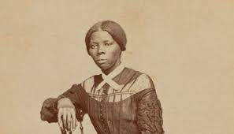  Amazing Grace is a song that has helped many Christians through tough times  https://www.youtube.com/watch?v=2tae3rpIvpg | WHY WE SHOULD NEVER GIVE UP  Roman 5:3-5  The Bible reminds me us that it is not unusual to go through hard times but that they help us to grow and give us hope.  What does this picture make you think of? How might it be possible for this tree to flourish here? I wonder what helps people to flourish when they are in a difficult situation.  You could take a piece of spaghetti. I wonder what happens if you put pressure on it when it is dry – it cracks easily. I wonder what happens when it is cooked. When it is cooked it springs back. I wonder if you have you ever had an experience where something difficult made you ‘crack’. I wonder if you have you ever experienced a time when you felt wobbly inside, but actually you were able to spring back from a difficult situation. I wonder who could you ask to help you if you are struggling to spring back. I wonder if there is anyone who might need your help with something hard right now.  A reflective song about not giving up even in the hardest times  https://www.youtube.com/watch?v=EGLSk3AVcUU  Dear God, Please help me move beyond the hurdles that trip me up, and give me the strength and wisdom to look up and see the hope I run toward in Jesus. AMEN | WHERE AND HOW WE FIND HELP  I Thessalonians 5:16-18  These verses talk about never giving up and having joy no matter what happens - this will show that trust in God can help people to be resilient as well as getting support from other people.  Sit facing a mirror or sit facing another person. When you are ready, give yourself or your partner a smile; a genuine, joyful smile, letting it show through your eyes. I wonder how this makes you feel. Hold on to this feeling. I wonder if you can look around and see if you can share this feeling with someone else.  Bounce a ball. Each time it comes back to you, imagine yourself ‘bouncing back’ from a difficult situation. If the ball isn’t pumped up with enough air, it will struggle to bounce back. I wonder what might help you to bounce back fully. For some Christians, it is the Holy Spirit or it might be the love of your family and friends, feeling understood and valued – or a combination of these.  Use the song from yesterday to sit quietly and reflect  https://www.youtube.com/watch?v=EGLSk3AVcUU | CELEBRATE  Jeremiah 29:11  Remind pupils about the theme of the week: resilience. Make sure that part of your celebration worship includes praise for those have shown resilience this week.  This quotation and prayer might be helpful for thought and reflection:  ‘To fight for change tomorrow, we need to build resilience today.’ Sheryl Sandberg  A prayer for resilience which could be accompanied by some appropriate images:  Make my spirit buoyant, like a lighthouse on the water. Make my soul rebound with joy at the arrows of the enemy. Make me lion-hearted, stubborn with fearless obedience. When I feel like breaking, be my flexibility. Bend, shape, squeeze me into Your image.  AMEN
Week 7: make sure everyone knows about all the ways in which your vicar blesses your school | THANK YOU VERY MUCH!  I Corinthians 1:4  You can think about your current vicar or your former vicar (if there is a gap between vicars just now). Find a photo or photos and think about the many reasons why you should be thankful.  Think about some special ways to show your vicar that you appreciate what they do for you and plan to invite him/her in later in the week to show your gratitude in practical ways. Or write to the vicar if they have recently left the parish.  https://www.stlukesforclergy.org.uk/thank-your-vicar-week/  Look at the website for the ideas for ways to thank your vicar – this is a specific time to do this but say thank you whenever you can! | WHO IS KINDNESS FOR?  Luke 10:25-37  You can watch the Parable of the Good Samaritan through one of these videos: https://www.youtube.com/watch?v=fO4qSAhI1sI  https://www.youtube.com/watch?v=MLzdQtetedc (up to 2 mins 45 secs) or read from an appropriate version  In the Good News Translation, we see the importance of kindness coming through: “In your opinion, which one of these three acted like a neighbour toward the man attacked by the robbers?” The teacher of the Law answered, “The one who was kind to him.” Jesus replied, “You go, then, and do the same.” In the time and place that this parable was told, Samaritans were not popular; it was certainly not expected that this person, from that place, would be willing to help the beaten man lying helpless in the road.  I wonder how the beaten man felt when the Samaritan helped him by showing kindness. I wonder how he felt when the others walked past and ignored him. I wonder what difference you think this act of kindness meant to the beaten man and to the Samaritan. Why do you think Jesus decided to tell this story?  Sometimes our acts of kindness, however big or small, can really make a difference in someone’s life. In the Parable of the Good Samaritan, Jesus helped the teacher of the Law realise that being a neighbour and showing kindness was much more important than deciding who is or isn’t a neighbour.  You might like to sing or listen to this song by Watoto Children’s choir. It is called ‘We will go’ https://youtu.be/tCEGDkdXOcM  One of the lyrics says, “I will be your hands and feet”. I wonder what you think this means. | WHAT IS KINDNESS FOR?  Luke 10:36-37  ‘We grow in kindness when our kindness is tested.’ Archbishop Desmond Tutu  I wonder if you can you think of a time when someone was unexpectedly kind to you. Maybe it changed your life. I wonder what you think Desmond Tutu was meaning when he said that kindness grows when it is tested. I wonder if you have experienced your kindness being difficult, being tested, being rejected.  This beautiful ‘real-life video about simple acts of kindness that change both the giver and receiver: https://youtu.be/GdYJr03eJjE.  Another option showing how one act of kindness can inspire another one:  https://www.youtube.com/watch?v=X3ld9_p2bS0  Be thankful for those who have shown you kindness. Think of others as you say these words:  May you feel safe, May you feel happy, May you feel healthy, May you live with ease.  And be kind to yourself as you say: May I feel safe, May I feel happy, May I feel healthy, May I live with ease.  Finally ask for guidance and strength to be kind today, and eyes to see where kindness is needed.  I wonder what you think kindness is for. To help our relationships with ourselves, with others and with the world? | WHEN IS KINDNESS FOR?  Matthew 25:31-45  I wonder how it feels to be able to give an act of kindness to someone you know. How about someone you don’t? I wonder when it is difficult to be kind to people. I wonder who you need to be kind to right now and why. I wonder what it feels like when someone has shown you an act of kindness. I wonder how we can grow kindness in our community.  The parable told by Jesus in Matthew 25 talks about helping all those in need regardless of who they are and whether you know them because that is how you serve Jesus himself.  The Servant King echoes this:  https://www.youtube.com/watch?v=8rh4xEvMVQQ  This is a prayer of St Teresa of Avila (1515-82) with a similar message  Christ has no body now on earth but yours; no hands but yours; no feet but yours. Yours are the eyes through which the compassion of Christ must look out on the world. Yours are the feet with which He is to go about doing good. Yours are the hands with which He is to bless His people.  Sung versions of this prayer: https://www.youtube.com/watch?v=bi9p888x38Q  https://www.youtube.com/watch?v=w7ymxW3rndk  I wonder when kindness is for. Whenever you see anyone who needs it from you? | CELEBRATE  I Corinthians 1:4  Perhaps this is good day to invite your vicar into school to make some special award to her/him for all they do for you and all they mean to your school community.  Thank God that your vicar heard God’s call and responded:  https://www.youtube.com/watch?v=EcxOkht8w7c  I wonder how you can work alongside your vicar to show kindness to others.  Dear God, thank you for all those who are sharing kindness in our communities especially our vicar today. Thank you for their acts of kindness, generosity and love. Help me to be kind through my words, actions and attitude. Please show me if one of my family members or friends needs me to be extra kind to them today. Thank you, God, for inspiring us to be kind through your love for the world. Amen.

Nehemiah and the Big Rebuild (Part One) - acknowledgement to the Diocese of Guildford schools’ department
Every time you hear the word ‘build’ or ‘rebuild’, ‘build’ using your fists (like in the Wise & Foolish Man song) – or use the Bob the Builder© refrain ‘Can we fix it?!’, whichever you think your school community would prefer – or just read the story! You choose…..
Nehemiah was not a build-er: he was the cup-bearer to the King of Babylon. It was a very important job in the royal household.
Most of God’s people were once again far, far away from home, living in exile in Babylon. They had never forgotten about Israel, the land that they called ‘home’ but had begun to build new lives for themselves in Babylon, not ever imagining that they would return.
One day, Nehemiah had a visitor from his homeland, a long-lost brother, who told him stories of Jerusalem that filled Nehemiah’s eyes with tears.
‘The walls of our great city, Jerusalem, are crumbling, it’s gates have been burned to the ground and all the build-ings lie in ruins.’ Nehemiah’s brother said.
Nehemiah’s heart was as broken as the walls, but he did the very best thing that he could do – he wept….and he prayed…. and he poured out his heart to God who built the world, and asked him to once again help His people.
Next day, Nehemiah took wine to the king, who noticed his tear-stained face and sad eyes and asked him what was wrong.
‘I want to go home’ Nehemiah replied ‘and rebuild Jerusalem, which lies in ruins. If you are willing, O King, please let me go. I will also need wood to build with, so please send this too.’
Then Nehemiah took the long journey home to Jerusalem, surrounded by the King’s soldiers to keep him safe. That night, he went out to the walls to see what needed to be done – and to plan the great rebuild. He knew that God, the great Master-builder would be with him and help him to know what to do. Everyone who was left in Jerusalem helped to build the gates and the walls, to keep the people safe. It was an enormous job!
But Nehemiah knew that he wasn’t just building the city, he was building a community again, so when he saw that some of the people were hungry, he fed them: when people were being unfair, he challenged them and reminded them of what’s important to God, who built the world.
Now they were ready for some of the people to return from Babylon, to help rebuild the rest of the city: houses, shops, businesses, farms – and to rebuild the great Temple. They brought with them everything they could to help with the work and rebuild their communities: gold, silver, cattle and building materials.
The rebuilding of Jerusalem continued for seven months until people had homes to live in and families were settled. But God, the master-builder, had more work to do. He knew that his people needed more than buildings and homes – they needed to remember who they were…..to rebuild their hearts. And you’ll hear how next time!

Nehemiah and the Big Rebuild (Part Two)
To help children to engage: every time you hear the word ‘hearts’ make a heart shape with your hands
As we heard last time, Nehemiah was not a builder: he was the cup-bearer to the King of Babylon, who had been sent to Jerusalem to rebuild the city, the home of the people of God. Most of God’s people had been living far, far away from home, in a land called Babylon. Their hearts had not forgotten about Israel, their ‘home’, but the people had never imagined that they would ever be able to return there.
The re-building of Jerusalem had taken seven months until there were homes for people to live in and some of them had returned from Babylon. But God, and Nehemiah, knew there was more work to do, that the people needed more than buildings and homes – they needed to remember who they were…..to re-build their hearts.
So Nehemiah gathered the people together – and Ezra the teacher read from the sacred scrolls containing the teachings of Moses. The people had not met together like this for a very long time, so long, in fact that they had almost forgotten what being together felt like. Their hearts were full of joy – and they worshipped God there together.
As Ezra read on, the people heard the stories of how God had been with them in the past: how he’d rescued them from Egypt and provided for them on their long journey to the land that God had promised them, their home. Their hearts were full of hope, as they remembered that God had been with them all this time.
They listened to Ezra read the rules that God had given to Moses many years ago and thought about what they meant, but then, suddenly, they realised how sad God must be that they had forgotten his rules….and as great big tears fell from their eyes, their hearts were filled with sadness. But God was using this sadness to help mend their broken hearts; to help the people to remember who they were and the things that should be important to them – the things that really mattered to God.
Nehemiah looked at the people and knew just what to do. ‘Don’t cry!’ he said. ‘This is a great day: a day for us to remember and be glad that we are God’s people. His joy will make your hearts strong!’ And he sent them home to eat, to drink, and to celebrate – and to share their food with those who were in need.
When they gathered the next day, the people heard how God had given them a way to celebrate that they were his people – and to remember his faithfulness on the long desert journey long ago, when they lived in tents. As God had told them to, they gathered branches from the trees – and built shelters on their rooftops, shelters in the courtyards and shelters in the grounds of the Temple. The people gathered up all their words of praise into a great prayer. Then they made promises to each other and to God and signed a charter to remind them of who they were, and what they had promised.

And as they celebrated, their hearts were rebuilt, just like the walls of the great city had been.
And God’s heart was very glad!

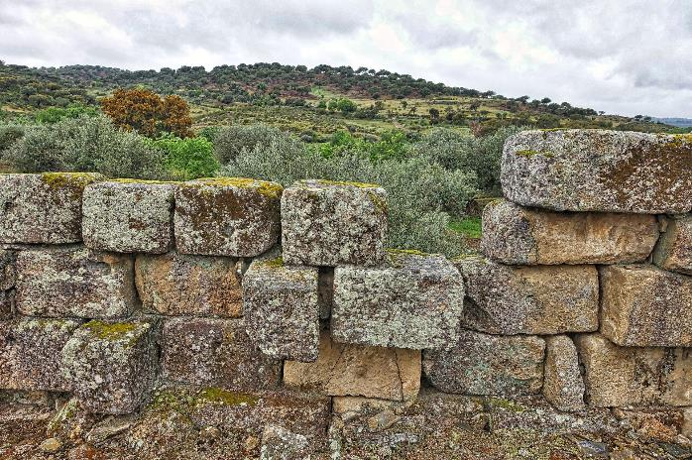

Acknowledgment to Annika Swansbury for illustrations

The wise and foolish builders
To be sung to the tune of ‘Here we go gathering nuts in May’, with actions. If you prefer, you can speak the story as a rhyme, or tell the story using the more traditional song (here: https://www.youtube.com/watch?time_continue=126&v=exRllFvHJFA&feature=emb_logo) or read it from a Children’s Bible. It can be found in Matthew chapter 27:24-29. You can find a set of pictures here: https://freebibleimages.org/search/?s=wise+and+foolish+builder
This is a story that Jesus told, [action: opening a book]
Jesus told, Jesus told,
This is a story that Jesus told,
Of a wise and foolish builder. [action: ‘wise’ – thumbs up; ‘foolish’ – thumbs down]

This is how the wise builder built, [action: fists building on each other]
Wise builder built,
Wise builder built,
This is how the wise builder built,
On the rock that was solid and firm. [action: fists solid, together, on ‘rock’]

This is how the foolish man built, [action: fists building on each other]
Foolish man built,
Foolish man built,
This is how the foolish man built,
On the sand that was sloppy and wet. [action: fingers rippling along a line]

When the wild winds blew and the rain came down, [action: fingers ‘rain’]
The rain came down,
The rain came down
When the wild winds blew and the rain came down
The house on the rock stood firm. [action: fists solid, together]

When the wild winds blew and the rain came down, [action: fingers ‘rain’]
The rain came down,
The rain came down,
When the wild winds blew and the rain came down,
The house on the sand fell FLAT! [action: clap hands]

Jesus said ‘Build your life on the rock, [action: fists solid, together, each time you say ‘rock’]
Life on the rock,
Life on the rock,
Jesus said ‘Build your life on the rock,
And do what God says is right.’ [action: thumbs up]

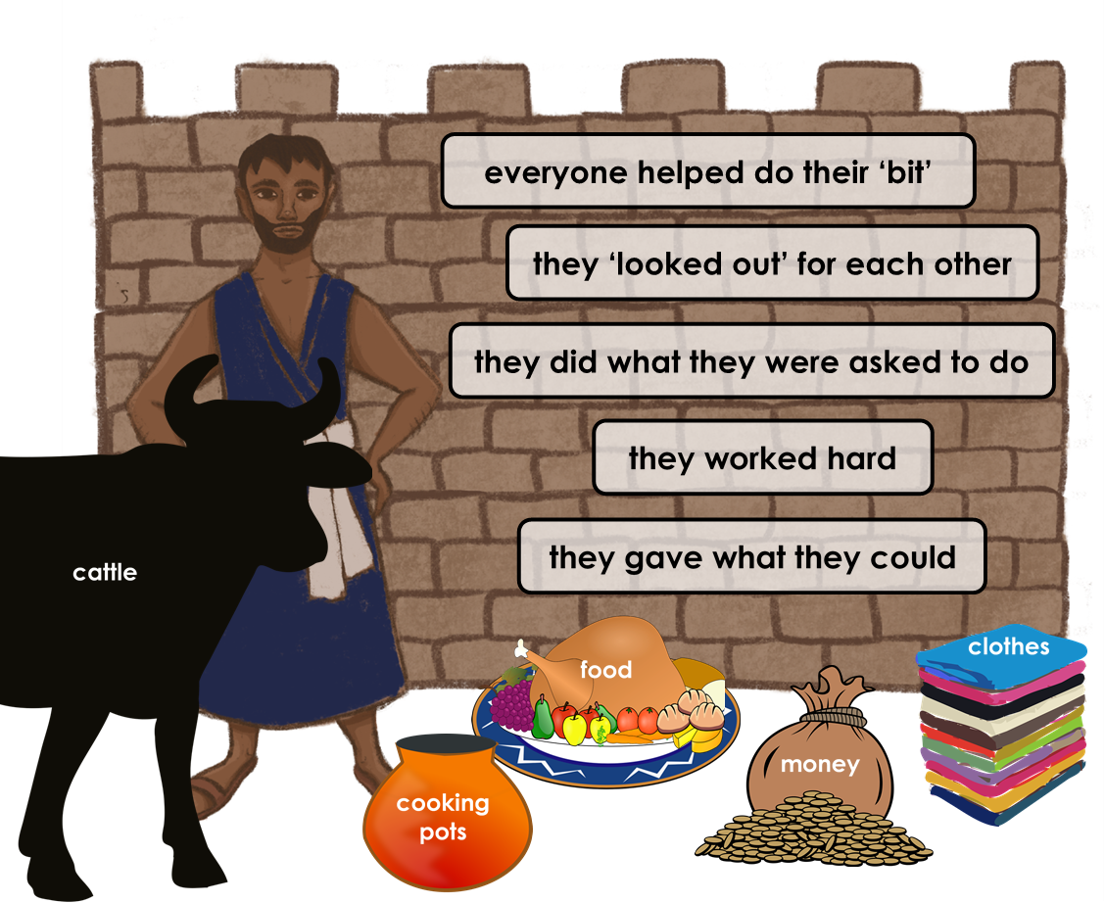
Acknowledgment to Annika Swansbury for illustrations

