Fresh Approach Collective Worship Planning
Year 1 Term 3: ‘I am……’, said Jesus

Week 1 | Epiphany
Week 2 | Jesus – who am I?
Week 3 | I am… ‘Life Giver’
Week 4 | I am… ‘Life Sustainer’
Week 5 | I am… ‘Life Guider’
Week 6 | I am… ‘Life Leader’
I am … said Jesus
Life Bringer
I am the same yesterday, today and forever
Life Giver
I am the water of life
Life Sustainer
I am the bread of life
Life Guider
I am the light of the world
Life Leader
I am the good shepherd
Life Protector
I am the gate
I am the way, the truth and life
I am … said Jesus
By Rebecca Swansbury

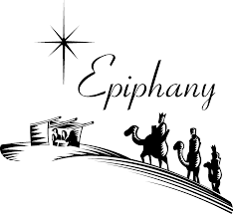
This term includes an exploration of who Jesus is through the stories associated with Epiphany and also through the ‘I am’ sayings of Jesus which can be found in John’s Gospel. It provides a pause for wondering and reflection about the life and teaching of Jesus and how his example can continue to underpin the everyday life of our school.

Liturgical colour | Monday | Tuesday | Wednesday | Thursday | Friday

EPIPHANY | EPIPHANY  Matthew 2:1-12  The colours of Epiphany are the same as Christmas, white and gold, which are the colours of celebration and newness.  Not many people knew how important Jesus were when he was born but gradually other people began to be told about the secret. They were given clues about how special Jesus was. This time of the Christian year is called ‘Epiphany’. The word Epiphany means ‘showing’ or ‘revelation’ and it is the time when Christians hear the stories about all the different clues in the Bible which reveal what is special about Jesus. Let’s see if we can be good detectives this week and solve those clues! Introduce the week with a magnifying glass as you will be looking for the clues.  Tell the story of the Wise Men in the way that best works for you.  https://www.youtube.com/watch?v=TCOW8NKfrBg  You might use pupils as the Wise Men and a volunteer to lead them round the hall following a star. At key points their passage should be blocked (after the star has passed) by a notice holder. At this point encourage the school to call out “What’s wrong now?” and the wise men reply with the words on the notice. The school then calls out “Carry on, carry on!” The Magi should end by the Magi from your crib set with their gifts. I wonder what we find out about Jesus from this episode and especially from the gifts of the Wise Men? https://aleteia.org/2018/01/07/why-did-the-magi-bring-gifts-of-gold-frankincense-and-myrrh/  Eternal God, by a star you led wise men to the worship of your Son. Guide by your light the nations of the earth, that the whole world may know your glory; now and for ever. Amen | EPIPHANY  Mark 1:1-11  Remember we are thinking about Epiphany and the clues which showed the world how special Jesus was. John was Jesus’ older cousin and the Bible tells us that he had also been given an important job by God. He was busy preaching to people about how they should give up their sinful ways of living and follow God. When people accepted what John was saying, and wanted to change the way they lived their lives, John would baptise them by dipping them in the Jordan River. This was how he got his nickname ‘John the Baptist’. But John himself knew that he was not the Messiah. He knew that a very special person indeed was going to be sent by God and that this man would arrive soon….. but he did not know who it was going to be. John had been given a clue by God. He had been told that when the person arrived he would see with his own eyes God’s Spirit come down on the man. John was sure he would recognise it when it happened. Then one day Jesus arrived at the River Jordan where John was preaching and baptising.  https://www.youtube.com/watch?v=JZ5jm5Ix5bY  https://www.youtube.com/watch?v=DUrzll0aQCY  or use an appropriate version of the story  I wonder how this episode showed that Jesus was the person sent by God? I wonder what this might have shown other people about what Jesus was going to do with his life?  I wonder how we can follow Jesus’ example of listening to God and doing what God wants for us? | EPIPHANY  The third “showing” of Epiphany is the Miracle at Cana (water into wine) which John’s Gospel tells us was the first of Jesus’ miracles (or ‘signs’ as he calls them). All of Jesus’ miracles manifest his power, God’s power.  Tell the story in the most appropriate way for the grouping.  https://www.youtube.com/watch?v=OilBJ5-GVE0 https://www.youtube.com/watch?v=s_Cbk4i37HM  https://www.freebibleimages.org/  The miracle at Cana demonstrates, amongst other things, how the wine, or gift, of Jesus is superior to that which was originally served. One way of introducing this act of worship is to think about what are pupils’ best or favourite foods and drinks, and whether they too ‘leave the best until last’. I wonder why Jesus saved the best wine until the last? I wonder what message he was trying to give about his ministry and about what God is able to do?  Alternatively, with the story of the Wedding at Cana, you could talk together about how people feel when you have big problems in life which are just too difficult to solve on our own. I wonder how what Jesus did at the wedding can help us to understand how Jesus can help with life’s problems and big questions?  Dear God, thank you for the ways in which we can be helped and encouraged by the example of Jesus. AMEN | EPIPHANY – TIME TO REFLECT ON OUR CHOICES  Matthew 2:1-12  Re-cap on the Bible account of the visit of the Magi or Wise Men to Jesus and the gifts they offered.  The story of Baboushka is related to the Biblical story of the Magi from the country of Russia about an old lady called Baboushka who, according to legend, is supposed to have met the Wise Men.  https://christmasfm.com/the-story-of-the-babushka/  https://www.expatica.com/ru/lifestyle/holidays/russian-christmas-105363/  or you may have a story book version of the story in school.  Russians say that Baboushka is still travelling today, looking for Jesus, and every Epiphany Eve, when children are asleep, she goes into homes and leaves some of her toys for the children, in memory of the baby Jesus.  Use the story to reflect in an age-appropriate way:  I wonder if we always make the right choices about what is the most important thing to do?  I wonder if we make the right choices about how we use our time?  I wonder how we are going to make the right choice about these things in school this term?  Dear God, thank you that you give us the gift of choice in our lives. Help us to make good and wise choices which are right for us and right for those around us. AMEN | CELEBRATE THE GIFTS WE BRING TO OTHERS  Matthew 2: 11  The gifts which the Wise Men offered to Jesus were very unique and different from each other but equally important because of their special meanings. They all added something to the overall picture of the life that Jesus was to lead.  We 3 Kings is a carol which unpacks the meaning of each gift  https://www.youtube.com/watch?v=jBwL3y-Wlms  https://www.youtube.com/watch?v=SUBTERdTKUg  I wonder how many different gifts come together to make your whole school such a special place? I wonder how we will offer those gifts in this New Year of 2022?
Who am I? | WHO DO YOU SAY THAT I AM?  Luke 9:18-20  I wonder how many questions you will ask or be asked today? I wonder what questions will be the most important ones that you hear today?  One of the important questions that Jesus asked his disciples was ‘Who do you say that I am?’. This was because there was a lot of speculation about who Jesus was because of all of the amazing things that Jesus was doing and saying. For some people, like the religious political leaders, Jesus was a threat. For others, Jesus was seen as a figure to lead them to freedom. For his disciples, he was their friend and teacher. The answer given to the question that Jesus asked would result in some people following him and others not doing so. So it was definitely an important question.  I wonder if you have your own ideas about Jesus? I wonder what words you would use to describe Jesus? I wonder if we can create our own wordle with all of our ideas? I wonder if what you think about Jesus means that you can follow his example and act on his words in your day to day life?  Dear God, As we look at the life of Jesus in the coming weeks, help us to ask and answer the questions which help us to become people who follow the right ways of living and service as Jesus did when he lived in the world. AMEN | INCARNATION  John 1:14  The verse here is one from St John’s Gospel often read at Christmas, describing how Jesus ‘took flesh’ – use the baby from your Nativity set as a visual aid.  It is important to start with Jesus being fully human if we are thinking about who Jesus is. The UC materials include Incarnation as a key concept<  The New Testament presents Jesus as the answer (to what has come before): the Messiah and Saviour, who will repair the effects of sin and the Fall and offer a way for humans to be at one with God again. Incarnation means that Jesus is God in the flesh, and that, in Jesus, God came to live among humans.  I wonder what it means to be a human being? You could try and write a handbook or a definition for what it means to be a good or fully functioning human being to include both the physical and emotional aspects of being fully human. You might also point out the flaws – that, however hard humans try, they can never really be perfect .  Reflect on these words from one of the Christmas carols:  For he is our childhood's pattern:  day by day like us he grew,  he was little, weak and helpless,  tears and smiles like us he knew;  and he feels for all our sadness,  and he shares in all our gladness.  I wonder why it is important that Jesus started life just as everyone of us started life? I wonder if it helps him to understand us and for us to understand him? | JESUS CHRIST IS THE SAME YESTERDAY, TODAY, AND FOREVER.  Hebrews 13:8  (This verse is taken from one of the epistles written in the Bible after Jesus’ lifetime to encourage Christians to carry on in difficult times).  Think back to the words we listed earlier in the week - I wonder which words stayed with you and why? (Think, pair, share). I wonder what you think was the most important thing that Jesus did and the most important thing that he taught?  You could show/use some examples of good change and not so good change to set the scene for thinking about Jesus as unchanging.  I wonder what you think this verse might mean? I wonder how this verse might make you feel? I wonder how we feel when things around us change? I wonder if change is sometimes quite unsettling? I wonder why it is important for Christians to know that Jesus is the same yesterday, today and forever?  (He doesn’t change and the messages he gave and the examples of how to live in the Bible are still true today)  Here are two very different versions of songs which use these words that have been so important to Christians across the ages  https://www.youtube.com/watch?v=g5djOUV5wWA  https://www.youtube.com/watch?v=bjOLDaSfIHQ | I CAME TO GIVE LIFE—LIFE IN ALL ITS FULLNESS  John 10:10  Christians believe that by following Jesus and his teachings enables them to be free to worship and follow him, to have hope and a life that is the best it can be. This doesn’t mean that being a Christian means life is now easy and free from suffering. Knowing that Jesus is with them every step of the way to help and guide means that navigating these times of suffering is more bearable.  Share some images which might say something about fullness of life – if they are personal, ask pupils why they think that you chose them. I wonder what a life that is full might be like for you? I wonder if it is full of money and things or family, experiences, joy and laughter? I wonder what things in life are really important? I wonder how it makes you feel knowing that Jesus said that he came to give us a life in all its fullness?  Reflect together on the year ahead: I wonder what you might ask Jesus to help you with this year so that you can live life to the full? I wonder what you might do to help others live life to the full?  You could start a display for pupils to add an image or a thought about what life in all its fullness means to them.  This is a song in which Christians express their thanks for Jesus’ gift of fullness of life:  https://www.youtube.com/watch?v=JnzLolq3zCw | CELEBRATE  The fullness of life that we see and experience in our school community  Use this a focus for rejoicing in individual, team and school successes, reflecting too the importance of trying again if you make a mistake, giving even more joy in the eventual success.
Life Giver | I AM THE WATER OF LIFE  John 4:13-14  These verses are taken from a description of a meeting which Jesus had with a Samaritan woman. Tomorrow, we will look at the story in a bit more detail.  https://www.youtube.com/watch?v=D2s9cB1pzZ8  This might be a useful resource without the sound (to 1:36)  https://www.youtube.com/watch?v=HLJl6MDuCWQ  Fact and figures about water  I wonder why we need water? I wonder how water gives life?  Jesus said, ‘Whoever drinks the water that I will give will never be thirsty. The water that I will give will become in him a well of life that lasts forever.’ John 4:13-14  I wonder why Jesus would describe himself as the living water? I wonder what this might teach us about Jesus?  I wonder how Jesus is a ‘Life Giver’?  Jesus is saying that he is offering ‘water’ that gives eternal life; a life with Jesus.  I wonder why Jesus used this particular metaphor to describe himself?  This traditional school hymn takes up the theme  https://www.youtube.com/watch?v=2Atfr07wPjc  Dear God, Thank you for the generous gift of water for our physical refreshment but also for the living water of Jesus which gives us spiritual health and strength. AMEN | I AM THE WATER OF LIFE  John 4:1-26  Watch the animated version Woman at the Well (John 4: 1-26): either https://www.youtube.com/watch?v=6Vf3rqnoG5c or  https://www.youtube.com/watch?v=pNxNWv6KZ7s  I wonder why the woman in the story needed the water of life (not only the water in the well)? I wonder what the episode tells us about the way we should treat everybody because the water of life is for everybody as a free gift? I wonder how the way in which we treat others can make us more like ‘life-givers’?  Running water ‘prayer’  The story of the Woman at the Well uses water as a symbol for love. Perhaps this week, every time you use running water (to wash your hands, to make a drink, to brush your teeth etc.), you could reflect or say a silent prayer based on this story. Consider how you are loved, accepted and known and how you can help others to feel this way.  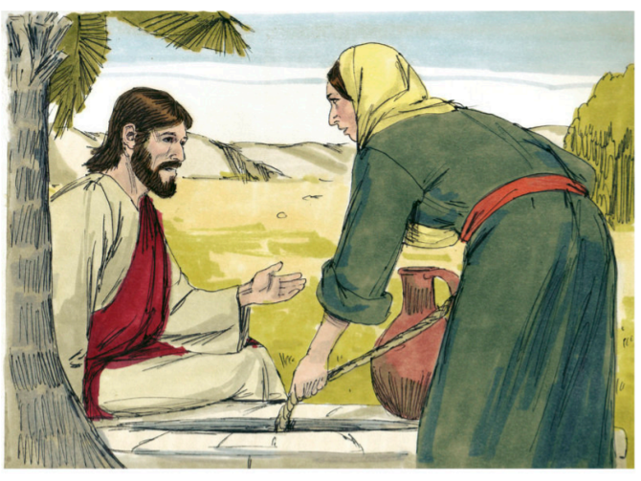 | JESUS HEALS A MAN AT THE POOL OF BETHESDA  John 5:1-9  https://www.youtube.com/watch?v=ohEwpguYB5k  https://www.youtube.com/watch?v=y1cykPOiMuY  I wonder why people believed that the water at Bethesda could be life-giving for them?  I wonder how Jesus gave life to this man? I wonder what sort of water the man needed/was wating for? I wonder what actually made him well?  I wonder if there are any ways in which Jesus can be our life-giver? I wonder if this story helps us to see what Jesus wants us to do in situations where someone is waiting for something positive to happen? I wonder if we could look out for opportunities to change their lives for the better?  Loving God,  we hear your call to all who thirst  for a brighter future:  Let a desire for change well up within us.  May we overflow with compassion and love.  And as a stream wears away stone,  may we reshape our world together  to reflect your kingdom of hope for all. AMEN | WHAT WOULD JESUS DO? – BRINGING WATER TO THOSE WHO DON’T HAVE IT  John 4:13-14  Explore these Christian charities who are working to provide clean water for all those who do not have access to it. What do they do? How does it help people? What difference would it make to their lives? I wonder why clean water is so important? I wonder how clean water brings life?  How does it bring life? What impact do these charities have on those they work with?  I wonder why these charities do this? I wonder how they are they following the example of Jesus?  https://wellfound.org.uk/about/  https://lifewater.org/  Pray for these charities – for those who are working in the villages, fundraising and running the charity.  Pray that all may have access to clean water.  ‘Oh come to the water all you who are thirsty.’ Isaiah 55:1  We thirst...for a world of peace and happiness.  We thirst....for people to be treated fairly.  Lord, you give us the gift of water: the water of life.  (CAFOD) | CELEBRATE  what you do to bring life to others  Celebrate people who have been ‘life-givers’ this week – those who have had a positive effect on the people or environment around them.  Have a time of reflection based on Psalm 42:1-2  As a deer longs for a stream of cool water, so I long for you, O God.  I thirst for you, the living God.  Use an image to help focus the children on this psalm.  I wonder why the Psalmist wrote this psalm, what does it tell us about their feelings for God? I wonder how it links to what we have been thinking about this week? I wonder what the world would be like if people longed for the life-giving water of Jesus like the deer longs for cool water in the heat of the day?  Listen to  www.youtube.com/watch?v=YY0t6_V1OqQ up to 3:45
Life Sustainer | I AM THE BREAD OF LIFE  John 6: 32-35  https://www.worldatlas.com/articles/most-important-staple-foods-in-the-world.html  Bring in some of these staple foods, including bread, and ask what they have in common. I wonder why they are called ‘staple’ foods? I wonder what would happen if these foods became unavailable in the parts of the world where they are the main foodstuff eaten?  I wonder if you have eaten any bread today? I wonder how often there is a type of bread in one of your meals?  Look at the words in the John 6:32  or use  https://www.youtube.com/watch?v=xdRDgaOgJlA  to think about the words.  I wonder why Jesus would describe himself as the bread of life?  Christians believe that, when Jesus used this description, he meant that he can satisfy people’s needs. If we eat some bread, we will get hungry again a few hours later. Christians believe that Jesus will satisfy them forever, bringing peace, forgiveness and a purpose to their lives, that he will be their Life Sustainer.  Dear God, thank you for the food that we enjoy every day. Help us to remember those who have little to eat. Thank you that you provide the right food so that we can live well but that you also promise to fill us with love and joy and peace. AMEN | FEEDING OF THE 5000  John 6:1-14  There are some ideas for exploring the story here https://www.brf.org.uk/product/the-big-picnic/  I wonder why so many people were following Jesus? I wonder why Jesus di not send the hungry people home? I wonder what the people felt when Jesus took the bread and fishes and shared them with everyone? I wonder what Jesus was showing the crowds when he did this amazing thing?  In the feeding of the 5,000 Jesus made sure that everyone had what they needed. Jesus wants us to do all we can to make sure that everyone, whoever they are, has what they need. Jesus said to give food to all those who need it. Jesus came for all people, he shared his love with everyone, and he wants us to do the same.  Generous God, we thank you for all your gifts. Help us to think of the needs of others. You show us how to love and share with everyone. We pray that we may truly share what we have, and so help our sisters and brothers throughout the world.  Amen.  Taken from  https://cafod.org.uk/Education/Primary-teaching-resources/Primary-school-assemblies/Feeding-of-the-5-000-assembly  where there is an additional PP if needed | THANKS FOR WHAT GOD HAS PROVIDED  Psalm 136:25-26  He gives food to every living thing. His faithful love endures forever. Give thanks to the God of heaven. His faithful love endures forever.  The Bible repeats the truth that God will provide all that we need. It also reminds us that we should be thankful for all that we have.  I wonder what you want to give thanks for today?  Share prayers of thanks together.  Listen to:  https://www.youtube.com/watch?v=t8dsxiDu2Xw  www.youtube.com/watch?v=Bk_7wUR2Wdg  Think about using a whole school or age appropriate class prayer or reflection spaces for thankfulness:  https://prayerspacesinschools.com/resources/thankful-play-dough/  https://prayerspacesinschools.com/resources/thankful-ducks/  https://prayerspacesinschools.com/resources/thankful-box/  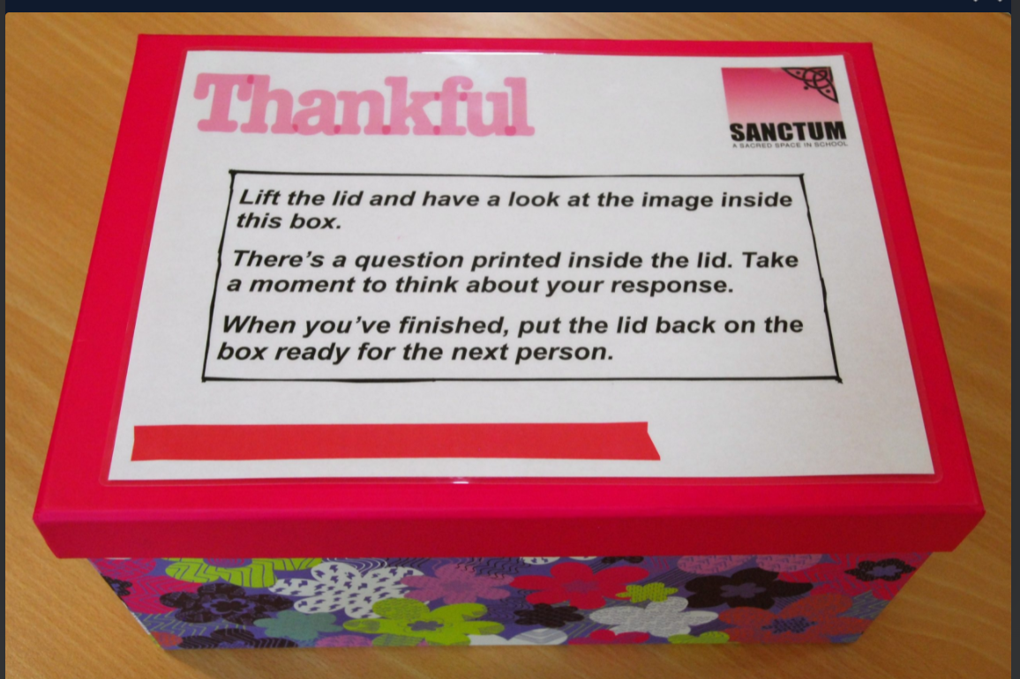 | WHAT WOULD JESUS DO? SHARING WHAT WE HAVE WITH OTHERS  John 6: 1-14  Continuing with the theme of the feeding of the 5000, I wonder how you could be like the boy in the story? I wonder how you could help to sustain others like the boy did?  There are some ideas here that you could adapt to age range  https://www.assemblies.org.uk/pri/2555/a-packed-lunch  You could also consider why people give to the local foodbank. I wonder what impact this food has on those how receive it? I wonder how those who run foodbanks are following Jesus’ example?  Remember that nothing is too small to be shared with others, the smallest of things can make a difference to those around us. I wonder what special act of sharing you will offer today?  Dear God, we thank you for everything that we have. Please help us to share in any way we can to make a small or large difference to those that need our help and friendship. AMEN | CELEBRATE  the acts of sharing that have been seen in school this week  Hebrews 13:16  You could have something that you share with pupils as they leave the hall as a thank you for all that they have shared this week  https://www.youtube.com/watch?v=7xQIcrPkVLs  This gives a sense of the many things that God shares and that we can share with others.
Life Guider | LIGHT IN THE WORLD AND LIGHT OF THE WORLD  Genesis 1:1-4 and John 8:12  Think about some amazing facts about light:  https://www.youtube.com/watch?v=arkyVpzf4WM (the sun – as much as you need)  Alternatively think about/look at other sources of light and why we cannot live well without them.  I wonder why light is such a powerful image?  Look at Genesis 1:1-4. I wonder why light is the first thing that is created in the Bible’s account of Creation? I wonder what was enabled to happen once light existed? I wonder how that might have guided the rest of Creation?  I wonder why Jesus, when he was on the earth, would describe himself as the light of the world? I wonder what this might teach us about him? I wonder how this might help us to understand how Jesus might be a ‘Life Guider’?  ‘Whoever follows me will never walk in darkness but will have the light of life.’  I wonder how this verse makes you feel? I wonder what difference walking in light might make people feel?  See also  https://www.assemblies.org.uk/pri/2866/light-of-the-world  for possible ideas | HEALING OF THE MAN BORN BLIND  John 9:1-17  Think about what we explored yesterday. Christians believe that the Bible explains how the world can be a dark place in need of light. It says that the bad and sad things in the world are caused by a darkness in the hearts of people. The Bible says that is why God sent Jesus, the biggest, brightest light into the world to show people how to live in light and in goodness. Without light, it is difficult to guide or be guided.  Be sensitive to those with visual difficulties if you use this story  https://www.youtube.com/watch?v=X4qZ2KSbdxI (Video clip of the story)  I wonder how Jesus brought light into the life of the blind man? I wonder how this showed Jesus’ love for those around him? I wonder what light Jesus might bring into the lives of those in our communities or school? I wonder how this might guide us to live better lives and to help those around us to live better lives?  Sing or listen to https://www.youtube.com/watch?v=OBdiGYhFJ80  God of life,  We thank you for the signs of your light in the middle of darkness;  May we be signs of your compassion in the heart of your world.  AMEN | CANDLEMAS – PRESENTATION OF JESUS IN THE TEMPLE.  Luke 2:22-40  Candlemas is celebrated on 2 February or on the nearest Sunday and marks the time when Mary and Joseph presented the young child Jesus in the Temple. Two older people called Simeon and Anna recognised Jesus as the one sent by God to show God’s glory and to save the people of Israel.  https://www.youtube.com/watch?v=9QNOANYWva4  https://www.youtube.com/watch?v=Ptx14jy1OU4 starting at 30 secs  I wonder what you think that the words that were said about Jesus might mean? I wonder how you might be a light to lighten the world?  So, even as a young child, Jesus was recognised as the light of the world. Simeon praised God in a famous song/poem called the Nunc Dimittis – Luke 2:29-32  https://www.youtube.com/watch?v=pIj3tu8mFgA  https://www.youtube.com/watch?v=0_zGnyq9IaI  Here is another way exploring the idea of Jesus as the light of the world through this event in the life of Jesus.  https://www.brf.org.uk/product/candlemas-2nd-february-the-presentation-of-jesus-in-the-temple/ | JESUS IS THE LIGHT OF THE WORLD  John 1: 5-9  Light of the World by Holman Hunt -  reflect on this image  https://www.wikiart.org/en/william-holman-hunt/the-light-of-the-world  More information at:  https://www.stpauls.co.uk/history-collections/the-collections/collections-highlights/the-light-of-the-world  I wonder why you think that Holman Hunt painted this image? I wonder what the image might say about Jesus?  I wonder what you can do to be a light in the world? I wonder what areas of ‘darkness’ (worry, sadness, hurt, fear) you can see in the world around you? I wonder where you can bring some light by sharing joy, hope, love, laughter and happiness?  Listen to and discuss how Christians see Jesus as a help in the world in all its complexity:  https://www.youtube.com/watch?v=eI302Av7vSI  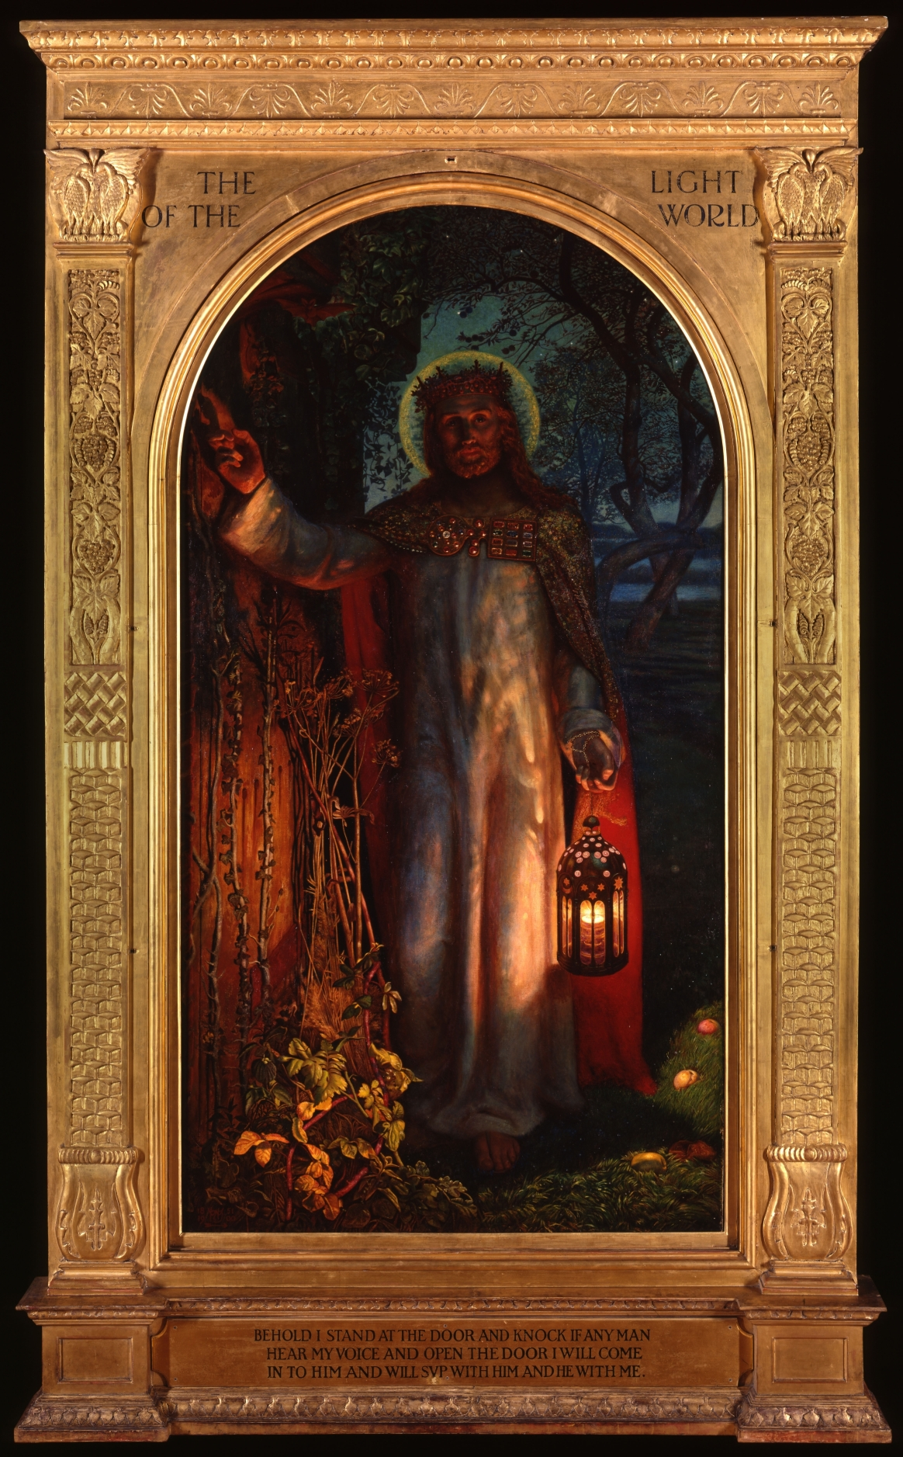 | CELEBRATE  the ways in which people have been life guiders this week  Reflect on all you have heard this week about Jesus. I wonder what you have found out about Jesus as a ‘Life Guider’? I wonder how you can shine out as light into the world like Jesus did?  Sing together:  https://www.youtube.com/watch?v=cKkbIZtqhyQ  or listen  https://www.youtube.com/watch?v=-MmRGSEG2LM  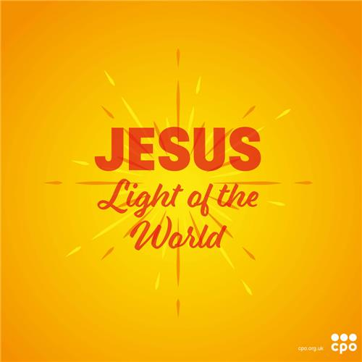
Life Leader | I AM THE GOOD SHEPHERD  John 10: 1-18 (relevant verses)  Put the words shepherd and sheep on the IWB flipchart. See how many Bible references/stories the pupils can think of using these words/images (David, Psalm 23, Christmas story, Lost Sheep etc). I wonder what words best describe the sort of person a shepherd needs to be?  I wonder what you know about shepherds? Find images and video clips to explain the job of a shepherd eg  https://www.compassionuk.org/blogs/psalm-23/  https://www.istockphoto.com/search/2/image?phrase=shepherd  Being a shepherd in Bible times was a difficult and dangerous job. Shepherds were often outside all day and night and had to fend off wild animals. The job of the shepherd was to feed, guide, protect and look after the sheep.  I wonder why Jesus would describe himself as the good shepherd? I wonder what this might teach us about Jesus? I wonder if being a good shepherd might be a good picture of Jesus as a Life Leader?  Watch together:  https://www.youtube.com/watch?v=Pu7L0ZwAJOo  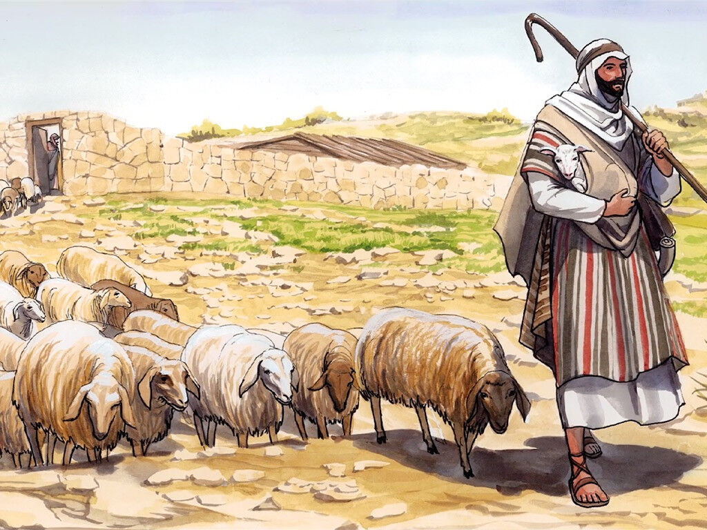 | HE CALLS THE SHEEP BY NAME AND LEADS THEM OUT  John 10:3-4  He goes ahead of them, they follow him because they know his voice.  John 10:4  I wonder if sheep really recognise the voice of their shepherd?  Watch this:  https://www.youtube.com/watch?v=e45dVgWgV64  I wonder what you think now? I wonder why Christians believe that it is important to listen to the voice of Jesus, the good shepherd? I wonder what are the other good voices that we should listen to which can guide our lives well?  Christians sing this song to remind them that God has called them by name.  https://www.youtube.com/watch?v=v2rO0LhSWJ0  Christians believe that their close relationship with God means that God hears every prayer they pray. They also believe that God speaks to them through Bible passages, through other people and hearing him deep in their hearts.  I love the Lord, because he hears me;  he listens to my prayers.  He listens to me  every time I call to him.  Psalm 116:1-2  Give the children some reflection time to ponder on how God hears them when they pray. I wonder whether you want to talk to God about something today?  Listen to whilst reflecting:  https://www.youtube.com/watch?v=x1lmZC1cosM | HE KNOWS MY NAME  Isaiah 42:2-3  Sing together or listen to:  https://www.youtube.com/watch?v=X2X-T_wn5Co (lyric version)  If you listened to the song suggested yesterday, you might recognise the words that were sung:  ‘Don’t be afraid, I’ve redeemed you.  I’ve called your name. You’re mine.  When you’re in over your head, I’ll be there with you.  When you’re in rough waters, you will not go down.  When you’re between a rock and a hard place,  it won’t be a dead end—  Because I am God, your personal God.’  Isaiah 43:2-3 (The Message version)  This passage was written before Jesus was even born, but it promises that God knows a person’s name and will be with them always. I wonder why it might be important that God knows all about you and promises to take care of you even in the rough times and hard places?  Thank you, God, that you know all of our names. Thank you, too for everyone else who knows my name at school, in my family and in the clubs and activities that I go to. Be with them as the help and support me. AMEN | WHAT WOULD JESUS DO? CARE FOR ALL  John 10:14-15  https://www.standby.me/story  https://www.standby.me/what-we-do  Explore this charity. I wonder how they follow the example of Jesus as they care for those children who have no one else to look after them?  Or  https://www.salvationarmy.org.uk/schools  Explore how the Salvation Army works in the community. I wonder how they are following the example of Jesus to care for his people like the shepherd cared for his sheep?  I wonder how you could be like the good shepherd? I wonder who could you help, listen to and care for?  Pray for the work of Stand By Me or the Salvation Army, may God bless all the work that they do and the people that they help. Thank God for those who are shepherds in our world. Ask God to help us to be shepherds and help and support people as God does.  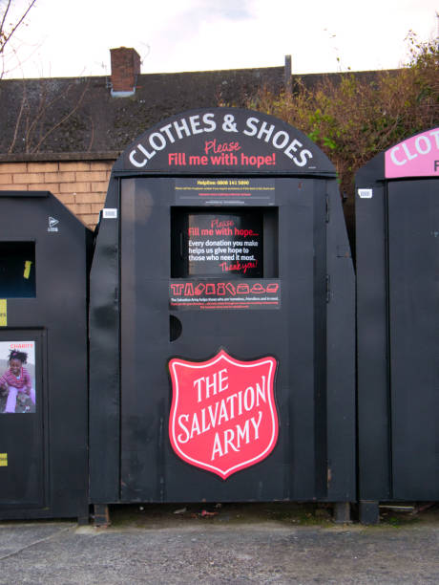 | CELEBRATE  Those who have a good example for others to follow  John 1:43  I wonder who might follow you? I wonder if you are a good person to follow?  I wonder if you are encouraging people to follow a good path?  Other songs you could listen to or sing this week:  https://www.youtube.com/watch?v=I8GLj2Z7M6o  https://www.youtube.com/watch?v=2fTO10iFNrI

