Fresh Approach Collective Worship Planning
Year 1 Term 6 : Journeying Together

Journeying individually and in community
Week 1 | The journey from Easter to Pentecost: waiting for what was to come next
Week 2 | The early followers of Jesus in their new community
Week 3 | Journeying as a Community
Week 4 and 5 | A prayer for our journey: The Lord’s Prayer (Matthew 6:9-13)  This is an opportunity to re-visit a prayer that the pupils might hear regularly and to deepen its meaning for the whole school community.  Use the version of the Lord’s Prayer that you have adopted in school.
Week 6 | Journeying in hope
Week 7 | Next steps on the journey
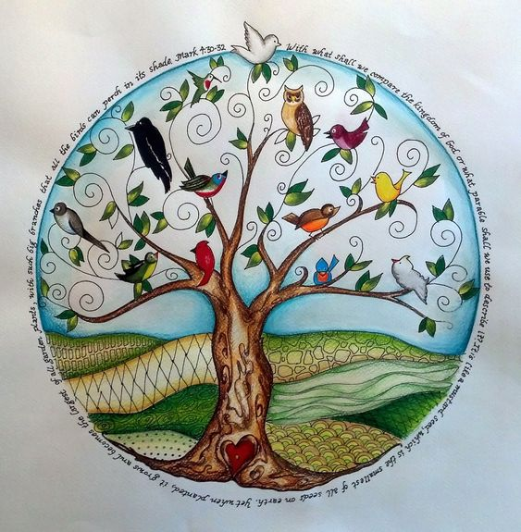

Liturgical colour | Monday | Tuesday | Wednesday | Thursday | Friday
Week 1  Pentecost – Waiting with hope and patience | Wait patiently and something surprising might happen  John 21: 3-14  This a week to help to re-cap on important aspects of Easter, Ascension and Pentecost. Perhaps creating a ‘timeline’ would be helpful.  I wonder if you find it easy to wait? Can you think of particular times when waiting has been easy or waiting has been hard? I wonder if some good can come out of waiting?  Jesus’ disciples waited after Easter Day, not really knowing what would happen next – the surprising thing that happened was that Jesus appeared to them many times. One account in the Bible is the story of how the disciples were fishing (lots of them were fishermen when they met Jesus) but they had caught nothing. When Jesus spoke to them from the shore and told them where to cast their big fishing net, there were hundreds of fish in it. They all ate the fish with bread for breakfast on a beach! Find it in a Bible John 21:3-13) or use the Lego Bible pictures  http://www.thebricktestament.com/the_gospels/the_final_appearance/jn21_09p12.html images 1 to 9  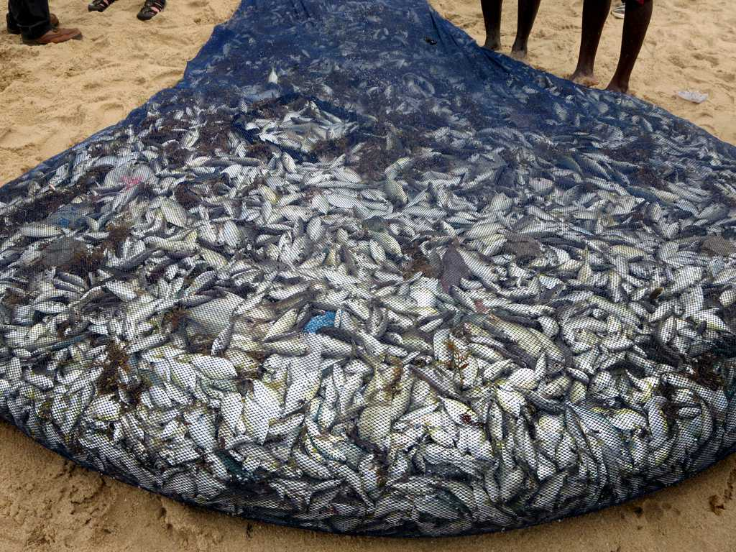  I wonder how amazing that special time with Jesus was? Do you think it was worth the waiting? Would you have enjoyed a breakfast like that?  Say thank you to God that surprising things can happen when we wait, and ask for help to be patient in times of waiting. | Wait patiently even in sad times  Acts 1:9-11  This should be dealt with sensitively using knowledge of context.  Jesus’ disciples had to say goodbye to him when he went back to be with God. Some of the disciples might have thought that Jesus was going to be with them for longer. The Bible says that, as the disciples were watching, Jesus was lifted up and a cloud hid him from their sight and that, as he was going, the disciples were looking into the sky (the Church celebrates this as the Ascension of Jesus).  Do you think that the disciples were happy or sad? I wonder if we can be both of these things at the same time when we say goodbye to someone who has left us forever?  Perhaps this story would help you to think about this?  https://www.youtube.com/watch?v=tRTRABhJTbo  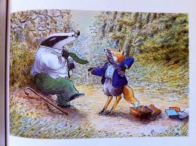 | Wait patiently and something amazing might happen  Acts 2: 1-4  Before Jesus left them, he told them that they must wait in Jerusalem to ‘receive a promise’ but Jesus did not say what the promise was going to be. I wonder how they would have felt when they heard this? I wonder how you feel when someone says that you have to wait for a secret surprise?  Perhaps someone could wrap up a surprise and hide it somewhere so that you wait and be amazed at the end of your worship time when you find and open it. I wonder what you will feel as you do this?  Read the account of Pentecost (this event happened fifty days after Easter Sunday) – see below for some images to use with the account in Acts. I wonder what you think the promise was? I wonder how the disciples would have felt about the flames? I wonder what they would have said to each other? Look at the way some artists have depicted this episode. I wonder if this is how you imagined it?  Renaissance art by El Greco and Titian  https://www.artbible.info/art/large/949.html  http://www.titian.net/pentecost/  Chinese artist He Qi  https://www.bibleodyssey.org/en/tools/image-gallery/h/he-qi-pentecost  Jim Whalen  https://fineartamerica.com/featured/pentecost-jim-whalen.html  Take time to be thankful for all the good surprises that come your way and think of how you could surprise others – not necessarily with things that cost money but with kindness. | Wait patiently and something amazing might happen  Acts 2:5-12  Think about diversity through language with thankfulness in an age appropriate way today – the Christian message was about to spread across the world.  I wonder if you can remember the amazing things that happened after the disciples waited in Jerusalem? If we read on in the account, there is a long list of people from all over the known world who were visiting Jerusalem. The gift of the Holy Spirit meant that the disciples could speak to them all in their many, many languages even though the disciples had never learnt those languages.  I wonder if you can speak a language other than English or if you learn another language at home or at school? How long does it take to learn another language? Can you speak it after just a few lessons? The disciples had not even had one language lesson!  The disciples could tell the amazing story of Jesus to everyone because language was not a barrier and then those people could go back home and spread the good news.  Think about the words you use every day – every word we say is having some sort of effect on the person hearing us. Look up some encouraging or hopeful words (eg ‘peace’) to say to others  https://www.indifferentlanguages.com/words/peace | Celebrate  Ecclesiastes 3:1  Look outside or go outside if you can – whatever you see there, celebrate the wonder of it.  We wait for each season of the year to come round in its turn (as Ecclesiastes 3:1 says) and, without fail, each season provides something new and fresh and beautiful.  Focus on one thing that makes you feel happy – it could be a very tiny flower or the whole of the sky.  Dear God  Thank you that you help us to wait because the waiting for the seasons always brings us joy and waiting can also teach us patience. AMEN  You might want to listen to or join in with this song  https://www.youtube.com/watch?v=q_tpA2luE1g
Week 2 | LIVING IN COMMUNITY  Acts 2:44-47  This week we will look at some of the things that happened in the weeks and months after Pentecost – how the early Christian community supported each other and how the good news (gospel) of Jesus was spread by the first believers.  https://www.freebibleimages.org/illustrations/anv-early-church-unity/  Look at the Bible verses. I wonder what the very first Christian community looked and felt like? Make a list of words which describe how they organised themselves and how a community like this was able to be successful. I wonder whether there are ways in which our school community could try and be more like the community just after Pentecost?  Cooperation means recognising our need of other people. It is a key building block for community. This is how a good team, committee or organisation is successful. Explore how a good team cooperates to win, or how a good school council or organising committee works together for the common good. Or think about any piece of machinery with lots of moving and interconnected parts such as a cog and gear. One piece on its own is useless and, if taken out, the whole machine will fail to work. But put back in and working together with all the other pieces, it plays its part, the machine works and the job is done.  Dear God, we pray for our school community; for a spirit of openness and co-operation that we may listen to God’s word and have the courage to put it into practice. AMEN | PETER AND JOHN  Acts 3:1-8  See what pupils can remember about Pentecost. I wonder what the followers of Jesus might have started to do after they had received the gift of the Holy Spirit and the command from Jesus to go and tell the whole world about him? They did as Jesus had asked and amazing things started to happen.  Today’s story is about the first big miracle performed by the first Christians. It came just after the events at Pentecost.  Possible ways to explore the episode  https://www.youtube.com/watch?v=AT7cnOkGcBQ  https://www.youtube.com/watch?v=AT7cnOkGcBQ  I wonder how much money you have got in your pocket. Sometimes we have some spare coins there. Have some people rattle the loose change in their pockets. There are people who ask for loose change - the charity collector, the homeless person on the street. There was someone in our story today who was also hoping for some small change… but God gave him a big change instead. He was lame. He couldn’t walk on his own. He asked for ‘alms’ (charity) and God gave him legs instead.  I wonder how we can be generous to others even if we do not have any money to give to them?  Giving God, we receive so much from you, and therefore have much to give. Help us to share in the blessings of giving as well as the happiness of receiving, that your love may be more widely, shared through Jesus Christ our Lord. Amen | PAUL  Acts 9:23-25  I wonder if you can remember anything about St Paul? He had been an enemy of the first followers of Jesus but then met with the risen Jesus on his way to Damascus. He was then in great danger and needed to escape.  Tell the story of his escape:  https://www.youtube.com/watch?v=q-6iKcxqRbU  https://www.youtube.com/watch?v=gyeKeun9rN8  https://www.freebibleimages.org/illustrations/ls-saul-escapes/  Also see ideas at  https://www.assemblies.org.uk/pri/45/the-adventures-of-st-paul--only-the-beginning  I wonder what we can learn about being courageous and standing up for what we believe from Paul and from other followers of Jesus, both through history and also today?  Dear God,  Thank you for Paul who lived in extreme danger in order to tell people about Jesus. Help us to appreciate those who are brave and courageous and to stand firm for what they believe as did Paul and the first followers of Jesus. Give us courage when we need to be brave. AMEN | BARNABAS (THE ENCOURAGER)  Acts 4: 32-37, 11:19-26  https://www.brf.org.uk/product/barnabas-the-encouraging-apostle/  11th June is St Barnabas Day. I wonder what sort of things really encourage you when you feel let down or left out in some way?  Use various ‘encouragement’ items eg a good-luck card; an e-mail that has been printed off; a letter; a photo of family or friends; a CD of favourite music. I wonder what other things would encourage you? I wonder what sort of things you might say to someone to encourage them? I wonder what you could do? An encourager is someone who comes alongside another person when they need a helping hand, a smile, some practical action. Perhaps you could act some scenarios where encouragement is needed and given.  There was an encourager in the early church called Barnabas. He encouraged by giving a very generous gift to help with the early Christians’ work in Jerusalem. He encouraged those same people to welcome the Paul, of whom they were very afraid because he had been against the Church. He encouraged his local church in a place called Antioch by being one of its leaders and also travelled off to tell other people about the story of Jesus. I wonder how can you be someone who is an encourager today? | Celebrate our community  John 15:1, 4, 5, 9-11  Celebrate some of the examples from your community life that have shown love or bravery or encouraging this week.  The Bible also looks at community through the image of a vine, with Christians connected to Jesus and each other like branches. Draw a vine with lots of branches and plenty of leaves to add to pupils’ understanding of community.  A song for reflection  https://www.youtube.com/watch?v=301PlhiRNx8  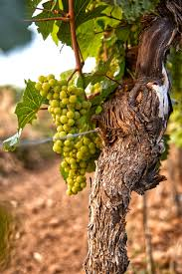
Week 3 | Journeying as a Community  All different, all equally valued  Matthew 6:28-29  Find images of a wide variety of wild flowers. Jesus spoke about the flowers he saw in the field around him and how we can learn something from them. When we see the wild flowers, we see and marvel at the host of beautiful colours. We do not think to say, ‘Oh, I see no yellow, I see no blue or pink, they are all the same!’ We are jubilant because they are all so beautifully different, reminding us of our own uniqueness and ability to bring a smile to the face of those who love us. We celebrate differences in nature.  I wonder if we do that for people too? I wonder how you celebrate difference?  Imagine a conversation between the flowers in your pictures. The poppy might say to the rose, “Do your thorns prickle you?”. The rose might ask the dandelion, “How do you do that thing with all the fluff?” The dandelion might enquire with the poppy, “How do you feel about your red petals representing something so sad?” etc This conversation would be about acknowledging difference and wanting to learn about it, from it and to celebrate it together. When we celebrate our differences as humans, we are showing how much we care about each other and how important it is to communicate with each other. Saying we cannot see difference would be like saying we can’t see all the beautiful flowers. The whole meadow is made all the more beautiful by the variety.  Dear God, help us to remember that we are as different as the wild flowers in the fields. Even so, we belong together and we need each other but we are not all the same. Thank you for diversity in our school community, like a field of wildflowers making the landscape beautiful. Amen. | Journeying as a Community  All different, all loved  John 4:7-30  In the Bible, there is a story about a Samaritan woman at a well who talked with Jesus.  Tell the story:  https://www.freebibleimages.org/search/?s=samaritan  https://www.youtube.com/watch?v=QszHeIUsbTQ up to 3 mins  This is a woman whom some people might have labelled as ‘different’. Because of this, the Jews may have chosen to not have a conversation with her. They would almost certainly not have asked her for a drink! But Jesus did, much to her amazement. She was not used to being seen, or spoken to, by those who saw her as different to them. Not only that, Jesus was interested in her life! He allowed her to meet a need of his (his thirst) whilst also trying to help her. He included her and welcomed her to join the growing number of people who believed he was the Messiah, the Son of God. Because of her and her story told to all her friends, many Samaritans believed in Jesus. I wonder why you think Jesus welcomed her? I wonder how you think that made her feel?  The great thing we all have in common is that we are made in God’s image! God is a God of difference and a God who loves everyone!  I wonder if you can think of a time when you thought of people as ‘in’ or ‘out’? I wonder how might it feel to be in the ‘out’ group? I wonder what you can do to make sure that this is not the case in our school?  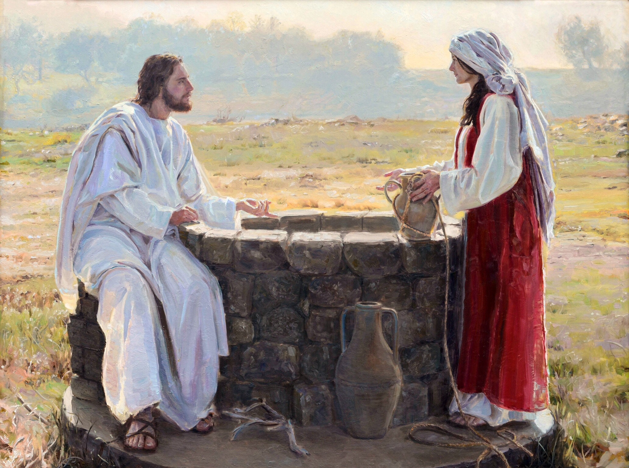 | Journeying as a Community  All different, all the same  II Corinthians 13:14  I wonder if you have heard the word ‘Trinity’ before? I wonder what it means and why it is important for Christians? The idea of community is captured for Christians in the way that the three persons of the Trinity live together in perfect and equal love, in perfect and equal community, whilst also being diverse and different.  Someone who has tried to explore the concept of the Trinity and of diversity is artist, Meg Wroe. Meg took the famous icon of Rublev’s Trinity  http://www.wellsprings.org.uk/rublevs_icon/trinity.htm  and recreated her own version of it to show how difference and diversity are all part of God’s loving expression towards the world he created.  https://megwroe.com/new-gallery/qflrl34d0fo51ba7exvh7uids4za9e - Trinity After Rublev, Meg Wroe  Christians believe that all people, of all skin types, from all nations and cultures, are made in God’s image. I wonder what Meg was trying to show through these images? I wonder how this captures something about God? I wonder what this tells us about ourselves and how we should live?  May the grace of our Lord Jesus Christ, and the love of God, and the fellowship of the Holy Spirit be with us all, now and evermore. AMEN  Sung grace/blessing  https://www.youtube.com/watch?v=INPoOfjFJ5s | Journeying as a Community  All different, all included  John 4:7-30  Here are some ideas to use in age appropriate ways to think about how we make sure that everyone is included and celebrated:  You could create a visual representation of this by decorating a box with a picture of the world and pulling out from it diverse images of people, a variety of different foods, diverse clothing, etc. What a brilliant box of God’s wonderful, diverse creation! Give thanks for this.  https://www.youtube.com/watch?v=XxNBXMTJbp4  Author Glennon Doyle encourages people to think in horseshoes not in circles Horseshoe shapes are open, they are not enclosed like circles. Circles can keep people in, but they can also keep people out. If you are on the outside of a circle of friends because they perceive you as being just too different, that is a very lonely place to be. At the well with the Samaritan woman, Jesus was thinking in horseshoes rather than circles. He welcomed her in, even though everyone else believed she was too different.  You might create a moment of quiet reflection with music or silence. Invite pupils to trace a horseshoe on their palm as they think about people who are different to them in some way. Invite them to imagine welcoming them into their friendship group, so that ‘us’ and ‘them’ becomes ‘we’.  https://www.youtube.com/watch?v=nIuuDBVgJIk | Celebrate  Martin Luther King once said: “We are caught in an inescapable network of mutuality, tied in a single garment of destiny.”  Imagine a beautiful coat, woven with beautiful threads and embroidered with wonderful images. All those threads are depending on each other to make a beautiful garment. It takes all of them to create something vibrant and special.  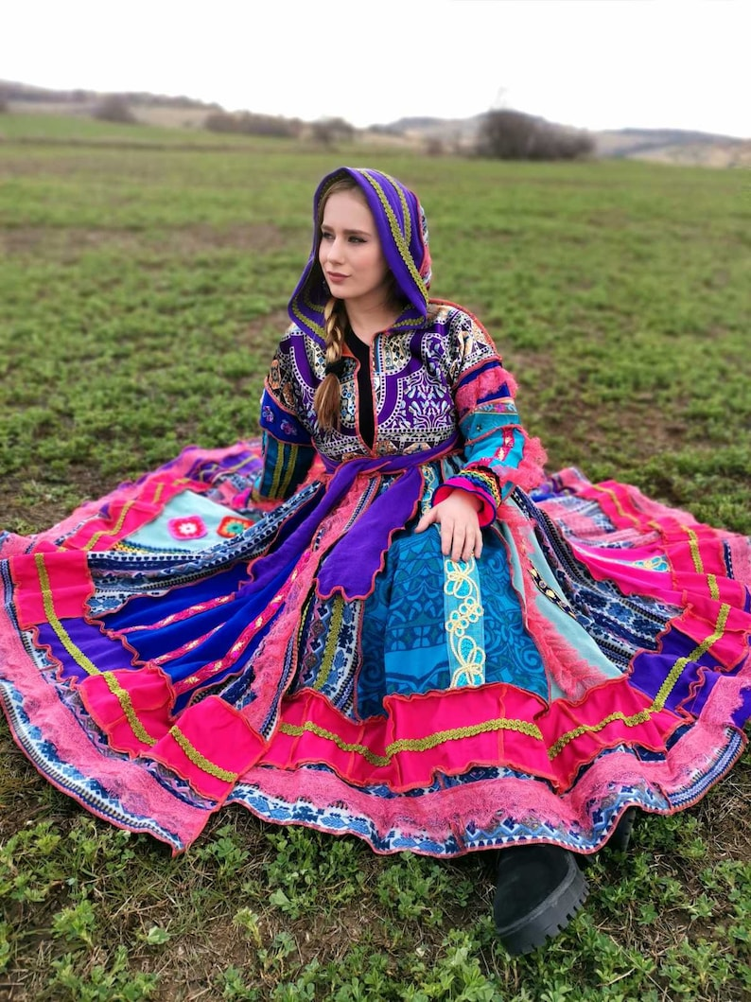  I wonder how we have created a beautiful garment like this in our school this week?  Thank you to ‘Faith at Home’ for the ideas used this week
Week 4 | OUR FATHER IN HEAVEN  Matthew 6:9  Draw ten stars on a flip chart. Imagine a competition for ‘the world’s 10-star dad’. I wonder what sort of person might win this 10-star gold award? Alternatively start an alphabet of words to describe a good parent. Or an acronym for ‘FATHER’.  When Jesus taught his followers the Lord’s Prayer, he told them to start ‘Our Father’; he used the word ‘abba’ which means ‘daddy. But this was no ordinary everyday ‘dad’, but a heavenly father, even more wonderful than a 10-star dad.  https://www.youtube.com/watch?v=vilh36C0kFc  https://www.youtube.com/watch?v=RmuphTKcDfs  Tell or show the story of the Lost Son (Luke 15) What do you like about this ‘dad’? I wonder what some of his star qualities might be?  Share the words ‘our father’ in other languages using the children’s knowledge or from the link below  Practise saying them; create a mosaic with them on.  https://www.wordproject.org/bibles/resources/our_father/in_many_languages.htm  May God who loves us like a father and knows every hair on our head, bless us this day. AMEN | HALLOWED BE YOUR NAME  Matthew 6:9  Below are two possible options:  1 - What is a name?  Explore the names of children. I wonder if they know why their name was chosen? (Parents liked it, family link, tradition, Bible?). I wonder why how our names are very important to us? God’s name is very important too, in fact in the Bible he has more than one name!  I wonder if you can remember any of the names God has in the Bible? (help pupils if needed e.g. Father, Abba, Most High, Almighty, Lord, Yahweh etc…)  Today’s line in The Lord’s Prayer tells us that God’s name is ‘hallowed’ or ‘holy’. I wonder what holy means? It means set apart, pure or perfect. This is a way of saying God’s name is very special and should be treated with respect.  2 – Handling with Care  I wonder what holy means? It means set apart, pure or perfect. God’s name is very holy and Christians hold it in awe and respect. It has to be handled with great care.  Show children eggs in their shell. Ask them to hold it carefully or, if possible, to pass it around without dropping it. If we weren’t careful, if we threw the egg around, it would break, so it has to be handled with care. I wonder what else is precious and needs to be handled with care? (new born baby, pet animals etc…) God’s name is just as precious, it has to be handled with great care and we need to think about how we use it.  Reflect, sit quietly and wonder. I wonder if there are there times when God’s name is not used carefully? I wonder how we feel about that? I wonder if there is anything we need to do differently? | YOUR KINGDOM COME  Matthew 6:10  I wonder what you think of when you hear the word kingdom? I wonder whose kingdom this prayer is talking about?  https://www.youtube.com/watch?v=YoARY3J2zco  Tell the story of the Mustard Seed from the Bible Matthew 13: 31,32  (you could give each child a mustard seed to hold.)  I wonder what God’s Kingdom would be like? I wonder what small things might start off God’s Kingdom?  Show a picture of a mustard tree. Small things make a difference.  I wonder what I can do today that will make a kingdom moment?  Plant the mustard seeds and label the container with ‘kingdom acts’ such as ‘holding the door open for someone’ or ‘smiling’.  This activity from Sara Hargreaves uses tea lights to help us think about shining our light in our community. You could adapt it for use in school.  https://engageworship.org/ideas/hidden-lights-activity | YOUR WILL BE DONE ON EARTH AS IN HEAVEN  Matthew 6:10  https://www.natre.org.uk/about-natre/projects/spirited-arts/spirited-arts-gallery/archive/2014/?ThemeID=58  These ideas might spark discussion  Let’s think about where God ‘lives’, God’s heavenly home. I wonder what you think it might be like? Pupils to talk in pairs and then ask for their ideas – have some ready in case pupils find this difficult.  In the very last book in the Bible (Revelation) written by a Christian man known as "John the Elder" who lived in a place called Ephesus. He wrote about the heaven in Chapter 21 verse 1. Christians think that heaven must be a very special as God is there. The Bible says that in heaven there will be no more crying, no more hunger and no more hurt.  I wonder what ‘your will’ means?  Your will is what you want to happen – so God’s will is God’s plan. In the Lord’s Prayer, this is a request in which Christians say that they want what God wants to happen. They are asking God for his will [his plan] on earth to be as perfect as it is in heaven.  This part of the prayer reminds us that we should be living the way God wants us to live every day of our lives. I wonder what you think God would like us to be doing today? | Celebrate that we are able to pray as a worldwide family  Matthew 6:11  Remind the pupils that this prayer is used across the world by Christians.  https://www.youtube.com/watch?v=aDcwX_3DIJw  Spend a little time on this line of the prayer.  ‘Give us our daily bread’  Today in school and at home, we will be fed physically and we must remember to celebrate and say ‘thank you’ for this aspect of our life which we simply take for granted most of the time.  ‘I am the bread of life. He who comes to me will never go hungry, and he who believes in me will never be thirsty’ – John 6: 35-51  Today we are thinking about these words and that the daily bread we receive links to the physical and spiritual.  God of miracle  provider of  daily bread.  word of life  and love,  we offer you  our thanks.  Thank you to Chelmsford Diocese for ideas used this week
Week 5 | FORGIVE US OUR SINS  Matthew 6:12  Music “Forgiveness, Forgiveness”- a song to listen to which is about what Christians believe about forgiveness  https://www.youtube.com/watch?v=YwK2tmpNpcc  “ Forgive us our sins”  I wonder what this might mean?  It’s a beautiful, but sometimes confusing, part of the prayer The Lord’s Prayer. Some pray it every day. Some several times a day. Some in church. Some in private. It is a prayer which says that those who pray it want and need forgiveness. In fact, when Jesus modelled this for his followers, he linked asking for daily bread with asking for forgiveness. “Forgive us” comes right after “Give us this day our daily bread.” It’s a hint that we might need both, every day—food and forgiveness, and should pray for both on a daily basis.  Video link for story:  https://www.youtube.com/watch?v=Fe7dTNID6h8  Look at the story of Zacchaeus. I wonder why Zacchaeus felt he had sinned? I wonder why he needed to see Jesus? I wonder why Jesus forgave him?  When Zacchaeus knew he had made a mistake, he said he was sorry. Jesus forgave him for all he had done, even though all those watching didn’t think he deserved it.  I wonder how we can ask God to forgive us and I wonder how that feels?  Dear God,  Please forgive us when we do things that hurt or upset people. AMEN | AS WE FORGIVE THOSE WHO SIN AGAINST US  Matthew 6:12  A simple chant from Taize, easy to pick up and hum. Choir version: https://www.youtube.com/watch?v=wGgGFguXwms (04.00) and solo version: https://www.youtube.com/watch?v=MQv8lQs7fTQ (03.15)  O God forgive us For King and Country. https://www.youtube.com/watch?v=tz4toSf-xQU - ballad by Grammy award winning Christian brother duo from Australia/USA. (03.09) (official video – words on screen)  Tell a brief story from real life of a person forgiving another. The story could be a famous one: e.g. Gordon Wilson (Enniskillen). His words "I bear no ill will. I bear no grudge" were reported worldwide, becoming among the most-remembered quotations from the Irish Troubles  Archbishop Desmond Tutu on Forgiveness  https://www.youtube.com/watch?v=raG6eIL-LM0 (03.02 – esp from 02.00)  and/or  https://www.youtube.com/watch?v=uo2LGGqtjqM (4.25 esp 00.00- 02.15)  I wonder if you can think of a time when someone forgave you for something? It could be from your friendship circles, from family life, from life in school. I wonder how it made you feel to be forgiven?  I wonder if you have ever forgiven who had hurt you or done something bad which had affected you? I wonder how it made you feel when you forgave someone?  Reflect on a situation that could arise in day to day life e.g. in school, with a friend or sibling etc. where forgiveness would be needed. I wonder if we could commit to showing forgiveness to others today? | LEAD US NOT INTO TEMPTATION  Matthew 6:13  Read Luke 4:1-13. Remind the pupils that Jesus was tempted to do the wrong thing but was strong and did not give in.  Explain to the pupils that temptation is when it might seem like a good idea to go against what God has told his people to do by disobeying him. Remind pupils that chocolate is not allowed in school. Give a pupil a bar of chocolate and tell them that under no circumstances must they eat it. Tell the other pupils that they must help their friend not to eat it. Leave the room having primed another teacher to persuade the pupil to eat it (obviously check beforehand for allergies etc). Will the pupil give in? Will the other children help?  Come back in. I wonder what happened when I was out of the room? I wonder if anyone ate any of the chocolate? Either way, explain that the lesson is that sometimes the wrong thing can seem like the right thing (because the other teacher told them to eat it) which can make it hard to know what to do.  I wonder how we can protect ourselves and each other from giving in to temptation?  Read Psalm 121:7-8 for encouragement:  The Lord will protect you and keep you safe from all dangers. The Lord will protect you now and always wherever you go. | BUT DELIVER US FROM EVIL  Matthew 6:13  Show opening sequence of Prince of Egypt, the song ‘Deliver us’ if appropriate to age and stage  https://www.youtube.com/watch?v=aZ9CJIlFGOQ  I wonder what ‘deliver’ means in the Lord’s Prayer?  Use a selection of pictures or items that might represent the theme (rainbow, emergency services, appropriate pictures of dangerous situations). I wonder what you would choose to go with this part of the prayer and why?  I wonder if you can you think of any other stories from the Bible that tell about God rescuing his people from evil? (the exodus or the calming of the storm perhaps). I wonder what these stories tell us about God?  I wonder what this line of the prayer might mean for our day to life?  Reflect on or pray St Patrick’s breastplate, a famous prayer for God’s protection and deliverance and God’s presence beside us:  https://www.youtube.com/watch?v=nQc4qS7TF-k  https://www.youtube.com/watch?v=pv3Rb0Dz93U | Celebrate  that we are free and able to to pray  By finishing The Lord’s Prayer with ‘Amen’ in this way, we are asking for it to be like this forever more, a way of saying ‘I agree’.  Prayer isn’t just about talking at God; it’s about having a two-way conversation. That means talking to God and listening to what he says.  Time for a quiet reflection: I wonder if you pray to God? I wonder if you can think of a prayer that God has answered?  Say The Lord’s Prayer together slowly thinking about all you have learnt about it over the past two weeks.  Or use actions  https://www.brf.org.uk/product/the-lords-prayer-in-movement/  Thank you to Chelmsford Diocese for ideas used this week
Week 6  Journeying in the strength of the Christian hope | Journeying in hope  Jeremiah 29:11  I wonder what words or images come into you mind when you hear the word ‘hope’? Alternatively, place the sentence starter, ‘Hope is…’ on the board. I wonder how you might finish this sentence? Share some thoughts. Look at the Bible verse. I wonder what this might mean for us a school community? I wonder how it can help us to move forward as a school community?  Reflect on Banksy’s ‘Girl and Heart Balloon’.  https://www.heart.co.uk/photos/banksy-pictures/balloon/  I wonder what this artwork makes you think about in relation to hope? I wonder what the girl is thinking? I wonder what you think the balloon might represent? I wonder if you agree with the words on the wall ‘there is always hope’?  https://www.youtube.com/watch?v=B5P0mOBFlsU  This is a song that you will probably know.  I wonder what it tells us about travelling with others in a hopeful community?  Dear God, we thank you for walking with us as we journey together through life. Thank you for walking with us through good times, as well as times when we might feel worried. Help us to be thankful for all good things, and to have hope each and every day. Amen. | Journeying in hope  Luke 24:13-35  Watch the ‘Road to Emmaus’ video: https://www.youtube.com/watch?v=ndtnZV-5QTo. Explore this through the acronym ‘DAOR’ (‘road’ backwards).  D - At the start of this story, we find the disciples disappointed and disheartened. The disciples had lost hope because of what had happened in Jerusalem a few days before. Jesus had died and his body had gone missing; they were expecting things to turn out a little bit differently  A - the disciples were a little anxious. I wonder what the future held now? The disciples were so worried that they could only focus on their disappointments. They didn’t recognise that the person, who was now walking alongside them, was Jesus.  O - Jesus listened very carefully to them, and then started to open up new possibilities. He explained that the messengers and prophets of old had all pointed to these things happening; do not worry, all of these things will turn out well. And, as they ate together, their eyes were opened too – this person was Jesus himself!  R – reasons for hope. The disciples realised that they had lots of reasons to be hopeful. Through walking with and meeting Jesus, they were no longer disappointed or disheartened; they now thought that Jesus’ death and missing body had actually pointed to the greatest hope possible. They ran back to Jerusalem to tell the other disciples what they had seen and heard.  If those disciples were asked the question, ‘How can you have hope for tomorrow?’, I wonder what they would have answered? Perhaps they would have replied, ‘we have hope because Jesus is alive and joined us on our journey!’ Sometimes hope is brighter because of the difficulties that come before. | Journeying in hope  Isaiah 40:31  I wonder what sort of hope this Bible verse describes? I wonder what your hope and dreams are for your future? I wonder if they are like the hope in the Bible verse?  This act of worship is based on  https://www.assemblies.org.uk/pri/3627/hopes-dreams-and-the-future and there is a PP provided. The idea that there are three trees who have grand dreams and that God makes their dreams come true but not quite in the way that they expected.  https://www.youtube.com/watch?v=z5qRzTOpOnk  It is not a Bible story but relies on the concepts of Incarnation, Gospel and Salvation to find its deeper meaning.  I wonder how the dreams of the trees came true? I wonder if we can learn something important about hopes and dreams from this story  https://www.youtube.com/watch?v=y6Fb1vxlyVM expresses something of the hope which Christians place in Christ  https://www.youtube.com/watch?v=eitDnP0_83k – a song which pupils might recognise, about looking to a bright future  In your journeys to and fro,  God direct you  In your happiness and pleasure  God bless you  In care, anxiety or trouble,  God sustain you  In peril and danger,  God protect you  AMEN | Journeying in hope  Luke 24:13-35  Here are some options to adapt in age-appropriate ways to help pupils to reflect on the importance of hope:  https://www.youtube.com/watch?v=8lf42qXAVjw  Use the images that accompany this song to reflect on ‘hope’. I wonder how we show hope in our work and in our play?  Alternatively find some different images of hope to encourage reflection.  There are also some prayer space ideas for the school or classroom to encourage us to be hopeful individuals and to be a hopeful community:  https://prayerspacesinschools.com/resources/hopeful-hopscotch/  https://prayerspacesinschools.com/resources/forest-hope/  https://prayerspacesinschools.com/resources/hope-blossoms-2/  https://prayerspacesinschools.com/resources/hopes-and-dreams/ | Celebrate  Isaiah 40:31  The fact that we live in a world where there is always hope. Celebrate the hopeful people in your school community – give some ‘hope’ awards this week.  Father,  Thank you that in a world of despair,  You are our Hope.  In a world of darkness,  You are our Light.  In a world of sorrow,  You are our joy.  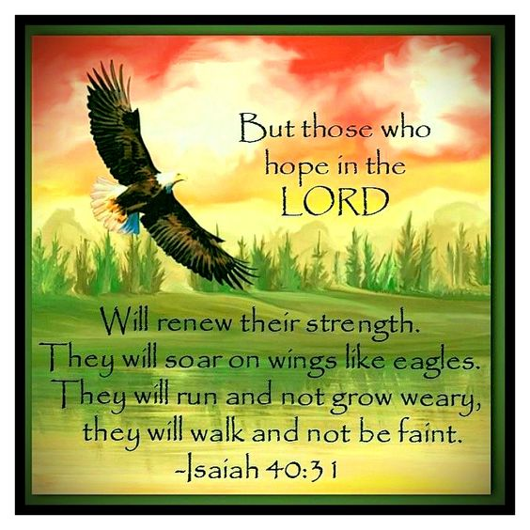
Week 7  A focus on those taking a new path for their journey in the future | Going on a new journey  Passport – a sense of belonging  Luke 19:1-10  This week of worship is aimed at your Leavers but has messages for everyone on their journey through life. It is based on some of the things that you might need as you prepare for a journey packed in a rucksack.  I wonder if you’ve ever felt the ‘odd one out’? Today we meet someone who always felt like that, as if he never belonged.  https://www.youtube.com/watch?v=3uL6FuAE2r4  https://www.freebibleimages.org/photos/lumo-zacchaeus/  I wonder what changed how Zacchaeus felt about himself? I wonder what Jesus’ words might mean? - ‘I have come to search for the lost and make them feel welcome in God’s kingdom.’ The story of Zacchaeus is a reminder to us that we all need to feel that we belong – but it’s also a reminder that God’s kingdom is for anyone, even people like Zacchaeus!  Open the rucksack and talk about what a passport is for, and how it shows the country that you ‘belong’ in. We belong to this school. Wherever you go in the future, you will always have belonged in this school – you will have many memories, learned many new skills and made many friends. So you will continue to carry your ‘school passport’ with you because of the things you carry within you (like you have a passport from your birth country for your world travels in your life)  Dear God  Help us to show a welcome to everyone, to show that they belong. As we journey through life, may we be like Jesus, who always welcomed those who felt as if they were the ‘odd one out’. We ask this in the name of Jesus. Amen | Going on a new journey  Muddy boots – always a chance to start again  Luke 22:54-62, John 21:15-17  Open your rucksack and get out the boots. Talk about where they might have been – and how they might have got dirty. Also talk about how the mud from dirty boots gets everywhere – especially on clean floors! Like our walking boots easily got dirty, and need a clean, the same is also true of our hearts. It’s very easy for each one of us to do or say things that hurt others and it’s often much harder than we imagined to put these things right.  How Peter ‘got muddy boots’  https://www.youtube.com/watch?v=8iD5luFO7-U  How Jesus made them clean again (after Jesus’ resurrection)  https://www.youtube.com/watch?v=MENWMTxW44M  I wonder how Peter know that he had been forgiven? I wonder how Peter might have gone forward after this and why? (He travelled and preached about Jesus for the rest of his life and died for being a follower of Jesus)  We can all be sure that at one time or another, we will do things that hurt others or make them sad – and you know that in school, we try to help you to say sorry and to forgive each other. Remember that as you travel through life in the future.  For times when we’ve hurt others – God, WE ARE SORRY  For the angry words we’ve spoken – God, WE ARE SORRY  For things we’ve done that have made others sad – God, WE ARE SORRY  As we journey through life, help us remember to forgive and to receive forgiveness. Amen | Going on a new journey  Map - trusting in God to know the way and to keep us safe  See below for Bible verses  Today’s rucksack object: a map, also  6 plastic water bottles, empty, for messages to be inserted into. Label the bottles 1-6, with these messages  DANGER!!; 2. PRISON!!; 3. TRIAL BY ROMANS!!; 4. SHIPWRECKED!!; 5. SNAKEBITE!!; 6. HOUSE ARREST!!  (or however many SOS adventures you want to choose – see below)  Paul had a vision of Jesus as he was travelling on a journey to Damascus, in Syria. He was so changed that he spent the rest of his life travelling around (about 10,000 miles!) to tell as many people as he could about what Jesus had done. Many of the journeys he took were dangerous but he followed God’s ‘map’ for him:  DANGER!! Acts 14:8-28 LYSTRA  PRISON! Acts 16:11-40 PHILIPPI  TRIAL BY ROMANS!! Acts 21:27-23:35; also Acts 24&25 JERUSALEM  SHIPWRECKED!! Acts 27:1-44 MALTA  SNAKEBITE!! Acts 28:1-6 MALTA  HOUSE ARREST!! Acts 28:11-31; letters to Timothy & Titus ROME  Another way of summarising what happened to Paul is here:  https://www.youtube.com/watch?v=R0p0W_Zbt1s  Paul wrote letters encouraging new Christians and one thing he wrote was “Run the race with perseverance! Keep on going and don’t give up!”  I wonder if you’ve ever felt like giving up? I wonder how you carried on?  Dear God  Thank you for the inspiration of Paul – how he trusted you and didn’t give up. As we journey through life, and hard times come, please help us to keep on going and not give up. Amen | Going on a new journey  Torch lighting our way and encouraging us to act as a light  Philippians 2:13-15  Start with finding the torch in the rucksack. I wonder how this might be useful on a journey? I wonder what we can use to lead us through the dark? You could get out the materials to make the light bulb circuit and challenge someone to make the light bulb shine. I wonder if people can be helped to shine? Read the Bible verses. I wonder if we can encourage each other to shine like stars? You might link with your school’s vision & values. You might also want to think about specific people who might ‘shine’ and act as good role models.  Jesus also talked about people ‘shining’: He said that in the same way that a light shines in a dark house, so the people of God’s kingdom should ‘be a light for others.’ (Matthew 5: 16) and not hide their light away.’ Light a candle/tealight (safely) and encourage children to spend some time reflecting about what ‘shining’ might mean for them.  Throughout life’s journey,  In our friendships, Jesus, light of the world, ‘HELP US TO SHINE’  In the way we treat others, Jesus, light of the world, ‘HELP US TO SHINE’  In our work and in our play, Jesus, light of the world, ‘HELP US TO SHINE’  In all that we do, and all that we say, Jesus, light of the world, ‘HELP US TO SHINE’ Amen  or use  https://www.youtube.com/watch?v=QCN893hzueQ | Celebrate  Luggage labels – remembering that God is with us  Joshua 1:9  Luggage always needs a label and perhaps this label says something important for the ‘rucksack’ which we might carry with us. I wonder what that mean to you?  Dear God  Thank you for all the people who have been with us during this year – our families, friends and teachers. Thank you that you promise to go with us as we take one more step along the world for the whole of our life’s journey. Amen  Thank you to Guildford Diocese for the ideas for this week

