Deanery Roadshows 2023 – CYPE team
Generous Hospitality
Principles and practical steps for including and welcoming children and young people wherever they are (in church, schools or within households)

Children, Young People and Education (CYPE) Team – Who are we?
Quentin Roper
Diocesan Director of Education
Rebecca Swansbury
Deputy Director of Education
Natalie Ralph
Schools Officer, Christian Character
Andrew Collie
Schools Officer, Organisation and Estates.
Jen Tobin
Lead Officer for Children and Young People’s ministry
Georgina Hedley-Smith
Youth Ministry Enabler
Sarah Buchan
Lead Team Administrator

Background
- The Church of England has shared its ambition to double the number of children and young people living as active disciples in our churches by 2030
- For many church school families, church attendance is not a priority – they find a sense of belonging to church through school
Faith in the Nexus research - Bowie, R., Casson, A., Hulbert, S. and Woolley, M. (2020) ‘Church schools and children’s exploration of faith in the home: A NICER research study of twenty church primary schools in England’. Canterbury: Canterbury Christ Church University. Available at Faith In The Nexus (nicer.org.uk)
- 99% of parents want the church to work in partnership with families to nurture children’s faith together.

Purpose – what is your why?
Why ministry with children and young people?
Answering the question 'Why' is critical to:

- Inclusion (being part of the whole church family)
- Belonging and welcome (their voices are heard and taken seriously)
- Growing young disciples

What is your why?
A change in mindset …
- Think differently and creatively
- Probably going to be messy!
- Get the whole church on board – support, prayer, financial
- Look at where the children are – join them
- See beyond the buildings
- Move on from ‘this is how we have always run/planned/held it!’

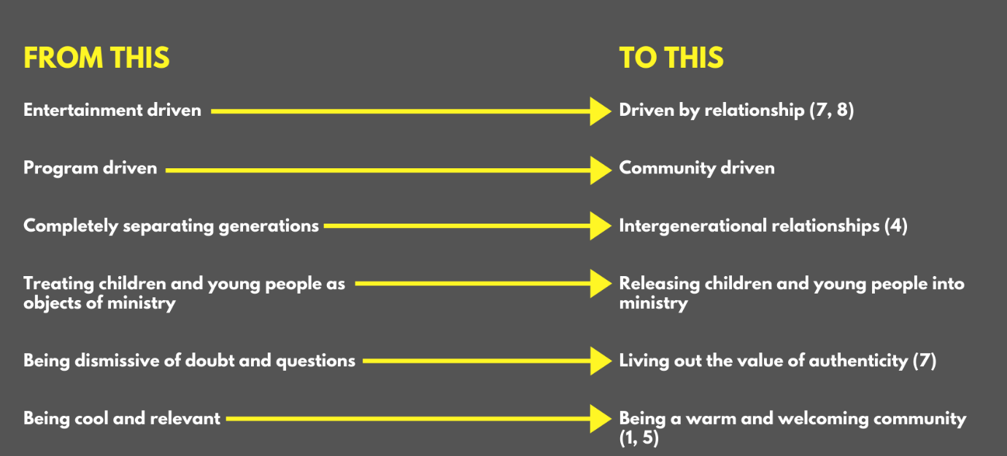

- Come to the table: supporting families
- Know your purpose
- Reflect on context – what are the key local, social issues e.g., cost of living?
- Identifying gaps for the church to step into the role of supporting families
- Not just church on a Sunday – be ready to meet with families where they are, extending invitation to 'come to the table'

- Practical ideas for the church environment
A culture of welcome
- Requires whole church participation, togetherness as a family of God
- Inclusion of SEND, acceptance (fearfully and wonderfully made, Psalm 139:14) e.g., sensory corner
- Find ways of listening to children’s perspectives on church and the Christian faith
- Imaginative practices – new ways of ‘being’ church (Wild, Messy, youth-led…)
Practical ideas
- Welcome note for adults with young children
- Children’s worship bags (not just a busy bag)
- Clear signage
- Sensory corner
- Dressing up rail
- Regular displays of school children’s work in the church

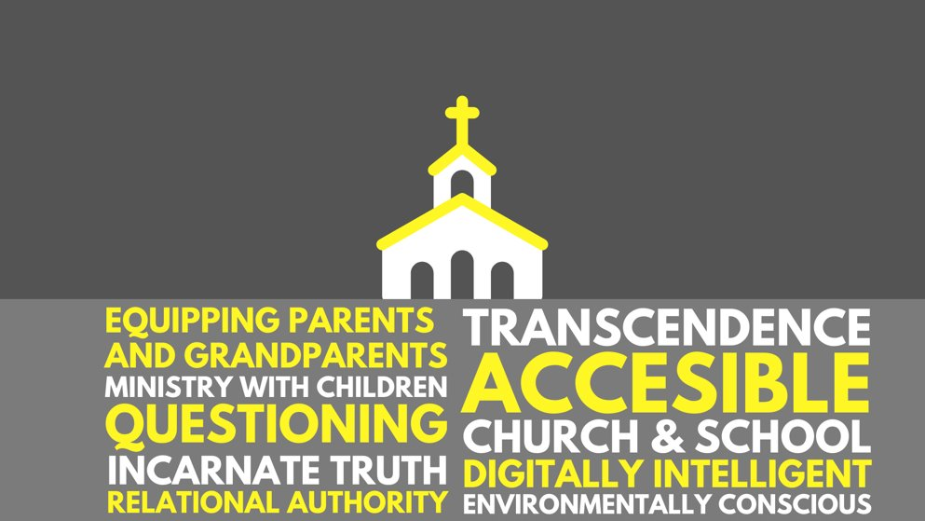

- Connecting with Schools
Flourishing church and school partnerships are based on safe, long term, listening relationships that faithfully and lovingly serve all children, young people and families in the local community without agenda.

Principles of working with schools

BEING - PRESENT
Most people don’t need to be cheered up
They need you to jump in their pain
And say ‘I get you; I understand you’
And not try and fix them
They don’t necessarily need you to be the answer man or woman
They just need you to be there with them.

BEING - INCARNATIONAL
The word became flesh and blood, and moved into the neighbourhood - John 1:14 (MSG)

LISTENING
- How can you listen well to what your school would find helpful?
- What skills or gifts can you offer a school?

SERVING
Church isn’t about getting people into a building; it’s about getting the Kingdom onto the streets.
- What needs are there in your local school community?
- Are you serving the school with an agenda or what you might get back?
- How can you GO …and find a new perspective
SEE expose yourself to others’ lived experiences
FEEL allow yourself to be moved by compassion
DO take action based on what you have seen or felt

RELATIONAL
means
MINISTRY WITH… There is a pattern in Jesus’ ministry:
- Watch me do it (Matthew 4:19)
- Do it with me (Matthew 14: 17-21)
- Do it (Matthew 28: 18-20)

SPIRITUAL ENCOUNTERS Allow space for young people to meet with God.

Transition points
How can these vital life changing moments be supported?
Toddler group -> School
Year 6 -> Year 7
Year 11
Year 13 -> University / College / employment

