Collated Report - Anna Chaplaincy Questionnaire 2024
A questionnaire was sent to all Anna Chaplains and Friends in order to capture a snapshot of the breadth of ministry being exercised by them across our diocese. It is important to note that the role of an Anna Friend is largely to assist and support their Anna Chaplain.
The Diocese of Canterbury partners with BRF Ministries to train, support and equip Anna Chaplaincy with older people. Anna Chaplains/Friends are locally commissioned to exercise this ministry with oversight from the Diocesan Anna Chaplaincy Working Group.
The following chart shows the level of responses to the questionnaire:

Statistical Overview
The following charts provide information about the context for exercising ministry:
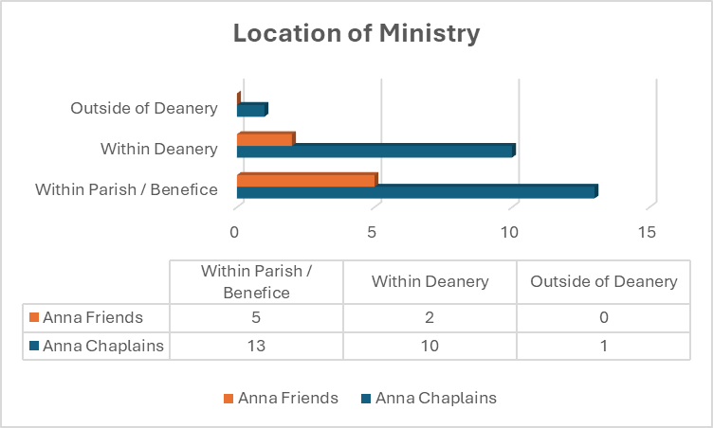

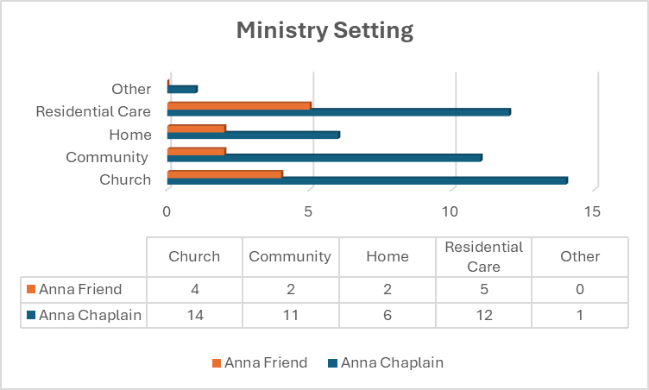

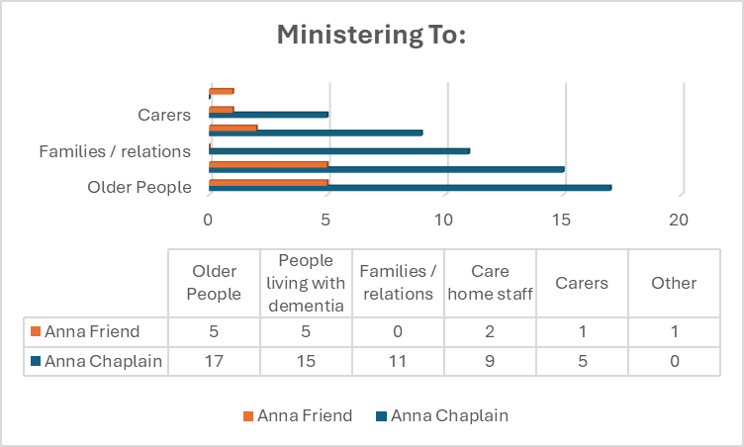

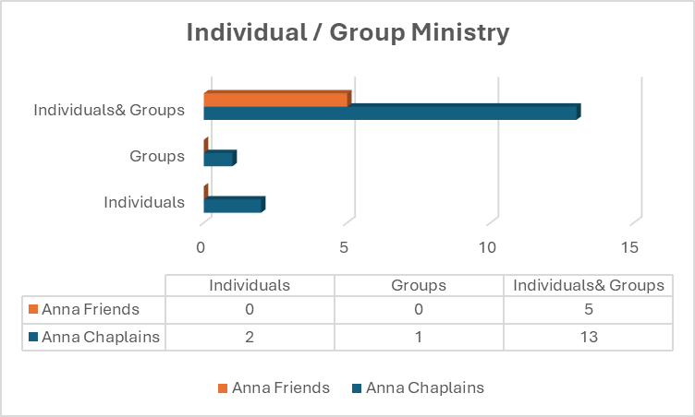

Anna Chaplains
Anna Chaplains were asked a set of questions; their responses are summarised here.
Frequency of Anna Chaplaincy Ministry
As volunteers Anna Chaplains are expected to commit to the equivalent of one day a week, it was clear from their responses that many give their time more generously. Their commitment ranged from one day a week to daily!
Where there were multiple care homes, an Anna Chaplain would typically attend each one over the course of a month as well as offering ‘on request’ visits.
What brings you joy in your role?
Typical responses included:
- Everything!
- The reaction from individual residents in care homes. “The smile when I enter a room
- Being a listening ear; the privilege and pleasure of hearing the personal stories of older people, especially those with dementia.
- Sharing the Christmas and Easter stories with care home residents, their families and staff.
- Interacting and engaging with older people, especially those with dementia.
- Seeing the visible response to hymns and Bible stories.
- Sharing in holy communion.
- Being appreciated and asked for prayer.
What do you find most challenging?
Typical responses included:
- Grumpy people.
- Cases of severe and advanced dementia.
- Intensity of encounters and feeling exhausted.
- Lack of interaction with care home staff.
- Being seen as part of the programme of entertainment in some care home settings; or as someone who could tick a box!
- Frustration with restrictions within some care homes, e.g. not being able to visit in residents’ rooms.
- Trying to gather a local team to support the ministry.
How would you like to develop your ministry over the next 6-12 months?
Responses varied, but there were some common ideas:
- Setting up new initiatives such as Messy Vintage, intergenerational activities.
- Recruiting more Anna Chaplains and Friends to share or support the ministry locally.
It is possible for Anna Chaplains to deliver local training for anyone interested in becoming an Anna Friend or volunteer in some other way. Support is available from the Anna Chaplaincy Working Group.

Local support for Anna Chaplains
Anna Ministry often goes un-noticed because it’s not a visible ‘up front Sunday’ ministry. Ideally Anna Chaplains should provide regular updates on their work to their parish clergy and PCC/s. We asked whether they felt supported by their local church/clergy team, this was their response:

- Some felt they were left to get on with it, with little financial or spiritual support.
- Some parishes were in vacancy, so priestly support was not often available.
- 100% of the Anna Chaplain respondents replied that they felt supported by the Anna Chaplaincy Network.
Any other comments
Comments included:
- Highlighting intergenerational work with CofE school and care home.
- Acknowledging own limitations, health etc.
- Need for more people to be involved in this ministry with older people, dementia sufferers, their families, friends and carers.
- Accepting invitations to share the work/give talks to churches, community groups and the deanery.
Anna Friends
Anna Friends were asked a similar set of questions; their responses are summarised here.
Frequency of Anna Friend Ministry
The role of Anna Friend was established to support Anna Chaplains; some complete the identical training, others a locally delivered course. Unlike Anna Chaplains, there is no set expectation with regards to the level of commitment for an Anna Friend. As would be expected, their responses varied greatly with some supporting their Anna Chaplain once a week, whilst others did this on a monthly or occasional basis.
What brings you joy in your role?
Typical responses included:
- Seeing the reaction of older people: being pleased to be seen; the smiles; seeing them relax.
- Listening, chatting, befriending, fellowship.
- Being able to support parishioners who are no longer able to attend Sunday church.
What do you find most challenging?
Typical responses included:
- Dementia and seeing it gradually taking a grip on people.
- Seeing people upset, disruptive or unable to speak. It’s tough when they are having a bad day!
How would you like to develop your ministry over the next 6-12 months?
Responses varied, but there were some common ideas:
- Developing a greater understanding of dementia.
- To see more Anna Chaplains and Friends.
- Continuing to support the Anna Chaplain.
Local support for Anna Friends
We were interested to know how supported Anna Friends felt, this was their response:

Yes | 4 | No | 0
Unsure | 1 | Rather not Say | 0
- The relatively small number of respondents may not reveal the full picture.
- Anna Chaplains may need support in their role as leaders of Anna Chaplaincy teams.
- 100% of the Anna Friend respondents replied that they felt supported by the Anna Chaplaincy Network.
Are there any areas of training support that you would find beneficial?
Most highlighted dementia and bereavement.
Any other comments
Comments included:
- The privilege of exercising this ministry and supporting the Anna Chaplain.
- Frustrations associated with ministering across-parish boundaries.

Parish Provision for Older People and Dementia Ministry
Being mindful that ministry with older people is not exclusive to Anna Chaplaincy we asked about other parish provision.
Does your parish have a named contact for older people / dementia ministry?
Ten out of the seventeen Anna Chaplains responded to say that they have a joint contact for dementia and older people ministry.

CAMEO – Come and Meet Each Other

* Congregational awareness, accessible buildings, signage…
** Large font orders of service, familiar hymns etc

Anna Chaplaincy is trademarked by BRF Ministries.

