Fresh Approach Collective Worship Planning
Year 3 Term 2: ‘Committed to…….’

Week 1 | Committed to helping those in need
Week 2 | Committed to Remembering  including Remembrance Sunday
Week 3 | Committed to creating a fairer world  including  Anti Bullying Week  Children in Need  https://www.anti-bullyingalliance.org.uk/anti-bullying-week  Suggestions from Christian Aid are aimed at KS2 so may need some adaptation if used. Suggestions from CAFOD are well suited to pupil led worship
Week 4 | Committed to praying for a better world  Build your Advent wreath ready for the following week using the themes of each of the candles as a focus for prayer:  Hope, Peace, Love, Joy
Week 5 | Advent: The Jesse Tree
Week 6 | Advent: The Jesse Tree
Week 7 | Christmas through the lens of Angels
The themes for this term encourage commitment to making the world a better and fairer place. We trust that this will help your school community to become more courageous advocates for improving the lives of others, following the example of Christians across the ages:
Dearest Lord,
teach me to be generous;
teach me to serve You as You deserve; to give and not to count the cost, to fight and not to heed the wounds, to toil and not to seek for rest, to labour and not to ask for reward save that of knowing I am doing Your will.
(St Ignatius Loyola 1491-1556)
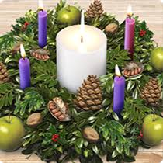
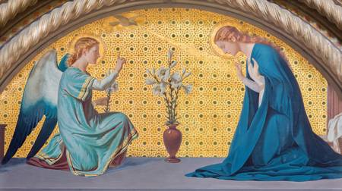
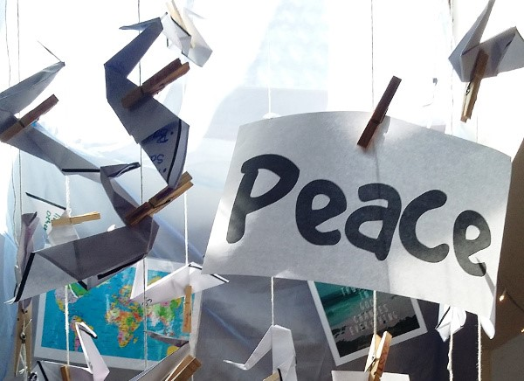
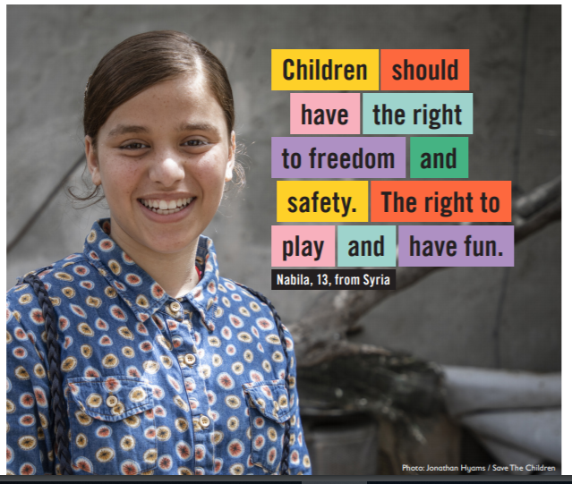
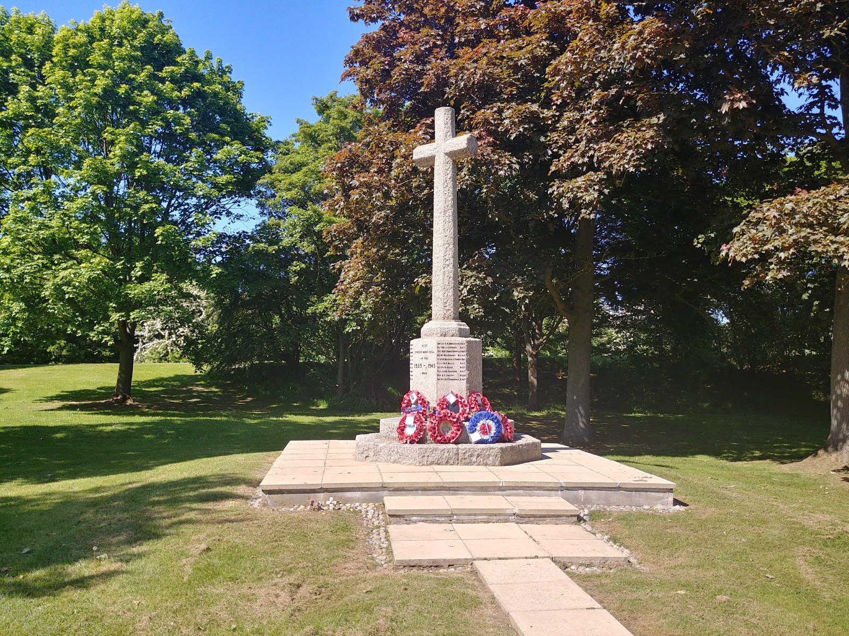
Liturgical colour | Monday  Whole School | Tuesday  Whole School | Wednesday  Whole School  Psalm Praise / Singing Worship | Thursday  Worship in the classroom | Friday  Celebration worship
Week 1  Committed to helping those in need | Florence Nightingale 1820-1910  John 5:12  This week gives an opportunity to look at ordinary people who did extraordinary things because they lived out what they believed. What they achieved continues to influence our lives today through health care, through systems to support the most needy in society and through our education system. We all have better lives because of them and what they believed!  I wonder why there have been hospitals called ‘Nightingale’ hospitals. https://www.youtube.com/watch?v=YKZlYuMwwMs is a summary of Florence Nightingale’s life and includes the importance of her Christian faith. You may wish to tell her story yourself.  I wonder why Florence felt that her work was an important way of living out her faith. I wonder if we are brave enough to challenge the things that are not right around us as Florence did. I wonder what Florence meant when she wrote "There will be no heaven for me, nor for anyone else, unless we make it, with wisdom carrying out our thoughts into realities ... We are to learn, first, what is heaven, and secondly, how to make it. We are to ascertain what is right, and then how to perform it."  O God, keep our nurses strong and healthy in every area of their lives. Help them to not grow weary in doing good. Do not let them doubt themselves and their purpose in life. Bless their hearts and fill them with your strength whenever they start coming close to being empty. Amen. | Dr Thomas Barnardo 1845- 1905  Proverbs 31:9  https://www.youtube.com/watch?v=FzTGp8PasZ8 (original footage of Barnardo’s funeral) - I wonder what is happening here. I wonder why there are so many people at this funeral.  https://www.youtube.com/watch?v=EEyvc9_BrKs – from 5 mins to 7 mins 35 sec explains how Barnardo set up his first home for destitute boys – later homes for girls would follow. Children had lived like this for a long time if they had no family or carers. I wonder what moved Thomas to act in this way and change the way things were done and attitudes towards the poor.  Dr Barnardo’s words might help us to understand this. ‘I have always felt a positive duty was laid upon me, to stir up the minds of Christian people generally to a greater sense of their responsibility’. He was a man of vision and action. He did not just see a need, but took immediate steps to address it.  The work of Barnardo’s continues to change the lives of children and young people today (if appropriate):  https://www.youtube.com/watch?v=VLAP-PYaJAY  Dear God, Thank you for people like Thomas Barnardo. Thank you for people who do not look the other way when someone needs help but instead go out of their way to be helpful. Please help us to follow good examples, to be people who care and to put our care into action. AMEN | William and Catherine Booth  I Timothy 6:12  I wonder what an army does best. I wonder if there are different kinds of armies. I wonder if there are different kinds of ‘fighting’.  Tell the story of William and Catherine Booth  https://www.youtube.com/watch?v=_IpyA1_e76E  I wonder what they were fighting for and fighting against.  https://www.youtube.com/watch?v=o4W_XfDz3iY  ‘I’ll fight’ – listen to the words of William Booth and of people today. I wonder what you might fight for.  https://www.youtube.com/watch?v=fIQGUj70np4  The Salvation Army also uses music, often brass bands to share the Gospel.  https://www.youtube.com/watch?v=CqGHVXfOFoo  I wonder what battles you think we should ‘fight’ as individuals and as a school.  Dearest Lord,  teach me to be generous;  teach me to serve You as You deserve; to give and not to count the cost, to fight and not to heed the wounds, to toil and not to seek for rest, to labour and not to ask for reward save that of knowing I am doing Your will.  (St Ignatius Loyola 1491-1556) | Robert Raikes 1736-1811  Psalm 119:105  I wonder if you are thankful for your school and your education. I wonder if you are thankful to come to school every day. I wonder how schools started and when?  https://www.youtube.com/watch?v=LTu8fqgih2c information for teachers, suitable for older pupils. Robert Raikes’ Christian faith was the reason for his setting up his Sunday schools but the education he offered was both religious and practical.  robert-raikes-and-how-we-got-sunday-school to help to tell the story as appropriate to age group  Robert Raikes said ‘The world marches forth on the feet of little children’. I wonder what he meant by this. I wonder why he believed that God wanted him to educate children who were poor and disadvantaged.  Lord God we pray your blessing on all who work in education, that they may see the kingdom come; We pray your blessing on all who influence education, that they may see your will be done; We pray for all who are receiving education, that they may receive their daily bread; We pray for all those who have received education, that they may share their gifts with all your children; Amen | CELEBRATE  Genesis 1:31  Those who are committed to making the world a better place. Focus celebrations on those who have made your school a better place over the past week.  A song to reflect that we can make the world a better place, the place that God intended, when you believe:  https://www.youtube.com/watch?v=NieC8KA0EvI
Week 2  Committed to remembering | REMEMBERING IS IMPORTANT  Joshua 4:4-8  This week, we will be thinking about Remembrance in different ways.  I wonder why it is important to remember. Can you tell a partner about a memory that makes you feel happy? I wonder if there are also some sad memories too. Memories are important because they are a link to the past that can affect the future.  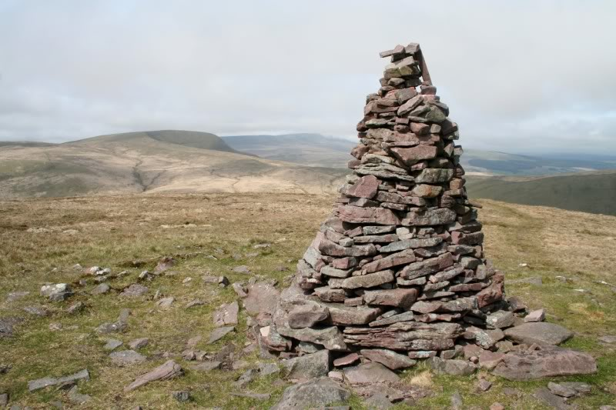  Show a picture of a cairn. I wonder if anyone has seen one of these or if anyone has added a stone to something like this.  Tell the story of Joshua’s memorial. I wonder why it was important for the Israelites to mark and remember this moment as God’s people entered the Promised Land.  A daily act of remembrance for today -every day at 8pm, this ceremony of remembrance is held at the Menin Gate  https://www.youtube.com/watch?v=W6MqLCqNroE  Dear God  Thank you for our many positive memories. Be with those who have sad memories at this time of year and help us to make the world a better and a safer place. AMEN | REMEMBRANCE - MEMORIALS  Revelation 21:4  You will need images of a large war memorial eg Theipval, the Somme, your local war memorial, of someone on your local war memorial with details of their life, also a poppy  I wonder who is remembered on each of these memorials. I wonder why these are important to people today. Focus down from the large numbers to the local numbers to the single person that you have found out about. You could ask a child to stand up to represent that one person and then ask others around them to stand up to represent that person’s family, their school friends, their work colleagues, neighbours, Army friends etc. This might be almost all of those gathered. In remembering this one person, we remember how many people would have been affected by their death in the war in which they fought. If you then think of multiplying the numbers back up to the local war memorial and then the French memorials – I wonder how many people were affected by the Two World Wars and are still being affected by wars today.  Reflect : each name is a life and each life lost is a heavy loss for their community. That is why we keep remembering as a community today with thanksgiving for those who served and for those who lost people they loved.  Dear God, we pray for everyone affected by wars today and by wars of the past. Help us to remember and to work for peace – at home, at school and always. AMEN  Nimrod played at the Cenotaph  https://www.youtube.com/watch?v=FFSg6IKsDkA | REMEMBERING THAT PEACE IS IMPORTANT  Philippians 4:6-7  I wonder what all of these symbols have in common. Explore each symbol through paired discussion and wondering questions.  Use all or select: A dove. A dove with an olive branch in its beak. A rainbow.  Peace sign designed in 1958. Origami cranes. Ankh. Handshake.  Also invite suggestions from pupils  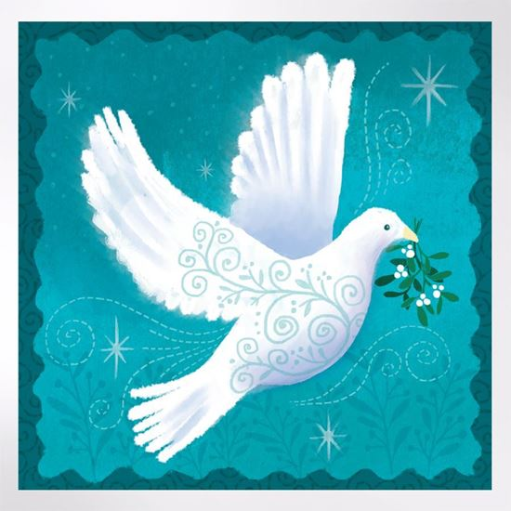  Also think about the peace which Jesus can bring – I wonder what ‘the peace that passes all understanding’ in the Bible reference might be.  I wonder why there are so many symbols associated with peace. I wonder why the world needs so many reminders of peace. I wonder why these reminders are important this week.  Listen to a musical reminder about peace: https://www.youtube.com/watch?v=Eve2y-P-Zjk  Share the peace with each other if you can.  Pray for the peace of the world by naming different countries in the world in particular need of the peace of Christ just now. | THE POPPY OF REMEMBRANCE  John 15:13  Explore the symbolism of the poppy in an age-appropriate way in your classroom.  For younger children:  https://www.youtube.com/watch?v=wOT5CDnYHEs  History of the poppy  https://www.youtube.com/watch?v=AGCHk5_2skY  https://www.youtube.com/watch?v=pAWfiTM2KsA  More detail  https://www.youtube.com/watch?v=jOJptRG7aJg  People see the poppy in a variety of ways:  It is the symbol of a charity fund that still cares for those who were bereaved or injured in wars.  It is also a way of remembering the sacrifice made by many who fought against those who would take away democratic freedoms from our world.  It is a sign of hope, inspired by the poppy fields in Belgium, where the flowers grew on the very land that had, during the First World War, been battlegrounds.  It can also be seen as a 'vote for peace'.  Practical prayer spaces ideas – Remembrance ribbons  https://prayerspacesinschools.com/resources/remembrance-ribbons/  Peace  https://prayerspacesinschools.com/resources/the-beatitudes-peace/ | CELEBRATE  the ways in which you mark Remembrance  John 15:13  Take time to both celebrate and reflect. You may have a special service at your local war memorial as part of a wider community event or have a way that you mark this as a whole school.
Week 3  Committed to creating a fairer world | ANTI-BULLYING WEEK  Ephesians 4:29  II Timothy 1:7  Matthew 7:12  Use the material on this year’s website  https://www.anti-bullyingalliance.org.uk/anti-bullying-week which will help you to adapt the message to your particular context.  Teaching from the Bible to support this is given above.  You might also like to look to particular role models to encourage the community to be united and committed against unfairness and inequality of which bullying is an example:  https://www.youtube.com/watch?v=gDZK09AUXT8  https://www.youtube.com/watch?v=9iQVMWGE3_s – relevant parts  Father God, You have placed Your children in a world where people push and shove to be first. But you have called us to view life from a perspective that considers others to be as important as ourselves. May our love and consideration for others grow and may the example of Jesus guide us as we make decisions that affect others and ourselves. Amen.  Encouragement for those having a hard time: https://www.youtube.com/watch?v=6gpoJNv5dlQ | A BETTER WORLD THROUGH FAIR TRADE  Matthew 25:14-30  Here are suggestions for acts of worship which explore unfairness in the world and what you might do to make things a bit more equal:  https://www.christianaid.org.uk/get-involved/schools/fair-trade-assemblies  https://cafod.org.uk/education/education-resources/fairtrade-school-resources  These suggestions might make a good starting point for pupil leaders to plan an act of worship.  I wonder what the teaching of Jesus says about what we are given. I wonder why we are not all given exactly the same in our lives. I wonder if there are ways that we can make the world more equal and fairer for everyone.  Dear Lord, we ask your blessing on all who are involved with Fairtrade, lifting before you:  • producers as they grow their crops and craft their works. Bless them, we pray, in their endeavours and grant them wisdom and discernment as they make decisions about how to use the benefits of Fairtrade. • people who transport Fairtrade goods to market. Grant, we pray, that they, too, may be fairly treated.  • those who import and retail Fairtrade goods. Grant them, we pray, a genuine commitment to fairer trade for all.  • all of us who shop where Fairtrade goods are for sale. Grant us an understanding of the impact of our choices.  We ask all these things in the name of Jesus Christ. Amen | A BETTER WORLD THROUGH EDUCATION  Proverbs 16:16  I wonder why it is important to be educate. I wonder how it helps you in your life now and how it will help you in your life in the future. I wonder if it is more important to be clever or to be wise.  Try and think about what is the same and what is different in terms of education in different places in the world and how we could help to even things up  https://cafod.org.uk/education/primary-teaching-resources/one-day-one-world-videos  Father God, lay a blanket of protection over children who cannot attend school, especially those whose educations are disrupted by conflict, emergencies, and natural disasters. In Your mercy, we pray for You to provide opportunities for learning so that through education, children find the hope and skills for a better future.  Amen  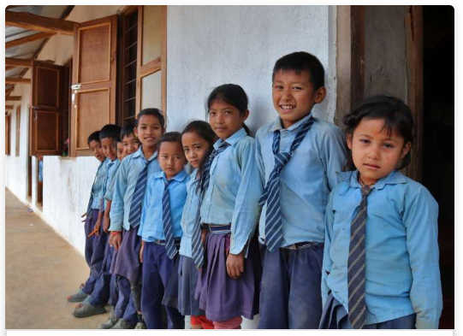 | A BETTER WORLD ON OUR DOORSTEPS AND BEYOND  Matthew 19:13-15  I wonder what Jesus thought about children. I wonder if he thought that they are important. I wonder if he showed that they are important.  Sections of this charter can be used in age-appropriate ways to think about all children locally, nationally and globally. Explore the idea of universal entitlement and rights and take time to pray for those who do not enjoy these things. https://www.savethechildren.org.uk/content/dam/gb/reports/humanitarian/uncrc19-child-friendly.pdf  Dear God, Thank you so much for all the precious children in this world. We know that they mean so much to you. We bring to you all of the wonderful work being done to release children from need, poverty and unfairness. We pray that you would bless every pair of hands that works for you to make children’s lives better day by day. Amen. | CELEBRATE  James 2:14-17  You may mark Children in Need in your school – remembering and responding to the needs of others who need your help.  https://www.bbcchildreninneed.co.uk/  All of the organisations that we have thought about this week see need around them and respond with compassion.  Take time to give thanks for those who respond with care, kindness and compassion in your school, your community and the wider world.
Week 4  Committed to praying for a better world | THE CANDLE OF HOPE  Romans 8:24-25  Take this week to build your Advent wreath ready for the following week, adding a candle each day for the four traditional advent themes which are  1. God's people, The Candle of Hope.  2. The Old Testament prophets, The Candle of Peace.  3. John the Baptist, The Candle of Love. 4. Mary the mother of Jesus , The Candle of Joy.  For each day, there is a suggestion for a prayer station that you can ‘build’ and ‘model’ during the act of worship and then continue in a common area of the school or in different classrooms according to age group. Prayers written during the week might then be brought together for Friday worship.  The Bible verses remind us to pray and wait patiently for the things that we cannot yet see as we pray.  For your hope prayer station, you will need:  • A map of the world or a globe  • Post-it or sticky notes  • Pens  • Printed instructions  Stick the map of the world to a wall. If you have chosen to use a globe instead, find an area in the room that works best. By the map, or next to the globe, place your pens and sticky notes. To use the prayer station: Use news items and stories from around the world which need our prayers of hope. There is so much turmoil and hopelessness throughout the world today. Pray for God’s Kingdom to come on earth as in heaven. Model how the community can pick up a post-it note and write down their HOPE for that nation and stick the post-it note to the map/globe. | THE CANDLE OF PEACE  John 14:27  I wonder why peace was so important to Jesus and why he wanted to leave peace with his disciples. I wonder why we see situations in school, in our community and around the world where peace is lacking. I wonder why peace is not a natural part of the way in which people live and act. I wonder if you have any ideas about how this could be changed.  Use this idea to model how to pray for peace:  https://cafod.org.uk/education/primary-teaching-resources/peace-liturgy  This could be led by your pupil worship leaders.  Encourage pupils to add doves of peace to the prayer station idea presented yesterday.  https://prayerspacesinschools.com/resources/dove-of-peace/ | THE CANDLE OF LOVE  John 13:35  I wonder if you have shown that you love someone this week. I wonder if you know anyone who is lonely or unhappy who especially needs your love just now. I wonder what Jesus meant by his words in today’s Bible verse. Happy times of celebration can be a lonely time for many people, and a time when some people can feel stressed and unloved as they see others being happy and being loved.  For this prayer station you will need: • A container  • A number of baubles and a small tree  • Permanent markers  • The Bible verse  Place the container in an area of the room and fill it up with baubles together with the permanent markers.  1. Spend some time thinking of someone you know to whom you could show love in the next few weeks.  2. Ask God to draw near to them and to show you how you can bless them. 3. Choose a bauble and write on it something that you love about that person, something encouraging or just their first name. Hang it on the tree.  4. Nearer to Christmas, if appropriate, take the bauble home with you and give it to that person, so they can hang it on their tree or just keep as an encouragement. | THE CANDLE OF JOY  Luke 2:10-11  Although it is a while to go to Christmas, the message of the angels is one of the most joyful in the Bible (see verses above) and can be used to express the Christian joy at any time of the year. I wonder what brings you joy. I wonder how you seek to bring joy to others.  For this prayer station you will need:  • Sheets of paper  • Tape to stick it up  • Pens/Markers and/or paint and paint brushes  • CD player and CDs or iPad etc.  • The Bible verses  Provide a large area of paper. Protect the surrounding area as needed.  1. It is so important to celebrate God’s goodness. Write, or paint your praise, celebrating everything that gives you joy, including the Good News that is Jesus.  2. If might help you to listen to joyful music as you express your thoughts to God or take time to reflect.  From The Messiah (Handel)  https://www.youtube.com/watch?v=04KcKPoTmBU  or  https://www.youtube.com/watch?v=av4PHBibTZ8 | CELEBRATE  John 8:12  Take time to celebrate the hope, peace, love and joy you have seen around the school this week.  Use some of the prayers that have been written as part of your worship.  Say a prayer of blessing for your completed Advent wreath which you will start to use next week.  Lord God, bless this wreath and bless us as well. May this wreath remind us of the hope, peace, love and joy that Jesus brings into the world. We ask this through Christ our Lord. Amen
Week 5  Advent | Advent: Jesse Tree  Isaiah 11:1  You will be using the idea of the genealogy (ancestry) of Jesus to lead up to Christmas and to develop understanding about how Christmas and the concept of Incarnation fit into the Big Story of the Bible. This can also be related to the Big Frieze from Understanding Christianity to make appropriate links with what pupils already know (as long as this does not become too complicated!)  https://www.youtube.com/watch?v=5qKuDIBvKf4 – this is an explanation of the Jesse tree for teachers. Set up a way of adding to a Jesse tree in school/your classroom each day – perhaps your pupil worship team can help with this.  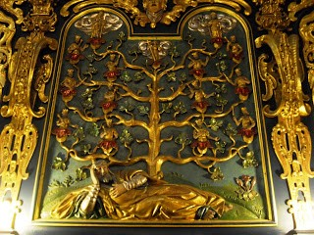  Use an image from a cathedral/church as above or similar  https://emmanuelbristol.org.uk/2016/09/21/what-on-earth-is-a-jesse-tree/  I wonder what you can see here. I wonder what questions you have about what you can see. (paired conversations). I wonder what is happening right at the bottom of the image. – relate this to Isaiah 11:1  Explain how you are going to reveal a different part of the Big Story of the Bible each day during Advent, to help you to understand how Christmas ‘fits in’. To help you to journey through Advent to Christmas, you might want to reveal the different characters in the way that you do with an Advent calendar, as well as using your Advent wreath. | Adam and Eve (Creation/Fall)  Genesis 2:4-3:24  Add to Jesse Tree: Tree with fruit/apple  It will not be possible to use all the suggested stories/characters over this Advent period, so here is a selection of nine of these - which you may wish to vary for your context.  The key things for these 2 weeks is to tell the stories well and to relate them to the Big Story of the Bible. Each day will provide some suggestions to help you but you will have your own ideas about what works best.  Clips to show – variety of approaches  https://www.youtube.com/watch?v=TuLRzlMtcpU  https://www.youtube.com/watch?v=D7LZnMHYrmY up to 2 mins 30 secs  https://www.youtube.com/watch?v=Kg2lkCxjMg8 up to 3 mins  Alternatively, choose an appropriate image to help pupils to wonder. There are many options from across the ages. I wonder what is happening here. I wonder who the people might be in the picture. I wonder how you know. I wonder what the key messages are from this account in the Bible. I wonder why it is the first story that to add to the Jesse Tree.  Add your symbol to the Jesse Tree  Thank you, Creator God, for making our wonderful world. Thank you for creating humans, thank you that we are all different, with different gifts and skills. Help us to remember that your promises are true and that you are with us every day. Amen. | Abraham (People of God)  Gen 12:1-7 and 15:1-6  Add to Jesse Tree: Tent  Make sure that pupils understand that God called Abraham (Genesis 12) and that Abraham responded to that call, wandering as a nomad and living in a tent because of his obedience. This is the context of the story of God’s Covenant with Abraham (Genesis 15).  This clip expresses the idea of the Covenant/agreement with Abraham which is the focus of the readings  https://www.youtube.com/watch?v=rDz-7OX4C9k  This clip focuses on waiting and on God who keeps his promises  https://www.youtube.com/watch?v=-rrcqpgEoug  Alternatively find an image for ‘God’s promise to Abraham’ to help you to think about and to tell the story. I wonder who this might be. I wonder why he is looking up to the sky/at the stars. I wonder why this picture is called ‘God’s promise’. I wonder why this tent is an important symbol for our Jesse Tree.  Add the new symbol to the Jesse Tree  Pray a prayer of THANKS – Thanking God for his call to walk with him and his promise to bless us.  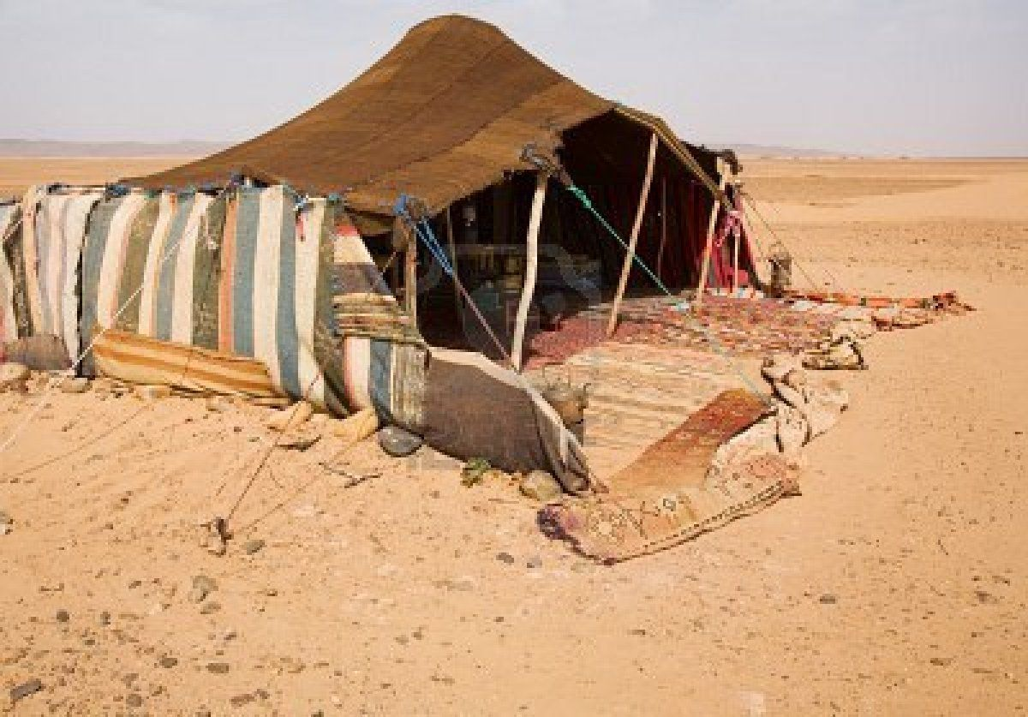 | Moses (People of God)  Ex 2:1-4:20  Add to Jesse Tree: Burning Bush  Set the context of the story. I wonder what you know about Moses. I wonder how his life began and why he became a shepherd in the desert.  Then pick up the story  From The Prince of Egypt  https://www.youtube.com/watch?v=g5BQWubuC8g up to 4 mins  Shorter animation  https://www.youtube.com/watch?v=LZpYMr-Ed0Q up to 2 mins 11 secs  Alternatively, use a selection of images as appropriate  http://www.freebibleimages.org/illustrations/moses-burning-bush/  I wonder why the bush was on fire but did not burn up. I wonder why Moses took his shoes off and hid his face when God spoke to him.  I wonder how this story is linked to the promise of God to Abraham.  Add the new symbol to the Jesse Tree.  God is with us and will help us. Invite people to think of how God helped Moses after this dramatic encounter with him. Ask the school community what they have need for and what they want God to help them with and pray for these things. | CELEBRATE  Joshua (People of God)  Joshua 6:1-20  Add to Jesse Tree: Ram’s horn trumpet  https://www.youtube.com/watch?v=ruqGz1480uc up to 3 mins 12 secs  https://www.youtube.com/watch?v=wfPOHQOc3uI – song  After Moses had led the people of God to the edge of the Promised Land, Joshua was the one who led them across the River Jordan to take Jericho. This was a great victory and something to celebrate.  I wonder what personal ‘victories’ we can celebrate this week.  Say a thank you prayer for all of those ‘victories’ as you add the ram’s horn to the Jesse Tree  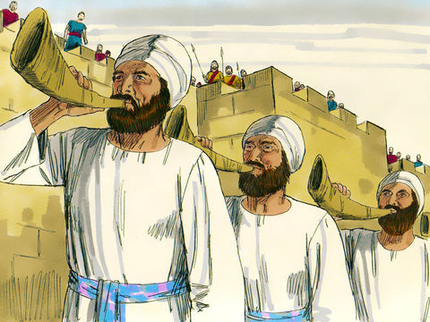
Week 6  Advent | Ruth (People of God)  Book of Ruth  Add to Jesse Tree: Sheaf of corn  Recap on your Jesse Tree so far making links with the Big Story of the Bible as an introduction to the stories and symbols for this week.  A story book with illustrations read out loud  https://www.youtube.com/watch?v=PEljSjqySDU  Quite a complicated story! This clip uses ‘we’ but it does make the links to Jesus well  https://www.youtube.com/watch?v=irThVpdeSXk  Alternatively find an appropriate version in a Children’s Bible  I wonder how you would describe Ruth in three words. I wonder what you like best about her. I wonder if she would have made a good friend. I wonder why we remember Ruth on the Jesse Tree.  Songs based on the words of Ruth promising to stay with Naomi  https://www.youtube.com/watch?v=saoPuv72mYw  https://www.youtube.com/watch?v=79KUTX-hE18  Add the new symbol to the Jesse Tree  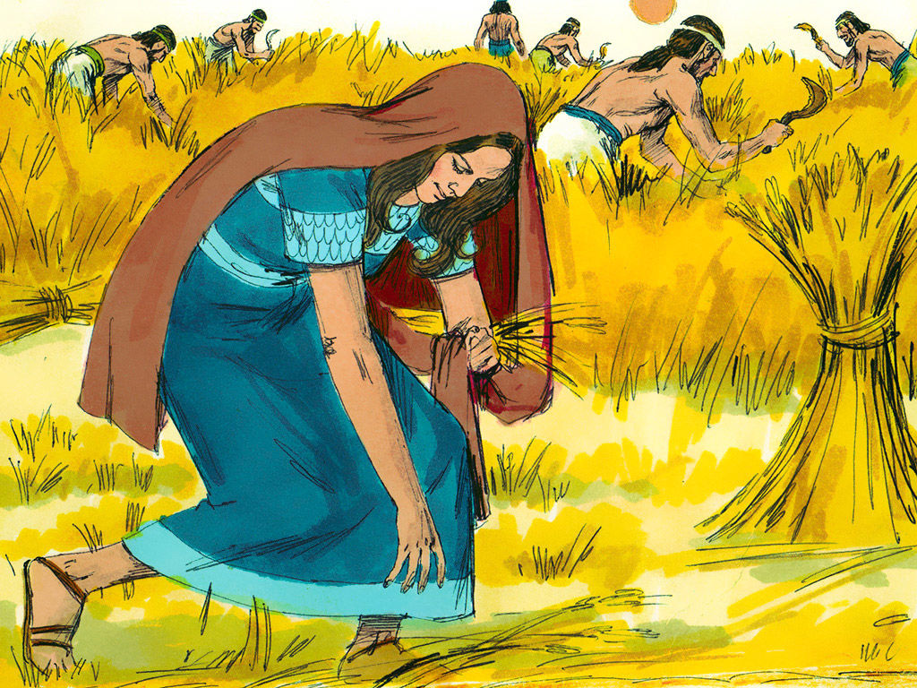 | King David (People of God)  I Sam 16:1-3  Add to Jesse Tree: 6-pointed Star of David  I wonder why King David is the next person we are thinking about. King David was the great grandson of Ruth. He became king after Saul, who was the first king of Israel. Saul had not obeyed God and so Samuel was sent to find the next king of Israel to replace Saul – this was David.  A short animation  https://www.youtube.com/watch?v=g9Obyj-BPWE  A reading of the story with illustrations  https://www.youtube.com/watch?v=RJa-X5BX36k  I wonder why David was anointed as the king after Saul. I wonder what made him a good king. I wonder if you know where David lived and why this might be significant in the Big Story of the Bible.  For possible origins of the Star of David:  https://www.newworldencyclopedia.org/entry/Star_of_David  Add the new symbol to the Jesse Tree  Thank you, Lord, that you see beyond the outward appearance into a person’s heart as you did for David. May my face reflect love and joy and bring encouragement and confidence to everyone I encounter today. Amen | Isaiah (Kingdom of God)  Isaiah 11:1-11  Add to Jesse Tree: Tree stump with one branch or original image at the base of the Jesse Tree (week 5)  I wonder what a prophet is. I wonder what a prophecy is. I wonder why this passage is read at Christmas services. Isaiah was an important prophet in the Big Story of the Bible. He looked forward to how the world might look in the future – he looked forward to the Kingdom of God and he used pictures to talk about what that Kingdom might look like and talked about the one who would bring that Kingdom (the shoot from the stump of Jesse that Christians believe is Jesus)  Song based on v 6-9 with images  https://www.youtube.com/watch?v=RQCwX5O1Of8  Alternatively, with some support, the pupil worship group could prepare some images to go with the words of v6-9 and talk about them.  I wonder what sort of world you imagine when you hear the words of Isaiah and look at the images. I wonder if it is a world that would be good to live in. I wonder if you can think of any other pictures for the world that are similar to the ones you have seen. I wonder if you could draw them for a display here in school with a prayer for a better world.  Add the new symbol to the Jesse Tree | John the Baptist (Kingdom of God)  Matt 3:13-17  Add to Jesse Tree: Scallop shell  I wonder why we are putting a scallop shell on our Jesse Tree today. Talk with a partner about what this might symbolise.  Here, children are talking about John the Baptist – it links Jesus and John in various ways  https://www.youtube.com/watch?v=cROnNgHCYQw  Alternatively, tell the story of who John the Baptist was and what he was saying before Jesus came to him to be baptised (repent for the kingdom of heaven is near)  I wonder what was most important to John. I wonder how there might be a link between the world that Isaiah talked about and the world which John wanted to see. I wonder how the birth of Jesus fits into what Isaiah and John were talking about.  Add the new symbol to the Jesse Tree  God for whom we watch and wait,  you sent John the Baptist to prepare the way of your Son: give us courage to speak the truth and to hunger for justice, in the name of Jesus Christ our Lord. Amen | CELEBRATE  Jesus (Incarnation)  Luke 2:1-8  Add to Jesse Tree: Jesus in the Manger  Add the final symbol to your Jesse Tree as part of your special school celebrations for Christmas this year and make the connections between the symbols with your community.  Some music for reflection: Like a candle flame – two different versions  https://www.youtube.com/watch?v=teZaQUKjx24  https://www.youtube.com/watch?v=TGAXlGBB10M  Lord Jesus, Light of Light,  you have come among us.  Help us who live by your light to shine as lights in your world. Glory to God in the highest.  Amen.  Almighty God, as we prepare with joy to celebrate the gift of the Christ-child, embrace the earth with your glory and be for us a living hope in Jesus Christ our Lord. Amen  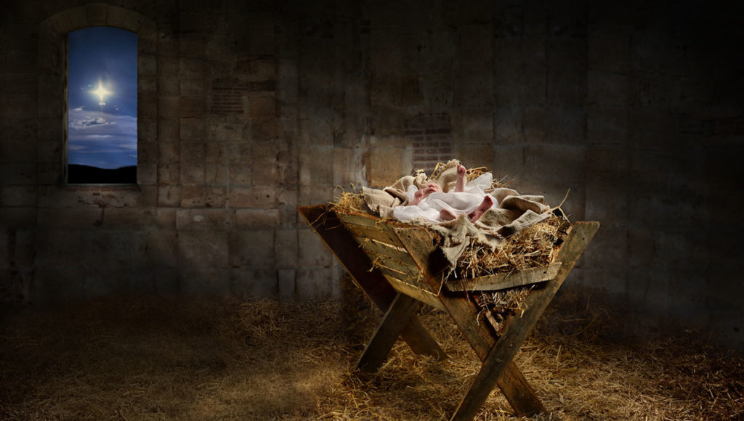
Week 7  Christmas | ZECHARIAH AND THE ANGEL  Luke 1:5-25  Throughout the Christmas story, angels appear with important messages, they play a key role in the whole story. Together you can explore the Nativity Story, focusing on the actions of the angels. Before you begin, create a display of representations of angels, using a variety of pieces of artwork from around the world from different periods of history.  I wonder what an angel is… what they do….where do they come from. I wonder what an angel looks like. How do you know? There are 273 references to angels in the Bible. I wonder if you can remember any stories that include them.  I wonder if you have said the phrase " I  don't believe it?’ Hamsters run up to 8 miles a night on a wheel. An ostrich's eye is bigger than its brain - these facts are true but hard to believe. Zechariah had such a surprise one day, brought to him by an angel, that he cried out the words "I don't believe it! How can  that happen?"  Tell the story of Zechariah and the angel in the temple using an appropriate version or use a clip such as  https://www.youtube.com/watch?v=FJapAoSzkBY  https://www.youtube.com/watch?v=490SDWdIG3U up to 2mins 13 secs  Dear God, very often if we have not seen something or do not fully understand something, then we do not believe it to be real or possible. Although we may never have met an angel, the Bible says that they are your special messengers. As we prepare for Christmas, help us to listen carefully to the words of the angels and learn more about your love for us. Amen | MARY AND THE ANGEL  Luke 1:26-38  I wonder what happens when someone taps you on the shoulder. - do you jump? Talk  about situations when someone has spoken to you or touched you and given you such a surprise that you jumped or you might set up a scenario/role play like this.  Today's story is about a surprise delivered by the Angel Gabriel. Use paintings of the Annunciation – it has been a popular episode with artists for many centuries. Find an appropriate retelling, use drama, or a suitable clip:  https://www.youtube.com/watch?v=VrYvuYwPAvU  https://www.youtube.com/watch?v=k2Ah-SbuqjQ (for older pupils)  Emphasise the surprise of Mary. She probably 'jumped'. Then Mary said yes! An angel from God ‘tapped her on the shoulder’ and said “God wants you to be the mother of his son, Jesus” and she said yes! What a brave thing to do. I wonder how many of us would say yes if God came and tapped us on the shoulder and asked us to do an amazing job.  We pray today, Lord, that you would bless us all with the courage of Mary. We pray that we will always be quick and willing to do your work so that 'your kingdom will come’, here on earth as it is in heaven' In Jesus’ name, Amen  Traditional Basque Carol  https://www.youtube.com/watch?v=L-Rv-J46gvM | JOSEPH AND THE ANGEL  Matthew 1: 18-25  I wonder what it feels like to be confused. I wonder what sort of things confuse us and why. Joseph was confused by the message that Mary had received from Gabriel. So God sent an angel to speak to Joseph in a dream – Matthew 1: 18-25.  Show the children a picture of Joseph with a troubled face. Explain that Mary has just told Joseph her wonderful news. Joseph is feeling very puzzled - he has promised to marry Mary but now he is not so sure if he should. Follow on by showing a painting of Joseph lying asleep being visited by the angel, eg  https://seedsoffaith.cph.org/2015/12/24/new-testament-1-lesson-5-an-angel-visits-joseph/  God sends an angel to speak to Joseph in a dream. The angel tells Joseph not to worry, that he must marry Mary and that she will give birth to a son. The angel tells Joseph to name the child Jesus, and that Jesus is the Son of God. When Joseph woke up, he did exactly as the angel had told him to. I wonder how Joseph felt when he awoke.  Sometimes we all become fearful,  worried and confused about things. You may wish to mention some examples that would be relevant to the children. In this time of quiet, remember that God is with us always, helping us to overcome worries and understand things more clearly.  Be sensitive to the fact that some children may want to talk through their worries later.  Peaceful music might be used  https://www.youtube.com/watch?v=unih2f-BGTA | THE ANGELS AND THE SHEPHERDS  Luke 2:8-20  You might want to set the scene like this or similar: Ask the children to close their eyes if they are happy to do this and imagine that they are shepherds sitting on a hillside, gathered around a fire with their friends. It is dark, they are laughing and sharing stories. In the distance they can see the lights of a town. On the hillside surrounding them are the sheep they are watching and every now and then, they can hear them bleating. They have had a good day and are feeling very happy. Suddenly! There is a flash of an incredibly bright light. Clash a cymbal or bang a drum, startling the children and hopefully they will grasp something of the surprise of the shepherds.  Tell the story as is best for your context perhaps using this  https://www.youtube.com/watch?v=sGak3d7HOck  I wonder how the shepherds felt  when the angels appeared. I wonder what you would have done. I wonder how the shepherds felt when they walked into the stable. I wonder what they did after they left the stable.  Dear God. In the midst of all the busyness of Christmas, we pray that we will not forget to be like angels and tell everyone about the real meaning of Christmas. Amen | End of Term – A time for a special celebration for your school and your families  Luke 2:10-11  Some music for the theme of the week for a musical celebration  Angels we have heard on high  https://www.youtube.com/watch?v=rRHuETZuLEo  Hark the herald angels  https://www.youtube.com/watch?v=pyXucFzLXwA&list=RDFn2wyKc_bUw&index=8  https://www.youtube.com/watch?v=YyJt0Qeo7dU&vl=id  John Rutter Angels’ Carol  https://www.youtube.com/watch?v=rYYT52KIuzs  John Rutter Shepherd’s Pipe Carol  https://www.youtube.com/watch?v=ousLBf0q1y8  Shout for joy  the whole earth,  and everything within.  Rejoice!  For Light has come into the world  The mountains sing,  the seas resound  to the praise of your name.  Salvation  once promised is here on earth  The angels' song  rings in the air,  a child has been born.  Hallelujah!  The Saviour of the world is here

