New Managing Safeguarding Allegations
Short Summary.

Quick Takeaway
Every safeguarding case follows a structured six-step process—from fast triage and compassionate support to formal decision-making, tailored intervention, and careful closure with ongoing learning. The Diocesan Safeguarding Officer coordinates each step, statutory agencies do necessary investigations, and the church ensures safety and accountability throughout.
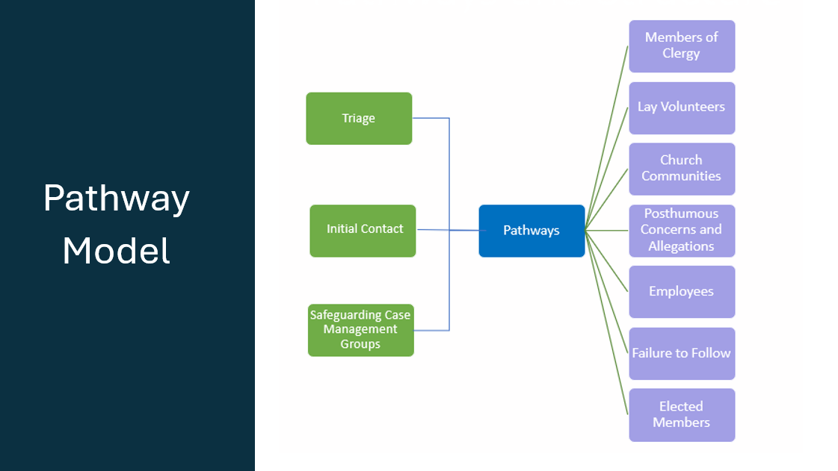

Key Principles
- Put victims first – Listen and support those affected.
- Act quickly and clearly – Concerns must be taken seriously and reported without delay.
- Follow the law – Cooperate with police and local authorities.
- Fairness for all – Support the person facing the allegation and ensure a proper process.

Roles and Responsibilities
- Anyone who hears a concern must report it immediately.
- The Parish Safeguarding Officer (PSO) or Incumbent tells the Diocesan Safeguarding Officer (DSO).
- The DSO leads the response, works with other agencies (like police), and keeps records.
- The bishop and diocesan team support decision-making and risk management.

Primary significant change
- Introduction of a ‘Failure to Follow’. This relates to a failure to follow the Church of England’s Safeguarding Code of Practice.
- The key messages in considering the Failure to Follow pathway the following:
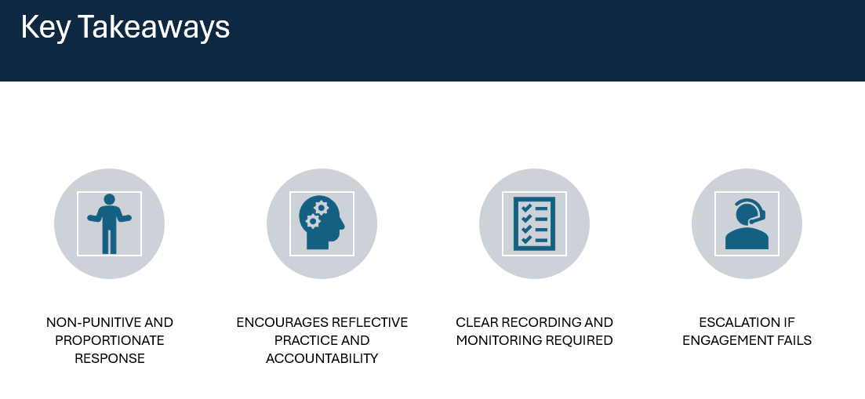
- Escalation in terms of the Failure to Follow is only considered if it is felt by the DSO that there is a lack of learning.

Final Messages
- Contact the police using 999 if someone is at immediate risk of harm
- This summary is not exhaustive please contact the DSO when an allegation is made and they lead on the Managing Allegations processes and will assist in helping church officers and bodies understanding the processes being undertaken and why.
- The full guidance can be found here

The Church of England's Safeguarding Code of Practice is a set of guidelines designed to protect children and vulnerable adults within the church community. It outlines the responsibilities of church officers (all clergy, paid staff or any form of volunteer) and bodies to ensure a safe environment, including the requirement to report concerns promptly and cooperate with statutory agencies like the police. The Code of Practice is legally binding, meaning that all church officers must adhere to it, and failure to do so can result in disciplinary action under the Failure to Follow process.

