
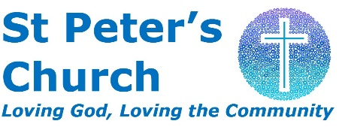
working with

Youth and Outreach Worker – Full-Time
Do you have a passion to see young people come to faith and grow in their faith in Jesus?
Do you have a heart to see and equip young people to fulfil God’s purpose for their lives as His followers?
Are you passionate about seeing the church reach out into the community blessing the lives of young people, seeing them become Jesus’ disciples?
Then we’d love you to apply to be our Youth Worker and join our growing church.
St Peter’s is a friendly, informal family church situated in the expanding community of Aylesham – an ex-mining village in East Kent.

Description of the job
We’re looking for someone with a passion for youth ministry and a heart to reach young people 10 years old and above beyond the church community with the good news of Jesus.
This is a new paid staff role and builds on the great work of our dedicated volunteer children’s and youth teams at St Peter’s. The role will require elements of building on existing ministries and pioneering new ones both inside and outside the church in our community.

Full-Time (37.5hrs/week)
Salary - £26,092 p.a. FTE + 8% into C of E pension
How to apply for the job
If this role grabs your attention we’d love to hear from you.
If you would like an informal conversation to find out more, or would like to come and visit, please contact Nick Ratcliffe 07535 999482 or email stpetersaylesham@gmail.com for a full job description and application form.

Closing date for applications: Saturday 21st December 2024.
Interviews: January 2025 (date to be confirmed)
Start Date: Early 2025 (date to be confirmed)

