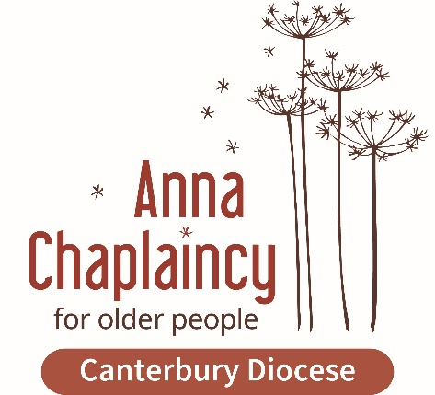

Anna Chaplaincy in Canterbury Diocese
Findings of a 2024 survey of Anna Chaplains and Friends

In September 2024 a survey was sent to 35 people who were then in the Canterbury Diocese Anna Chaplaincy team (21 Anna Chaplains, 14 Anna Friends).

- 17 Anna Chaplains responded (81% response rate)
- 5 Anna Friends responded (37% response rate)

This summary is based on the responses of the 22 who generously shared reflections on their ministry among older people.

Key facts
- 62% had a ministry that extended beyond the parish.
- Around 71% of Anna Chaplains ministered in care homes.
- Around 35% of Anna Chaplains ministered in older people's own homes.
- 15 out of the 17 were ministering with people with dementia.
- 53% of Anna Chaplains worked with care home staff as well as residents.
- All but four Anna Chaplains exercised both group and individual ministry.
- 65% of Anna Chaplains felt supported by their local church leadership.
- 100% of Anna Chaplains felt supported by the Anna Chaplaincy network.
- Training was requested on: end of life care; bereavement care; dementia ministry; ministry among those with severe learning disability.

Frequency of ministry
Anna Chaplains:
- 33.3% spend 1 day a week in role
- 33.3% spend 2 days a week in role
- 33.3% spend more than 2 days a week in role (3 ministered ‘most days’)
Anna Friends
- 20% spend a day a month in role
- 60% spend 1 day a week in role
- 20% spend 2 or more days a week in role
What brings you joy in your role?
‘Talking to people seeing their pleasure during services and generally talking and interacting’
‘Serving people who are often on the edge of society and church’
‘Engaging with people’s stories’
‘I am constantly amazed at what people will share of themselves and how God is in the sharing. I am aware that it is such a privilege - especially to be able to pray with people.’
‘I love being part of the weekly Holy Communion service in the care home. The smallest smile or eye contact with someone with dementia fills my heart with joy.’

What do you find most challenging?
- Emotional impact: 10 spoke about the impact of being alongside people who were distressed or unable to communicate verbally in their dementia, and those in low mood or hostile in their response to the visit.
- Lack of support in care home ministry: 4 mentioned occasions where interaction with care homes was lacking, negative or obstructive.
- Capacity: 4 said they wished for a bigger team or that they could do more and had more time.
‘Getting over being part of the "entertainment" in some residential settings’
‘Reaching those with advanced dementia’
‘It is frustrating when Managers / Activity Managers leave, so that access has to be renegotiated.’
‘Finding the energy to deal with so many individuals' personal challenges in one day. It can be quite exhausting.’
‘When those living with dementia are upset; it is tough at times to see them having a bad day.’
‘Seeing people disappearing as dementia takes them’

How would you like to develop your ministry over the next 6/12 months?
Several were fully stretched. Some spoke of the need to grow the team. Others mentioned new areas of ministry they would like to develop (e.g. Messy Vintage). Further hopes expressed included seeking training, linking with other organisations, and increasing intergenerational work.

‘We are in urgent need to expand the team, especially Anna Chaplains, to cope with the pastoral demands and opportunities coming in via social prescribers.’

