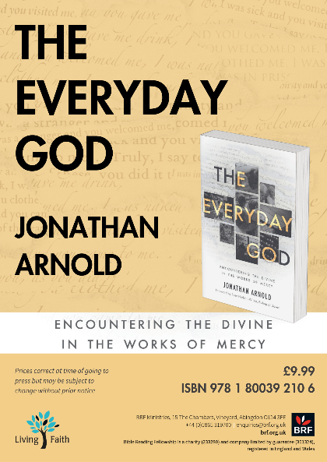
Compelling stories of loving our neighbour today
‘The everyday God is a God who is for everyone…who appears in everyday events and ordinary people. He calls us to move out of our comfort zones and into his liminal space on the margins of our society, to see the face of Christ in a stranger…’
Jonathan Arnold, Director of the Social Justice Network in the Diocese, delves deep into the heart of the biblical mandate to love one’s neighbour. Through a tapestry of real-life stories, he unveils the power of practical faith, illustrating how it can ignite transformation among the homeless, refugees, the poor and vulnerable, imprisoned and marginalised, as well as those living with dementia, disability and disease.
In these pages, you’ll witness how acts of social and environmental justice, intertwined with mercy, have the potential to reshape lives, offering a vivid portrait of the profound impact of embracing the everyday God. As he reflects upon Jesus’s teaching in Matthew 25:34–40, Arnold challenges us to discover God’s presence in the most unexpected places and join in with where he is acting, whether inside or outside our churches.

Ways to use the book during Lent

- Weekly Lent Group Course
Guide for each week
Preparation: Read the recommended pages (set out below)
During the Group Session: Discuss, use the questions at the end for reflection and do the spiritual exercise together or in your own time.
Week 1 (3-9 March)
Pages 11-26 (Foreword, Prelude and Overture)
Week 2 (10- 16 March)
Chapters 1 and 2
Week 3 (11-23 March)
Chapters 3 and 4
Week 4 (24-30 March)
Chapters 5 and 6
Week 5 (31 March – 6 April)
Chapters 7 and 8
Week 6 (7-13 April)
Chapters 9 and 10
Week 7 (14-19 April)
Chapter 11 and Conclusion
Questions for Reflection having read The Everyday God
Reflect on what your story is with God
Where is God acting near you? In your home, family, work, wider community, in the nation, in the world?
What is God saying to you about the Works of Mercy?
What have you discovered about yourself and others this Lent?

- Private Reading and Devotion
Guide for Daily Reading and Prayer
Day 1: pp. 11-14 – Foreword and Prelude
Day 2: pp. 15-20 – Overture pt.1
Day 3: pp. 20-25 – Overture pt.2
Day 4: pp. 26-32 – The Melody of Mercy pt.1
Day 5: pp. 32-36 – The Melody of Mercy pt.2
Day 6: pp. 37-41 – The Song of Justice pt.1
Day 7: pp. 42-45 – The Song of Justice pt.2
Day 8: pp. 46-50 – The Chimes of the Church pt.1
Day 9: pp. 50-55 – The Chimes of the Church pt.2
Day 10: pp. 55-59 – The Chimes of the Church pt.3
Day 11: pp. 61-64 – Feeding the Hungry pt.1
Day 12: pp. 64-68 – Feeding the Hungry – Sharon’s Story
Day 13: pp. 68-72 – Feeding the Hungry – Matt’s Story
Day 14: pp. 72-75 – Feeding the Hungry – Liz’s Story
Day 15: pp. 75-81 – Feeding the Hungry – Helen’s Story and Spiritual Exercise
Day 16: pp. 83-85 – Giving Drink to the Thirsty pt.1
Day 17: pp. 85-92 – Giving Drink to the Thirsty p. 2 – Patrick’s Story
Day 18: pp. 92-95 – Giving Drink to the Thirsty pt.3 and Spiritual Exercise
Day 19: pp. 97-101 – Finding a Home
Day 20: pp. 101-104 – Finding a Home – Jo’s Story
Day 21: pp. 104-108 – Kelly’s Story
Day 22: pp. 108-111 – Finding a Home pt.2 and Spiritual Exercise
Day 23: pp. 113-116 – Welcoming the Stranger pt.1
Day 24: pp. 116-123 – Welcoming the Stranger – Domenica’s and Chris’s Stories
Day 25: pp. 123-133 – Welcoming the Stranger – David’s and Kirrilee’s Stories
Day 26: pp. 133-138 – Welcoming the Stranger – Martin’s Story and Spiritual Exercise
Day 27: pp. 139-141 – Visiting the Sick pt.1
Day 28: pp. 141-149 – Visiting the Sick – Dominic’s Story
Day 29: pp. 149-154 – Visiting the Sick – Julia’s Story and Spiritual Exercise
Day 30: pp. 155-160 – Visiting the Imprisoned pt.1
Day 31: pp. 160-169 – Visiting the Imprisoned – Nick’s Story
Day 32: pp. 169-172 – Visiting the Imprisoned – Reflection questions and Spiritual Exercise
Day 33: pp. 173-175 – Burying the Dead pt.1
Day 34: pp. 175-182 – Burying the Dead – Emma’s Story
Day 35: pp. 182-184 – Burying the Dead – Questions for reflection and Spiritual Exercise
Day 36: pp. 185-192 – Caring for Creation pt1
Day 37: pp. 192-197 – Caring for Creation – Teresa’s Story and Spiritual Exercise
Day 38: pp. 199-204 – Conclusion pt.1
Day 39: pp. 204-208 – Conclusion pt.2 – Coda: My Story
Day 40: pp. 213-216 – Soundbites

Questions for Reflection having read The Everyday God
Reflect on what your story is with God
Where is God acting near you? In your home, family, work, wider community, in the nation, in the world?
What is God saying to you about the Works of Mercy?
What have you discovered about yourself and others this Lent?

