Fresh Approach Collective Worship Planning
Year 1 Term 1: Knowing the God who helps us to be wise

Week 1/  Week 2 | There are ideas here to encourage you to:  - Explore how your school’s vision and its associated values help you all to grow and flourish together  - Remind the school community about the different elements of an act of worship
Week 3 | A New School Year: Being wise in God’s eyes
Week 4 | A New School Year: Being wise in God’s eyes
Week 5 | Harvest  Use this week where appropriate for your school calendar
Week 6 | What’s in a Name?
Week 7 | What’s in a Name?
Week 8 | What’s in a Name?
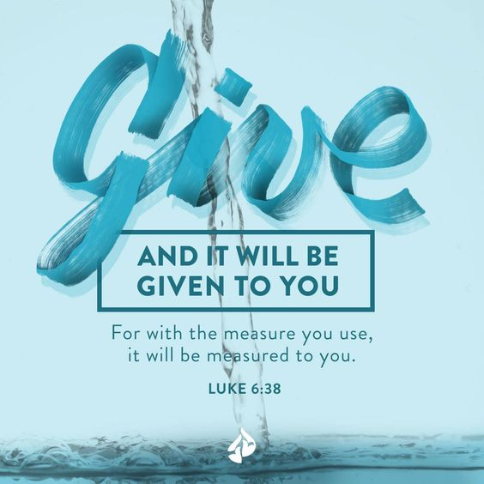
Some of the inspiration for the later weeks is from the book ‘Praying the Names of God’ by Ann Spangler. The names of God we will look at in this series are all Hebrew names from the Old Testament. By exploring each one the children should get a glimpse of the nature and character of the God that Christians worship.

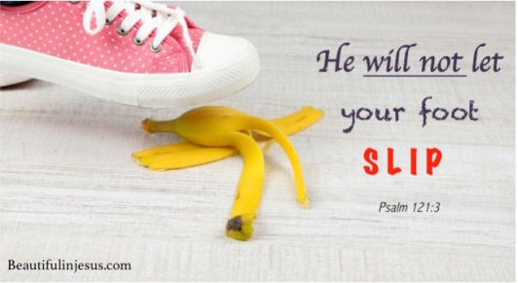
As a new school year starts, these materials aim to help you to grow and develop together as a school community. Week 1 and 2 are flexible weeks which encourage you to re-establish your school’s Christian vision and values (this will be specific to your context) and to think about the different elements of an act of worship in preparation for the year ahead. We aim for these to be flexible depending on how the school is operating – feel free to use the ideas as starting points and places to visit rather than as a plan to be followed without any deviation at all.
Thank you for all that will do to adapt the suggestions in ways which will best bless your school community.
The LORD bless you and keep you: The LORD make his face to shine upon you, and be gracious to you: The LORD lift up his countenance upon you, and give you peace. (Numbers 6:24-26 RSV)
Knowing a God who helps us to be wise
Liturgical colour | Monday | Tuesday | Wednesday | Thursday | Friday  Celebration worship
Week 1 or 2 | During this week, take the opportunity to re-visit your Christian vision, associated values and the ways in which the whole school community can live, learn and flourish together. For some ideas relating to different values which may match your own see:  https://www.brf.org.uk/?s=values  https://www.cofeguildford.org.uk/education/christian-distinctiveness/collective-worship/assembly-resources  Re-familiarise your community with your gathering and sending responses and whole school prayers and favourite songs.  Encourage pupils to write thank you prayers for what they have experienced over the summer and add to a whole school display  https://prayerspacesinschools.com/?s=thankful  Celebrate being back together again!
Week 1 or 2

Week 3 | BEING WISE: THE WORDS OF JESUS  Matthew 7:24-29  Show a picture of a sandcastle and spade. How many of you went to the beach and built sandcastles or dug huge holes in the sand? Did anyone try to beat the tide and build a wall or mound to try and stop the water? Did you succeed? The water always wins; it always knocks the sandcastles down eventually.  Jesus told a story in the Bible about two house builders.  https://www.youtube.com/watch?v=is9Rt29v01M tells the story of the wise and foolish men in an African context or tell the whole story from the Bible (act it out or use props/images to support your retelling).  I wonder if the story is just about building a house on good foundations? I wonder why Jesus told this story? God says those who listen to his words and put them into action are like the wise man. I wonder what it means to be wise? (More than just knowledge) The Bible is full of wise sayings to help us today.  I wonder how you are going to be wise today?  The song of the story:  https://www.youtube.com/watch?v=dkNOcr5iHP4  Dear God, I pray that you will help me to achieve all that I want to this year, even if it feels too hard or difficult, even if I sometimes make mistakes and need to try again. Help me to be wise and listen to all those who offer me help. Thank you for giving me some of your wisdom. Amen. | BEING WISE: THE WORDS OF JESUS  Matthew 7:24-29  Think about the parable from yesterday – I wonder why the one who built on the rock is described as a wise man?  I wonder if there is a difference between being smart and being wise?  https://www.youtube.com/watch?v=Ynq1evqeKmg  I wonder if you like learning new facts?  Did you know  • Sharks have outstanding hearing. They can hear a fish thrashing in the water from as far as 500 metres away!  • Butterflies taste food by standing on top of it! Their taste receptors are in their feet unlike humans who have most on their tongue.  • Although Polar Bears have white, fluffy fur, their skin is actually black.  • Sneezing with your eyes open is impossible.  Now you know these facts, I wonder if that makes you wise? Being wise is more than just having knowledge. Being wise means you put the knowledge into action and apply the most appropriate solution or action to the situation. I wonder if the wise builder learned something new from seeing what happened to the foolish builder?  Invite some teachers to come up and share some wisdom they have learnt from others. (e.g. not putting metal in a microwave, always look before you jump, read every day etc.)  I wonder how you are going to be wise as well as being good at learning today? | BEING WISE; THE WORDS OF PROVERBS  Proverbs 14:4  Without oxen, a stable stays clean, but you need a strong ox for a large harvest.  I wonder who has been wise this week? I wonder what advice you have listened to? Encourage some children to share examples.  We are going to look at a wise saying from a book of wise sayings called Proverbs today and see if it can help us think about our learning.  Read Proverbs 14:4. I wonder what you think this Proverb might mean? I wonder how thinking about oxen help us with our learning? Remember in Bible times, oxen were very important as they did all hard work on the farms as they didn’t have machinery to do it as we have now https://www.dreamstime.com/photos-images/yoked-oxen.html  Show an image of an empty cattle shed and a full one. I wonder what the might differences be? Remember that without the dirty, noisy, full stable, there is no harvest, no food to eat or to sell. I wonder what God’s people to learned from this Proverb when it was written? (If you want to get results, you have got to be prepared to work hard and get dirty. The stable was built to house oxen, without them it is useless)  I wonder what we can learn about our school by thinking about today’s Proverb/wise saying? (Our school is built for learners, without children who want to learn it is pointless) | BEING WISE; THE WORDS OF PROVERBS  2 Chronicles 1:7-12  This is an opportunity to look at wise sayings from Proverbs in an age- appropriate way. King Solomon was the son of King David and, when he became King, God asked him what he needed to be a great King. Solomon replied with: ‘Give me the wisdom and knowledge to lead them properly’. Solomon then wrote down the wisdom that God gave him in the book of Proverbs. He wanted to share the wisdom with God’s people to help them to know how to live a good life as God intended The proverbs are designed to give people options, either be wise or foolish, listen to God’s words or don’t listen.  Here are a few Proverbs, from Proverbs chapter 15. I wonder if you think they are still relevant today? I wonder how following them might make you wise and help you to live a good life?  • A gentle answer will calm a person’s anger, but an unkind answer will cause more anger.  • Only a fool despises a parent’s discipline; whoever learns from correction is wise.  • It is better to eat vegetables with those who love you, than to eat meat with those who hate you.  • Plans fail without good advice, but plans succeed when you get advice from many others.  I wonder if any of these sayings could help us to live more wisely today in our classroom, school, playground or home? | Celebrate  Wisdom  Matthew 7:24  You might want to highlight some of the wise words and actions seen in school this week.  Also take some time to reflect  https://www.youtube.com/watch?v=99hNLjiM3LI  I wonder whose wise words we should listen to? I wonder if you have listened to and used wise words this week? Spend some time being thankful for the wise words that you have heard and will hear from your teachers, helpers and friends in school? I wonder if you are going to listen and act on them like the wise builder?  In darkness and in light, in trouble and in joy, help us, heavenly Father, to trust your love, to serve your purpose, and to praise your name; through Jesus Christ our Lord. Amen
Week 4 | WISDOM FOR LIFE (PROVERBS)  Proverbs: 4.13, 19.27  ‘Hold on to what you learn, for your education is your life. When you stop learning, you soon neglect what you already know’.  Use a calculator, a sheet of paper and a thick felt-tipped pen, some clean pebbles.  I wonder how much of your life you spend in school. Using the calculator, a pupil could help to calculate the minimum time spent in school in hours and write them up: 6 hours a day, 5 days a week, 39 weeks a year, 11 years minimum.  I wonder if school is the only place that we learn? Most of a person’s learning is done between 0 and 5 years. I wonder what sort of learning we do at this age?  Learning goes on for ever.  In the Bible, education is about a way of life. Christians believe God has filled the world with things to discover about himself and the way he made the world. However long people live, they only ever find out a little about the world. The great scientist Isaac Newton, who discovered gravity, was a Christian. He said he felt like a small boy who had managed to pick up a few pebbles of knowledge from a vast beach. As a Christian, Newton felt that life was a journey of discovery and learning which never ends.  Information about Isaac Newton  https://www.youtube.com/watch?v=UjUxRE_TiZc  Dear God, you have crammed the world full of things to discover and learn. Teach us that the excitement of discovery never ends. May we use our knowledge alongside the gift of wisdom which comes from you. AMEN | WISDOM FOR LIFE (PROVERBS)  Proverbs 16.32  ‘A patient person is better than a soldier, and it is better to win control over yourself than win control of whole cities.’  Use a radio controlled car or similar, a bowl, a packet of corn flakes.  I wonder how a radio controlled car and works? It is controlled from the outside. You can make it go where you wish.  https://www.youtube.com/watch?v=a-LAcV72jZM  It is the same with robots. They are controlled by a computer programme. They cannot think for themselves. You can demonstrate this by using a pupil or another member of staff to act as a robot. Stand the person in front of a table and treat them as a robot. Give them instructions on opening a packet of corn flakes and pouring them in the bowl. They must not think for themselves!  I wonder what we mean by self-control? Christians believe God has not made people like robots. People are free to make their own decisions about right and wrong. People are free to ask for advice or help from God or others, but in the end it is up to them what they do. That freedom includes the freedom to do wrong, although there are consequences which have to be taken into account. I wonder what this means about the choices that we make? If we have self-control, what sort of choices might be wise choices?  Dear God, Being a robot is easy, You don’t have to think just follow your programme. Being human is difficult. You have to make choices. Help us to control ourselves And make right and wise choices with your help.  AMEN | WISDOM FOR LIFE (PROVERBS)  Proverbs 11.4, Luke 12:13-21  ‘Wealth will do you no good when you die!’  Use a suitcase, paper, and a thick felt-tipped pen, sweets made by Cadbury and Rowntree’s. I wonder whether a baby has anything at all when it arrives in the world. If babies could choose what they could bring into the world, I wonder what they might bring? Write the pupil’s suggestions on pieces of paper and place them in the suitcase. If no one suggests money, add it yourself.  The Bible does not condemn money or possessions, it reminds people that they came into the world with nothing and they leave it with nothing. The Bible says that people need to concentrate on what they do with their money and possessions during their lives. Jesus told a story about this called ‘The rich fool.’ (Luke 12. 13-21) which you might want to use as well or instead of the Proverb – Jesus says the man in the parable was ‘a rich man in other people’s eyes, ‘but poor in God’s sight.’  https://www.youtube.com/watch?v=mwn4XtgyVeA  Show the sweets. The Rowntree and Cadbury families were both Christians. Both families made money in their business, but they did not keep it all for themselves, they used their money to help others. They built good homes for their workers, and decent factories. They built clinics and schools. They tried to do good with their money in their lifetime. Money that they did not spend was left in trusts to do good even now. | WISDOM FOR LIFE (PROVERBS)  Proverbs 20.11, Matt 7. 16-20 ‘People show what they are by what they do. You will know what people are like by the fruit they bear.’  Use a magnifying glass, an orange or apple, large felt-tipped pen, paper and scissors, a plastic drinking glass with fingerprints on it. I wonder if you know about any television detectives and the sorts of clues they look for? Look for the fingerprints n the glass. Finding out what a person is like on the inside (their true character) is rather like being a detective. I wonder how you tell what someone is like on the inside? We usually have to work out someone’s character from their actions.  If someone produces loving behaviour, they are probably not an evil person. Jesus said a person is like a tree. You tell what type of tree it is by its fruit - an orange tree produces oranges, apple trees produce apples. Good trees produce good fruit, rotten trees produce rotten fruit. In a similar way, you tell a person by their actions. The ‘fruits’ mentioned in the Bible are: love, joy, peace, patience, kindness, goodness, faithfulness, humility and self control (Galatians 5: 22-23).  I wonder how you will produce the best fruit that you can each day? I wonder how you can help others to produce good fruit too?  https://www.youtube.com/watch?v=X-hrxEjWxkE | Celebrate  Galatians 5: 22-23  Celebrate those in the school community, both pupils and adults, who have demonstrated the fruit of the Spirit wisely this week:  Dear God, As we grow in your garden. Help us to produce good fruit - the fruits of: Love, our world is desperate for love. Kindness, the daily acts of practical love which make the world a better place. Patience, enjoying the time you give us, not anxious to be on to the next thing. Self control, gaining control over our own behaviour. Faithfulness, being loyal to those we love. Peace, bringing peace to those around us. Joy, rejoicing in the good things in life. Goodness, practising goodness in daily life. Humility, holding a right view of ourselves: created, special but not perfect
Week 5: Harvest | HARVEST GIFTS  Deuteronomy 8:10  ‘You will have all you want to eat. Then praise the Lord your God. He has given you a good land’.  Harvest is a time for celebrating abundance, giving thanks for all the good gifts we have received. Close your eyes and think about your favourite food. I wonder who cooks that food for you?  I wonder if you have ever thought about  how many people we need to thank that we had enough for our evening meal yesterday? I wonder what ingredients were needed to make that food? I wonder if you know where they are grown or where they come from?  Take a moment to think about how that food got to you…give thanks for all those who were involved…the farmer…the delivery driver…the shop or supermarket workers. Although no-one came and gave you that evening meal as a gift, Christians believe that their food is a gift from God. Think about the words that you say if you have a school lunchtime grace or the words of a similar prayer.  https://www.learnreligions.com/childrens-dinner-prayers-701296  https://outuponthewaters.com/9-simple-creative-mealtime-prayers-for-families/  We can also sing a grace:  https://www.youtube.com/watch?v=5G_QZEQPylQ  https://www.youtube.com/watch?v=V_IrdS-zu48  Perhaps you could introduce new graces for lunchtime at school – pupils could write them or could find some that they like and that are meaningful for them. | HARVEST GIFTS  Deuteronomy 24:19  Watch this video clip as the children enter into worship.  https://www.youtube.com/watch?v=ha628Pj_Rns&list=RDha628Pj_Rns&start_radio=1  I wonder what the children doing? I wonder why people give gifts of food at harvest time? This hymn is a traditional harvest hymn sung in churches. The chorus says:  All good gifts around us Are sent from heaven above Then thank the Lord, then thank the Lord For all his love.  I wonder why the writer of this hymn chose these words? What might these words mean? I wonder why Christians say thank you at harvest time?  Deuteronomy 24:19 “When you gather your crops and fail to bring in some of the grain that you have cut, do not go back for it; it is to be left for the foreigners, orphans, and widows, so that the LORD your God will bless you in everything you do.  I wonder what you think God meant when he gave this instruction to the Israelites. (Think, pair, share). In Bible times, there were not the big shops and convenience foods we have now. People had to grow all their own foods to prepare the food they would eat, so farming was very important and an image that everyone understood. We still have farming now, but not all of us are involved in it. So, I wonder what this verse might mean to those of us who are not farmers? I wonder what we could do in response to this verse? We will think more about this tomorrow.  This song is a joyful thank you for the gifts of the Harvest  https://www.youtube.com/watch?v=Wz35-O8I9d0 | HARVEST GIFTS  Luke 6:38  Give, and you will receive. You will be given much. It will be poured into your hands—more than you can hold. You will be given so much that it will spill into your lap. The way you give to others is the way God will give to you.  I wonder what this verse is encouraging us to do? We know that many people do not have enough. In the Bible, God frequently reminds His people of the importance of taking care of those who are in need.  Use this image or information about a local food bank to think about food banks – why they are needed and how the world could become a fairer place  https://news.sky.com/story/foodbank-calls-for-donations-over-fears-children-going-without-food-during-summer-holidays-11458781  I wonder what difference the bags of food families receive when they visit the food bank has on their lives?  Giver of Life is a song which helps Christians to think about God as the one who gives everything that sustains them and their lives. This is what God wants for everyone  https://www.youtube.com/watch?v=bV5usNv4WEo | HARVEST GIFTS FOR EVERYBODY  Amos 5:24  But let justice flow like a river.  Let goodness flow like a never-ending stream.  In an age-appropriate way, use some of the prayers/ideas suggested in the links below to widen Harvest petitions beyond ‘thank you’ prayers to the wider issues of justice in the world and being courageous advocates for those who cannot seek fairness for themselves.  https://www.youtube.com/watch?v=EevdFYPYEz0  https://www.trusselltrust.org/wp-content/uploads/sites/2/2020/08/Prayer-guide.pdf  file:///C:/Users/virginia.corbyn/Downloads/Prayers%20and%20Worship%20Ideas%20-%20FINAL.pdf  https://www.christianaid.org.uk/sites/default/files/2019-05/harvest19-prayer-sheet.pdf  https://creationtide.files.wordpress.com/2018/07/harvest-intercessions.pdf | Celebrate  Your local Harvest  Your own ‘Harvest’  Take a day this week to hold your own Harvest service, remembering the food we receive and taking the opportunity to give food to those less fortunate than ourselves if that is appropriate in your context.  Reflect:  I wonder what you can do to bring happiness to people? Does it always need to be money? I wonder what you could give or do to make people happier? I wonder what you might bring in to show how thankful you are for all you have?
Week 6 | WHAT’S IN A NAME? Elohim  Genesis 1:1  I wonder if you think that names are important? I wonder why each of us has our own name? I wonder if any of you know what your name means?  https://www.behindthename.com/  I wonder if your name says something about the sort of person that you are? I wonder what names you would give to describe God?  Over the next few weeks, we are going to be exploring some of the names the Israelites used to describe God in the Old Testament. As we explore them, we will learn more about the nature of God, more about what the Bible says that God is like.  This week’s name for God is Elohim. (e-lo-HEEM)  The word Elohim is the first name of God given in the Old Testament:  “In the beginning, God (Elohim) created the heavens and the earth” (Gen. 1:1).  I wonder why God was described as a creator?  This song might provide some clues:  Creator God by Nick and Becky Drake.  https://www.youtube.com/watch?v=7uDwnqynJD4 | WHAT’S IN A NAME? Elohim  Genesis 1:1-25  I wonder if you have a favourite element of Creation which makes you say ‘wow’? (talking partners)  Explore the creation story- what does the Bible say that God created? -Genesis 1: 1- 25.  https://www.youtube.com/watch?v=9MPef0FT7oY – Creation story video.  https://www.youtube.com/watch?v=qHu352QwXXM Creation story animation  (Also link or make use of UC Big frieze and Creation or God units in appropriate ways)  I wonder why one of the important names of God is ‘Creator’? I wonder if there are other words that you could think of which also help us to understand more about God as Creator?  You might think of starting a whole school display about ‘Elohim’, inviting classes to add their own thoughts and illustrations which expand the thinking and understanding of this name for God.  You might create a prayer space on a related theme  https://prayerspacesinschools.com/product-category/prayer-activity/?ixwpss=Nature&title=1&excerpt=1&content=1&categories=1&attributes=1&tags=1&sku=1 | WHAT’S IN A NAME? Elohim  Genesis 1:26-27  Explore Genesis 1: 26-27 – God created humans in his own image.  Look at the person next to you. I wonder what is similar about both of you? I wonder what things are not the same? Being different is ok, being different is good, it would be boring if we were all the same! Even identical twins have differences.  God created you to be as you are. He doesn’t make mistakes. When God created the world and the humans in it he said that the world was good and that people were very good. You are good and perfect. Isn’t God amazing that he made us all to be different.  God is a creative as well as a Creator God. Link to Psalm 139 13-14  For you created my inmost being;  you knit me together in my mother’s womb.  I praise you because I am fearfully and wonderfully made;  your works are wonderful.  I wonder how it makes you feel when God says he made you perfectly and in his image? It says you are wonderfully made – WOW!  Here are some related songs:  Big family of God by Nick and Becky Drake.  https://www.youtube.com/watch?v=UEvJzOxm6zs  https://www.youtube.com/watch?v=v1yu1L6LZCo – Lovely Jubbly by Doug Horley | WHAT’S IN A NAME? Elohim  Genesis 1:1-27  In age-appropriate ways,  Listen and reflect to all the ways the writer describes God in this song called Elohim.  https://www.youtube.com/watch?v=ssrGqyQDCZI (Hillsong Elohim)  Be still and quiet: I wonder which of these names means most to you? I wonder which name you would use to describe God?  Pray together:  Thank you, God, for the lives you created.  Thank you for the planet we play on, the hot burning sun that warms our faces, for the cool rain that waters the plants and for the moon that reminds us that you are still there in the night.  Amen.  Thank you, God, for your beautiful world, for the wonderful colours and amazing animals. We thank you Elohim that you created all of this for us to enjoy. Help us to take care of your world and love it as much as you do. Amen.  In your head, think quietly about your favourite place or animal. Think about all the different things God created to make that place or animal different to other creatures. Thank God in the quiet for all the amazing things he has created. | Celebrate  Elohim (Genesis 1:1)  Look at the display you created at the start of the week. Use some of the prayers that have been written.  Take some time to consider:  I wonder what you can do to take care of the world God created?  As you go outside today or this weekend, look closely at creation. Look at something you have not looked at before and reflect on how amazing it is.  I wonder what you can do today to tell others they are amazing?
Week 7 | WHAT’S IN A NAME? El Roi  Genesis 16:13  Recap the name of God from last week, Elohim. I wonder if anyone looked closely at Creation over the weekend? I wonder what you learning about the Creator God?  Introduce the name for this week:  El Roi (EL raw-EE)  In the OT there were many times where God’s people went through difficult and challenging times, but they were reassured knowing that God was watching over them and would bless their lives and families.  In Genesis 16, a servant girl who was running away because she was afraid of her mistress who was angry with her and she met with God – this is what she found out about God (El Roi)  So she called the name of the Lord who spoke to her, “You are ‘God who sees,’ because I have truly seen the one who looks after me.” Genesis 16:13  https://www.youtube.com/watch?v=JY8UQB3nrPE  I wonder what you think about God watching over us? I wonder why the Bible describes God in this way?  He watches over us because He loves you, like a loving parent who watches over their children.  The Bible tells us that God watches over us and also hears our prayers:  https://www.youtube.com/watch?v=bfOVHoSN7Kg | WHAT’S IN A NAME? El Roi  Psalm 121: 3-8  He will not let your foot slip—  he who watches over you will not slumber;  ⁴ indeed, he who watches over Israel  will neither slumber nor sleep.  ⁵ The Lord watches over you—  the Lord is your shade at your right hand;  ⁶ the sun will not harm you by day,  nor the moon by night.  ⁷ The Lord will keep you from all harm—  he will watch over your life;  ⁸ the Lord will watch over your coming and going  both now and forevermore.  A reading of the Psalm  https://www.youtube.com/watch?v=Gy4bk31rIKo  I wonder which words or which verse strikes you the most from this Psalm (a Psalm is a poem/song)? I wonder how this helps us to understand more about El Roi, the God who watches over his people?  Some sung versions of the words  https://www.youtube.com/watch?v=gJjiTleAz3A  https://www.youtube.com/watch?v=NphQ7uFhbpo  Use the Psalm as a prayer that God will watch over us and those that we love today. | WHAT’S IN A NAME? El Roi  Psalm 33:12-15  Explore these verses from Psalm 33.  Happy is the nation whose God is  the Lord.  Happy are the people he chose for  his very own.  The Lord looks down from heaven.  He sees every person.  From his throne he watches  everyone who lives on earth.  He made their hearts.  He understands everything they do.  I wonder who watches over you day by day? I wonder whether that people/those people can watch over you every moment of the day? I wonder what this Psalm tells us about God’s way of watching over his people? I wonder if this is a comforting picture of God?  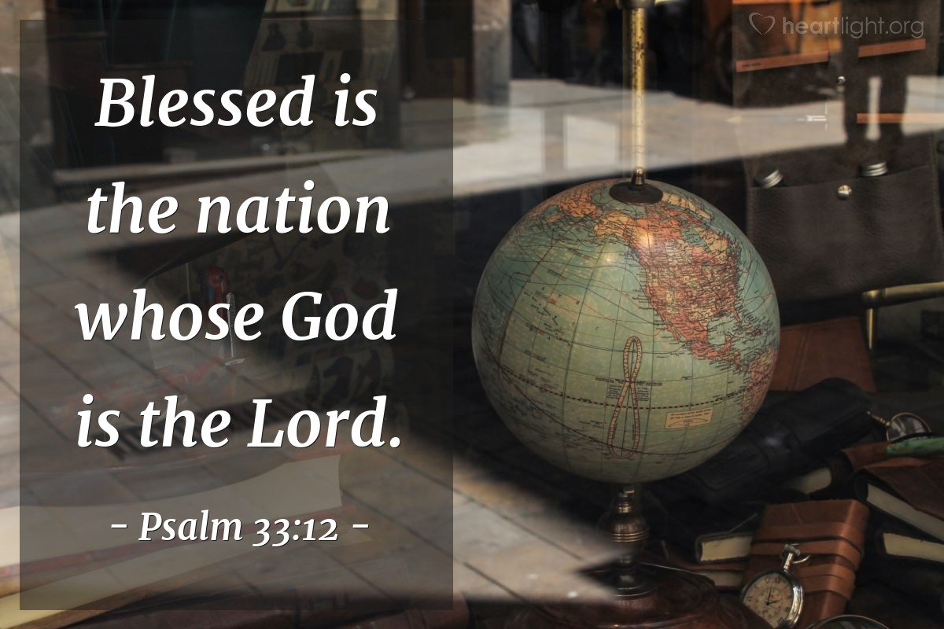  Use these songs to think about what God is like and how he watches over his people  Wonderful Lord  https://www.youtube.com/watch?v=1qZWK8ZE2Pk  God is watching over you.  https://www.youtube.com/watch?v=Rs02V1hcpQc | WHAT’S IN A NAME? El Roi  Luke 12:6-7  Think about this poem as appropriate to age group.  His Eye Is on the Sparrow by Civilla Martin  “Why should I feel discouraged?  Why should the shadows come?  Why should my heart be lonely  and long for heaven and home?  When Jesus is my portion?  My constant friend is he;  His eye is on the sparrow,  and I know he watches me.”  I wonder what you think we can learn from this poem about who is watching over us? I wonder if this is an encouraging poem for you? These words have formed many gospel songs as it talks about how if God is watching and caring for the sparrows of course he will be watching over us.  Prayer  Thank you, God, that you are always watching over me. Thank you that you know what is best for me, so help me to trust you and your plan for me life. Amen.  The God who sees everything by Andrew Thompson.  https://www.youtube.com/watch?v=tKVVvPPADwA  Listen quietly to some of this song and reflect on the words and consider what it is like to have God watching over you at all times.  ‘You are the God who sees everything,  You never let go of me.’ | Celebrate  Psalm 121:7-8  Take some time to think about and give thanks for those who ways over you in different ways, both in school and also beyond.  Take time to think about those who watch over us in wider society so that we feel safe and that no harm comes to us, even thought this is sometimes dangerous for those people.  Thank you, Lord, that you will watch over our coming and going both now and forevermore. AMEN
Week 8 | WHATS IN A NAME? El Shaddi  Genesis 15: 5 -7  Start with an impossible task: Have an image on the screen of the night sky which is full of stars. Ask some volunteers to come and count them all. I wonder if you can count the stars for us? I wonder if you keep losing count or are there just too many?  This week’s name of God is El Shaddi, (EL shad-DAI) which means God Almighty- for whom nothing is impossible.  I wonder what things you might think are impossible? I wonder if you can think of any stories in the Bible where God did the impossible?  This week we are going to hear about a story where El Shaddi helped one of his followers, Abraham. Tell the story of God’s promises to Abraham. At this point in the story Abraham and his wife Sarah, were very old and did not have any children yet. God says that Abram will have as many descendants as there are stars in the sky. There is a clip at  https://www.youtube.com/watch?v=AkK-ZLkW7Q8 – up to 2mins 30secs  I wonder how you think this promise made Abraham and Sarah feel, knowing they were very old and did not have any children? I wonder what you think that they did d? (Had to trust God) | WHAT’S IN A NAME? El Shaddi  Genesis 21:1-8  Use an image of Abraham looking up at the stars. I wonder how Abraham felt when God made the promise to him about how many descendants he would have? I wonder how you feel when you look up at the stars?  This clip tells how the story we started yesterday carries on:  https://www.youtube.com/watch?v=-rrcqpgEoug  What did God do that was impossible?  How did Abraham and Sarah respond to God when he fulfilled His promise?  Hebrews 12: 8-12 which is in the New Testament and written many years after the episode we have looked at,  Abraham is descried as an example of a person with great faith. I wonder what faith is and why Abraham and his family had faith and trusted God?  Reflect on the stories you have heard this week – what did God (El Shaddi) do that seemed impossible to us humans?  Use these songs to think about the ideas https://www.youtube.com/watch?v=7nuzbWEiaeY – God can do anything.  https://www.youtube.com/watch?v=L5D9M8ZpX8o – Nothings to big big big for His power. Doug Horley.  https://www.youtube.com/watch?v=Yopo6DvV9Z8 – with actions! | WHAT’S IN A NAME? Yahweh  Exodus 3:1-15  How do you send messages to people? What about really important messages? How does your Mum or Dad call you for dinner?  Our name for God today is Yahweh, which means Lord. God had a really important message to give to Moses. I wonder how God got the attention of Moses?  Moses was living in Midian as a shepherd after running away from Egypt.  https://www.youtube.com/watch?v=LZpYMr-Ed0Q or/  https://www.youtube.com/watch?v=6ds9y3lJGig  How did God speak to Moses?  What did God call himself?  God said to Moses, “I am who I am. This is what you are to say to the Israelites: ‘I am has sent me to you. Exodus 3:14  I wonder what that name of God might mean? I wonder if it helps to understand more about what God is like?  More for teachers about this name:  https://www.youtube.com/watch?v=eLrGM26pmM0 | WHAT’S IN A NAME? Yahweh  Joshua 21:45  I wonder if you can think of anyone who has kept every single promise they have ever made to you? If you can think of someone, then you are very fortunate as it can be difficult to keep some promises.  https://www.youtube.com/watch?v=poDDYK4ervc  When Moses led the people of God out of Egypt, He promised to take care of them and give them a land of their own. After 40 years of wandering in the wilderness, he did just that and Joshua led them into Canaan. Even though the people made promises to God but broke them -  He (Yahweh) kept every promise he had made to the Israelites. No promises failed. Each one came true.  I wonder what Yahweh, who keeps all his promises, would want us to learn from his example?  https://www.youtube.com/watch?v=kCQKW-EAXG4  Dear God, thank you that you keep your promises. Give me the strength and the courage to keep mine. AMEN | Celebrate  The End of Term 1  Matthew 7:24  Take time to look back over term 1 and to celebrate the wisdom that has been seen within the school community and the ways in which this wisdom has helped and supported the school community.  Dear God  We thank you for all the ways in which we have been shown wisdom by our teachers and staff and all of our friends during this term. We pray our school would continue to be place of great discovery, adventure and creativity. May it be a place where we love to learn and where we learn to love, A place where every one is respected and all are deeply valued.  Send us out for our holiday with joy and keep us safe until we come back together again.  AMEN

